Oferta Piscine si Bile Gonflabile Waterboyz
Sc Waterboyz Srl Constanta
Str Constantin Brancusi nr 63
Telefon 0724 547 343;
e-mail: waterboyz.romania@gmail.com
Web: www.waterboyz.ro
Persoana contact: Toda George

Produs | Dimensiuni | Material | Dimensiuni ambalare | Greutate | Accesorii | Pret final eur | FOTO
TPU water ball | 2.0m diametru | 1.0mm TPU | 0.05m3/buc | 15 kg | kit de reparatie si lubrifiant | 450 eur | 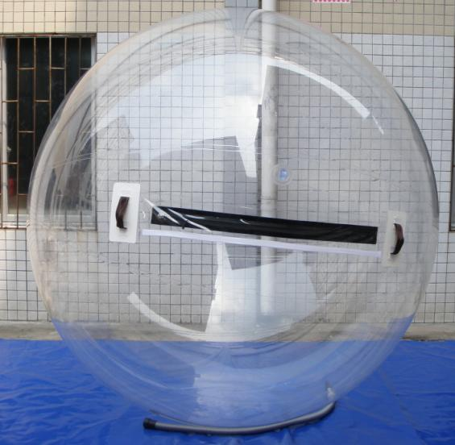
TPU water ball | 2.0m diametru | 0.8 mm TPU | 0.05m3/buc | 14.5kg | kit de reparatie si lubrifiant | 420 eur
TPU water ball | 1.8 diametru | 1 mm TPU | 0.04m3/buc | 14.5KGS/pc | kit de reparatie si lubrifiant | 430 eur
TPU water ball | 1.8 diametru | 0.8 mm TPU | 0.04m3/buc | 14KGS/pc | kit de reparatie si lubrifiant | 410 eur
PVC water ball | 2.0m Diametru | 1 mm PVC | 0.05 m3/buc | 14KGS/pc | kit de reparatie si lubrifiant | 370 eur
PVC water ball | 2.0m Diametru | 0.8 mm PVC | 0.05 CBM/buc | 15KGS/pc | kit de reparatie si lubrifiant | 360 eur
PVC water ball | 1.8m Diametru | 1mm PVC | 0.04CBM/buc | 13.5KGS/pc | kit de reparatie si lubrifiant | 360 eur
PVC water ball | 1.8m Diametru | 0.8mm PVC | 0.04CBM/buc | 13.5KGS/pc | kit de reparatie si lubrifiant | 350 eur
Bazin(nu include bile) | 4x6x0.65m | 0.9mm PVC Tarpaulin | 0.7m3/buc | 50kgs/pc | Pompa de aer si kit de reparatie | 1000 eur | 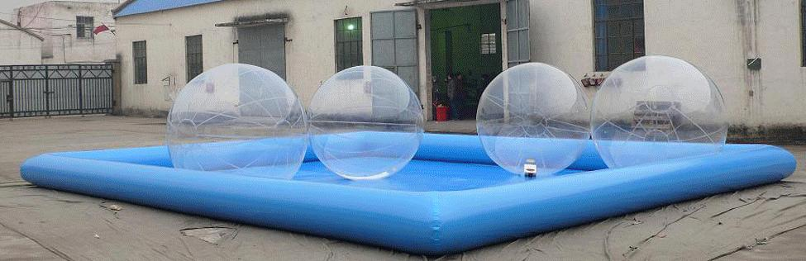
Bazin(nu include bile) | 6x6x0.65m | 0.9mm PVC Tarpaulin | 0.7m3/buc | 60kgs/pc | Pompa de aer si kit de reparatie | 1250 eur
Bazin(nu include bile) | 8x6x0.65m | 0.9mm PVC Tarpaulin | 0.4CBM/buc | 75kg/pc | Pompa de aer si kit de reparatie | 1500 eur
Bazin(nu include bile) | 8x8x0.65m | 0.9mm PVC Tarpaulin | 0.6CBM/buc | 85kgs/pc | Pompa de aer si kit de reparatie | 1750 eur
Bazin(nu include bile) | 10x8x0.65m | 0.9mm PVC Tarpaulin | 0.6CBM/buc | 105kgs/pc | Pompa de aer si kit de reparatie | 2000 eur
  Bazin
Blower pentru bile | 330W | // | 0.02CBM/buc | 7kgs | // | 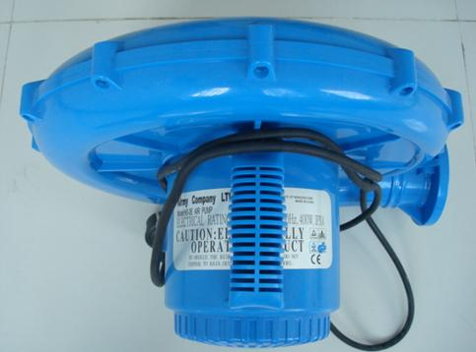  100 EUR; GRATIS  LA PACHET  PISCINA+BILE
Pompa de aer pentru piscina | 550W | // | 0.002CBM | 1.1KGS | // | 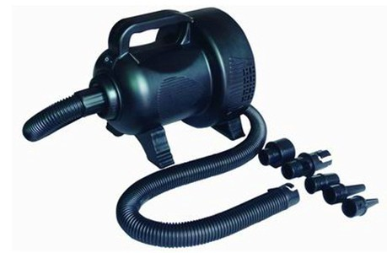  50 EUR; GRATIS  LA PSICINA; SAU  PACHET  PSICINA+BILE

