Manufacturer | Mitsubishi Motors
Also called | Plymouth Champ  Plymouth Colt  Eagle Summit  Plymouth Cricket
Model years | 1994
Assembly | Kurashiki, Okayama, Japan
Successor | Dodge/Plymouth Neon  Eagle Summit (For sedan, U.S.)

The Dodge Colt and the similar Plymouth Champ and Plymouth Colt, were subcompact cars sold by Dodge and Plymouth from 1970 (MY1971) to 1994. They were captive imports from Mitsubishi Motors, initially twins of the rear-wheel drive Galant and Lancer families before shifting to the smaller front-wheel drive Mitsubishi Mirage subcompacts in 1979. With the 1994 introduction of the Dodge/Plymouth Neon, Chrysler felt no need to continue selling captive imports under these badges, although the Eagle Summit (also a Mirage clone) continued to be available until 1996.

Seventh generation
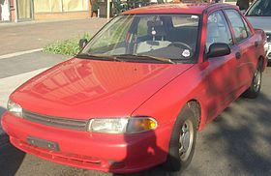
Also called | Mitsubishi Mirage  Eagle Summit  Plymouth Colt
Production | 1993–1994
Body style | 2-door coupe  4-door sedan  3-door van (see Mitsubishi RVR)
Layout | FF layout
Engine | 1.5 L 4G15 I4  1.8 L 4G93 16V I4

