
S.C. ARNA COM SERV S.R.L

STR. MIHAI EMINESCU NR. 41-C1, CONSTANTA, ROMANIA
CUI 16001037 Telefon: 0241611509 0733676700
ATRIBUT FISCAL : RO Fax: 0241611463
NR. IN REG. COM. : J13/7474/2004 E-mail arnasrl@yahoo.com
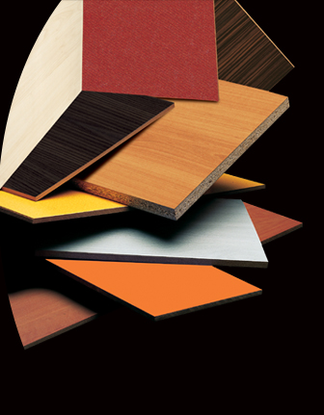

OFERTA DE PRETURI

Stimate client ,

Societatea noastra va pune la dispozitie o gama de
PAL si MDF melaminat de dimensiuni 210*280*18
intr-o gama variata de nuante , deasemeni profile mdf
si canturi abs.
Alaturat va atasam lista de preturi cu tva inclus .
In vederea unei colaborari va rugam sa ne contactati.

 | LISTA PRETURI
Nr  Crt. | Descriere  produs | Culoare | Pret lei cu tva
buc Pal melaminat
1 | 210*280*18 | Stejar deschis | 189.53
2 | 210*280*18 | Nuc | 174.92
3 | 210*280*18 | Fag | 174.92
4 | 210*280*18 | Venge deschis | 174.92
5 | 210*280*18 | Seleniu | 174.92
6 | 210*280*18 | Bej | 174.92
Placi MDF
7 | 210*280*18 | Bej | 254.52
8 | 210*280*18 | Nuc | 254.52
9 | 210*280*18 | Fag | 254.52
10 | 210*280*18 | Venge deschis | 254.92
11 | 210*280*18 | Seleniu | 254.92
12 | 210*280*18 | Bej | 254.92
buc | Profile mdf
13 | 25 1 | Venge deschis | 13.35
14 | 30 5 | bej | 30.80
ml Cant ABS
15 | pvc lgn napolyon Cires 22*0,4 |  | 0.38
16 | pvc lgn napolyon Cires 22*2 (150 ML) |  | 1.73
17 | pvc lgn napolyon Fag 4 22*0,4 |  | 0.38
18 | pvc lgn napolyon Fag 4 22*2 (150 ML) |  | 1.73
19 | pvc lgn napolyon Venge deschis 22*0,4 |  | 0.38
20 | pvc lgn napolyon Venge deschis 22*2 |  | 1.73
21 | pvc lgn napolyon Seleniu 22*0,4 |  | 0.38
22 | pvc lgn napolyon Seleniu 22*2 (150 ML) |  | 1.73
23 | pvc lgn napolyon Bej 22*0,4 |  | 0.24
24 | pvc lgn napolyon Bej 22*2 (150 ML) |  | 1.04

BANCA : CREDIT EUROPE BANK CONSTANTA / IBAN : RO78FNNB000502042699RO03

TEL : 0241 611509, 0341803329;FAX : 0241 611463; MAIL : arnasrl@yahoo.com, arnacomservsrl@yahoo.com

