

ANED PLAST DISTRIBUTION
ADRESA: Str. Aviatiei nr. 5
TEL: 0734.165.401
TEL: 0723.280.451
E-MAIL: andrei@aned.ro
madalina@aned.ro
Societatea ANED PLAST DISTRIBUTION vă oferă produse de ambalat pentru: Firme Catering, Carmangerii, Supermarket-uri, Fast-Food, Pizza, Cofetării, Patiserii, Fabrici de ambalat carne şi ferme păsări, Fructe şi Legume, Fabrici de produse lactate şi brânzeturi cum ar fi: Caserole polistiren cu capac, Caserole compartimentate, Caserole salate, Caserole supe, Cutii pentru sandwichuri, Cutii pizza carton, Tacâmuri unică folosinţă, Produse igienă.

Ambalaje polistiren expandat pentru catering
Cutie prânz LB1 | 1 compartiment | 200 buc/box | 57.2 RON/BOX
Cutie prânz LB2 | 2 compartimente | 200 buc/box | 57.2 RON/BOX
Cutie pranz LB 3 | 3 compartimente | 200 buc/box | 57.2 RON/BOX
Cutie hamburger HB6 | 1 compartiment | 500 buc/box | 58.8 RON/BOX
Cutie hamburger HB7 | 1 compartiment | 500 buc/box | 44.4 RON/BOX
Cutie hamburger HB9 | 1 compartment | 250 buc/box | 39.65 RON/BOX
Cutie hamburger HB10 | 1 compartiment | 250 buc/box | 44.4 RON/BOX
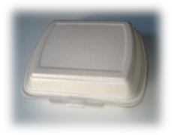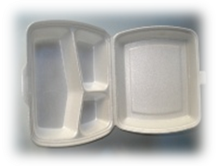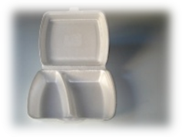
Caserole transparente pentru salate, sosuri cu capac detasabil
Polar Cup 250 gr. | 1000 buc/box | 81.6 RON/BOX
Polar Cup 500 gr. | 1000 buc/box | 128 RON/BOX
Capac Polar Cup | 1000 buc/box | 62.4 RON/BOX

Castroane supa
Castron supa 475 ml. | 30 buc/ set | 7.5 RON/SET
Capac castron | 30 buc/ set | 6.5 RON/SET
Castron supa 340 ml. | 30 buc/ set | 6.8 RON/SET
Capac castron | 30 buc/ set | 6.5 RON/SET
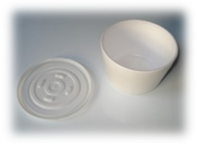

Caserole transparente pentru salate cu capac incorporate (PET)
Caserola cu capac 250 gr. – FT 208 | 100 buc/ set – 1200 buc/ box | 18.59 RON/ SET
Caserola cu capac 375 gr. – FT 208 | 100 buc/ set – 1200 buc/ box | 23.27 RON/ SET
Caserola cu capac 500 gr. – FT 208 | 100 buc/ set – 1200 buc/ box | 28.08 RON/ SET
Caserola cu capac 750 gr. – FT 208 | 100 buc/ set – 600 buc/ box | 37.31 RON/ SET
Caserola cu capac 1000 gr. – FT 208 | 100 buc/ set – 600 buc/ box | 41.99 RON/ SET
Caserola cu capac 1500 gr. – FT 208 | 100 buc/ set – 600 buc/ box | 64.87 RON/ SET
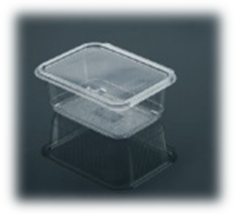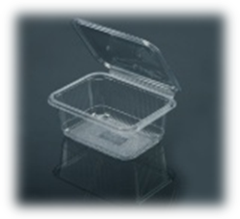

Caserole sos
Caserola sos 50 ml. - FT 150 | 100 buc/ set – 1000 buc/ box | 6.89 RON/ SET
Caserola sos 80 ml – FT 150 | 100 buc/ set – 1000 buc/ box | 8.84 RON/ SET
Capac caserola sos – FT 155 | 200 buc/ set – 1200 buc/ box
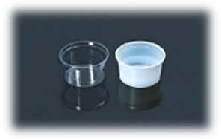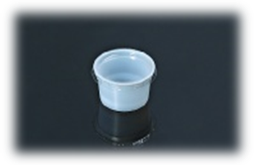

Caserola salate
Caserola rotunda salata FT 120 | 50 buc/ set – 600 buc/ box | 25.61 RON/ SET
Capac FT 121 | 50 buc/ set – 600 buc/ box | 31.2 RON/ SET
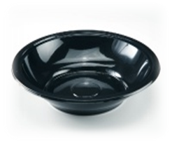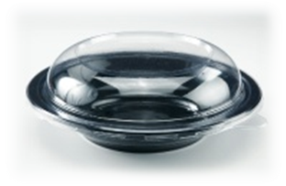
Caserole rectangulare Aluminiu/ Capac carton laminat cu Aluminiu
Caserola rectangulara Al 310 ml. – S227 L | 100 buc/ set – 1000 buc/ box | 18.2 RON/ SET
Capac Al – S227 LK | 1000 buc/ box | 68.9 RON/ BOX
Caserola rectangulara Al 430 ml. – S528 L | 100 buc/ set – 1000 buc/ box | 19.11 RON/ SET
Capac Al – S528 LK | 1000 buc/ box | 68.9 RON/ BOX
Caserola rectangulara Al 510 ml. – S335 L | 100 buc/ set – 1000 buc/ box | 24.31 RON/ SET
Capac Al – S335 LK | 1000 buc/ box | 96.2 RON/BOX
Caserola rectangulara Al 650 ml. – S487 L | 100 buc/ set – 1000 buc/ box | 28.08 RON/ SET
Capac Al – S487 LK | 1000 buc/ box | 102.7 RON/ BOX
Caserola rectangulara Al 690 ml. – S843 L | 100 buc/ set – 1000 buc/ box | 30.42 RON/ SET
Capac Al – S843 LK | 1000 buc/ box | 123.5 RON/ BOX
Caserola rectangulara Al 850 ml. – S901 L | 100 buc/ set – 1000 buc/ box | 34. 58 RON/ SET
Capac Al – S901 LK | 1000 buc/ box | 123.5 RON/ BOX
Caserola rectangulara Al 1000 ml. – S815 L | 100 buc/ set – 1000 buc/ box | 42.12 RON/ SET
Capac Al – S815 LK | 1000 buc/ box | 101.4 RON/BOX
Caserola rectangulara Al 1500 ml. – S816 L | 100 buc/ set – 1000 buc/ box | 57.07 RON/ SET
Capac Al – S816 LK | 1000 buc/ box | 135.2 RON/ BOX
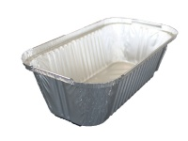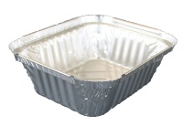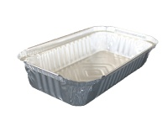

Caserole Aluminiu 2 si 3 compartimente
Caserola Al – S680 L – 227 x 177 x 30 | 2 comp. | 100 buc/ set – 1000 buc/ box | 44.46 RON/SET
Caserola Al – S681 L – 227 X 177 X 30 | 3 comp. | 100 buc/ set – 1000 buc/box | 46.8 RON/SET
Capac Al – S680 LK/ S681 LK |  | 1000 buc/ box | 141.7 RON/ BOX
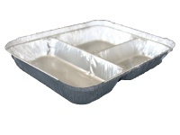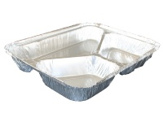

Caserole sandwich si pentru mancare calda
Caserola pt. sandwich – FT 104 B | 100 buc/set – 1000 buc/ box | 38.35 RON/ SET
Caserola mancare calda – FT 101 | 50 buc/ set – 600 buc/ box | 30.48 RON/ SET
Capac FT 101 | 50 buc/ set – 600 buc/ box | 31.33 RON/ SET

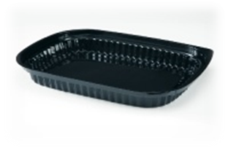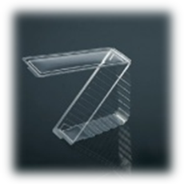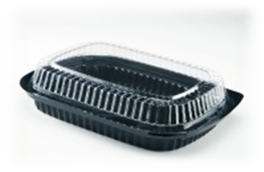

Cutii pizza carton
Cutie pizza 28 ø – 280 mm. | 100 buc/ set | 59.67 RON/ SET
Cutie pizza 31.5 ø – 315 mm. | 100 buc/ set | 66.04 RON/ SET

Pahare albe
Pahar alb 200 ml. | 100 buc/set – 3000 buc/ box | 2.78 RON/ SET
Pahar alb 220 ml. | 100 buc/ set – 3000 buc/ box | 3.04 RON/ SET
Pahar alb 250 ml. | 50 buc/set - 3000 buc/ box | 2.14 RON/ SET
Pahar alb 330 ml. | 50 buc/ set – 3000 buc/ box | 3.29 RON/SET
Pahar alb EXPRESSO 80 ml. | 50 buc/ set – 5400 buc/ box | 1.76 RON/ SET

Pahare plastic cristal
Pahar cristal 200 ml. | 100 buc/ set – 3000 buc/ box | 2.78 RON/SET
Pahar cristal 220 ml | 100 buc/ set – 3000 buc/ box | 3.03 RON/ SET
Pahar cristal 250 ml. | 50 buc/ set – 3000 buc/ box | 2.13 RON/ SET
Pahar cristal 330 ml. | 50 buc/ set – 3000 buc/ box | 3.28 RON/ SET
Pahar cristal 400 ml. | 50 buc/ set – 2000 buc/ box | 5.70 RON/ SET
Pahare cristal BERE 500 ml. | 50 buc/ set – 2000 buc/ box | 7.91 RON/ SET

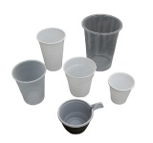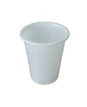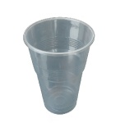
Tacamuri
Cutite | 100 buc/ set – 3000 buc/ box | 2.80 RON/ SET
Furculite | 100 buc/ set – 2500 buc/ box | 2.65 RON/ SET
Linguri | 100 buc/ set – 2500 buc/ box | 3.46 RON/ SET
Lingurite | 100 buc/ set – 4500 buc/ box | 2.28 RON/ SET
Lingurite inghetata | 200 buc/ set – 6000 buc/ box | 4.32 RON/ SET
Palete cafea | 100 buc/ set – 25000 buc/ box | 5.33 RON/ SET
Set tacamuri
Set tacam – furc. + cutit + serv. + piper + sare | 100 buc/ set – 600 buc/ box | 24. 18 RON/ SET
Set tacam – furc. + cutit + serv. + scob. + ling. | 100 buc/ set – 600 buc/ box | 18.85 RON/ SET
Set tacam – furc. + cutit + serv. + scobitoare | 100 buc/ set – 1000 buc/ box | 14.82 RON/ SET
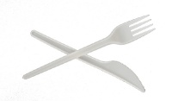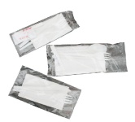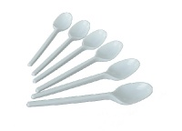

Folie Aluminiu
Folie Al 30 x 100 m | 1 buc/ set | 27 RON/ ROLA
Folie Al 30 x 150 m | 1 buc/ set | 33 RON/ ROLA
Folie Al 45 x 100 m | 1 buc/ set | 34 RON/ ROLA
Folie Al 45 x 150 m | 1 buc/ set | 50 RON/ ROLA

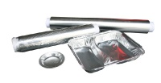
Farfurii plastic
Farfurii albe 17 cm | 50 buc/ set – 2000 buc/ box | 3.16 RON/ SET
Farfurii albe 19 cm | 100 buc/ set – 6000 buc/ box | 5.50 RON/ SET
Farfurii albe 21 cm | 50 buc/ set – 2000 buc/ box | 4.42 RON/ SET
Farfurii albe 3 compartimente | 40 buc/ set – 2400 buc/ box | 7.65 RON/ SET
Farfurii albe adanci | 50 buc/ set – 1600 buc/ box | 5.44 RON/ SET

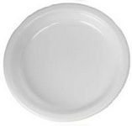
Pungi alimentare pe rola
Pungi alimentare pe rola – 0.5 Kg. | 500 buc/ rola | 2.42 RON/ ROLA
Pungi alimentare pe rola – 1 Kg. | 500 buc/ rola | 4.04 RON/ ROLA
Pungi alimentare pe rola – 2 Kg. | 500 buc/ rola | 5.83 RON/ROLA
Pungi alimentarepe rola – 3 Kg. | 500 buc/rola | 9.8 RON/ROLA

