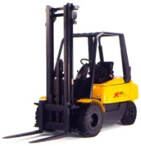
S.C. INTERRELU S.R.L.
Vindem , inchiriem, intretinem si reparam stivuitoare ,
trnspaleti, piese de schimb si accesorii.
OM PIMESPO, NISSAN, STILL, TCM, BALKANCAR, HALLA,
FENWCH, HISTER, CATERPILAR

Catre |  | De la | SC INTERRELU SRL
In atentia |  |  | Florin Simosca
Tel/fax  Mob  E-mail |  |  | 0256378685 0256378483  0756082071  florin.simosca@interrelu.ro
Subiect | Oferta stivuitor Linde H 50 353 | Nr.366 | 10.08.2011
Detalii utilaj REL006  Număr produs REL 32  Capacitate (kg) 5000  Înălţimea de ridicare (mm) 4850  Anul de fabricaţie 1996  Oră de citire a contoarelor (h) 8220  Garanţie 6 luni  Pret (Preţurile fără TVA) 16800€ |  | 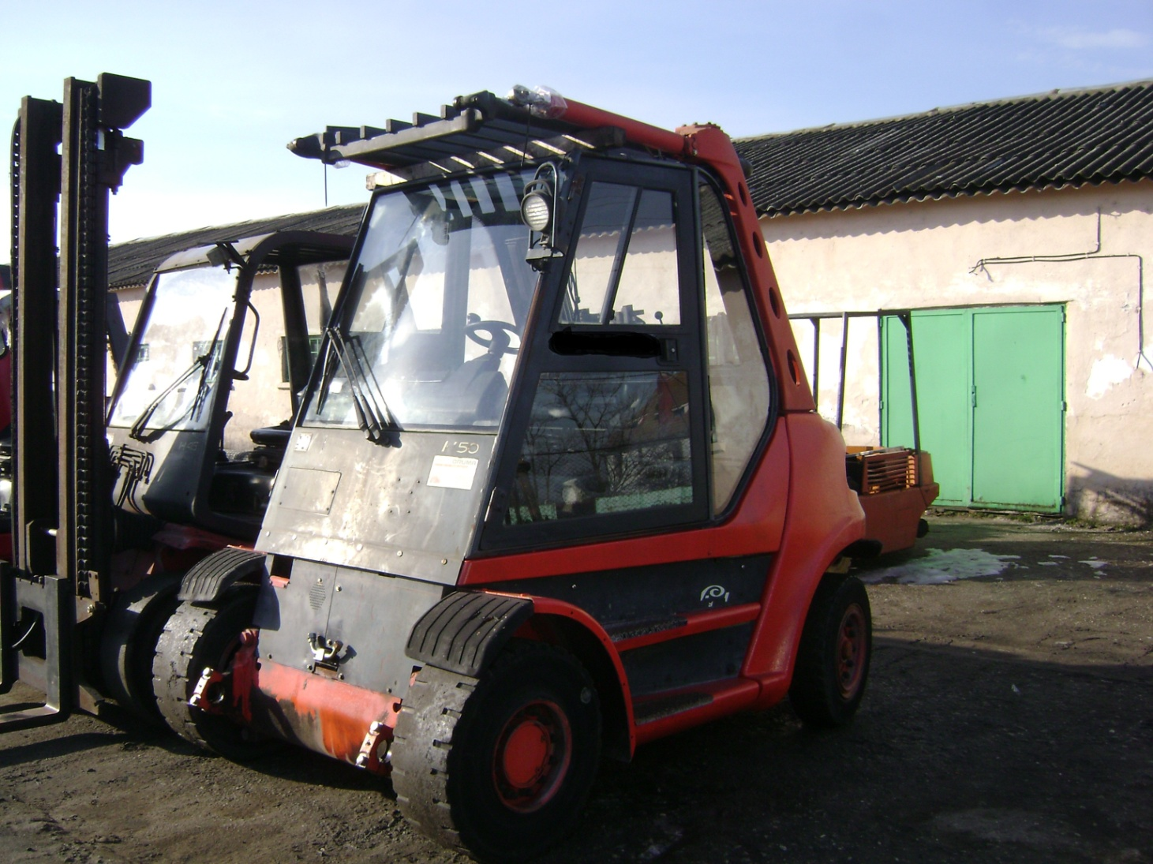
Oferta detalii
Dealer produs nr.
Producător | Linde
Model | H 50 D/353
Propulsie | Diesel
Tip de stivuitor | Patru roti cu contragreutate
Capacitate (kg) | 5000
Centrul de greutate de încărcare (mm) | 600
Catarg | Standard
Anul de fabricaţie | 1996
Înălţimea de ridicare (mm) | 4850
Înălţime (mm) | 3300
Ridicare libera (mm) | 150
Oră de citire a contoarelor (h) | 8220
Greutate (kg) | 10200

