SC DAFY TOOLS SRL
CUI : RO27908326
Reg.Com.: J18/27/2011
Persoana de contact: Isar Daniela
Tel: 0733694266

Oferta produse in stoc august 2011

Nt.crt. | Denumire produs | Imagine | Cod | UM | Canti-tate | Pret lei fara TVA
1 | CHEIE BUJII CU MANER "T" 16 MM | 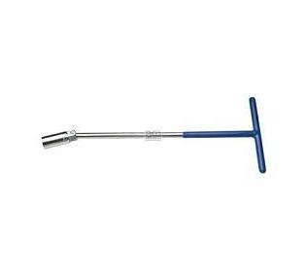 | 4238016T | buc | 1,00 | 44,20
2 | CHEIE BUJII CU MANER "T" 21 MM | 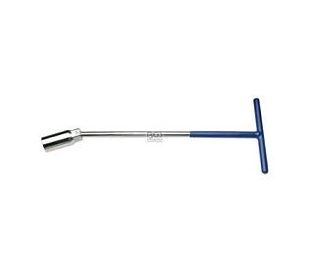 | 4238021T | buc | 1,00 | 44,20
3 | CHEIE INELARA DE IMPACT 24 MM | 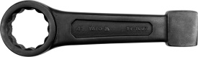  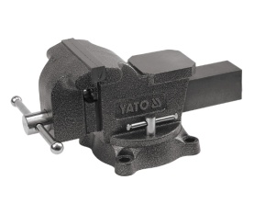 | YT-1601 | buc | 1,00 | 39,00
4 | MENGHINA ROTATIVA 150 MM |  | YT-6503 | buc | 1,00 | 390,00
5 | PISTOL PNEUMATIC 1/2" 678 NM | 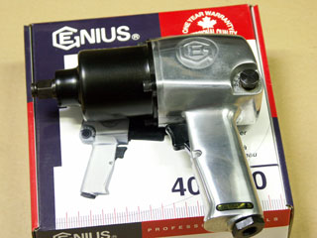 | 400500 | buc | 1,00 | 838,50
6 | PRESA CAP DE BARA 23 MM | 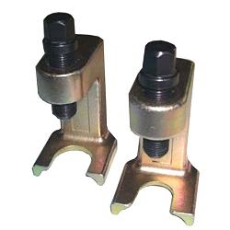 | KA-5532 | buc | 1,00 | 101,40
7 | PRESA CAP DE BARA 23 MM | 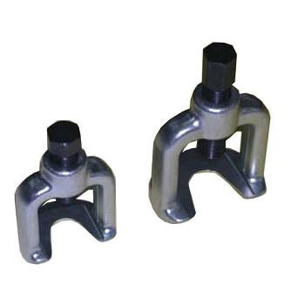  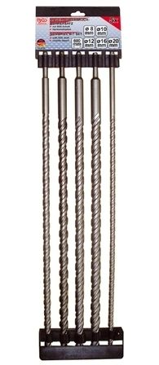 | KA-5536 | buc | 1,00 | 101,40
8 | SET BURGHIU BETON SDS 5 BUC |  | 2016 | set | 1,00 | 140,40
9 | SET LEVIERE PLATE 300-400-500-600 MM 4 BUC | 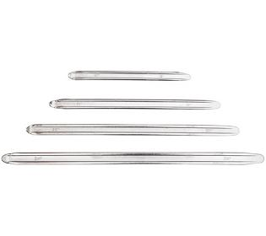 | 1548 | set | 1,00 | 111,80
10 | SURUBELNITA CU AER 3 VITEZE | 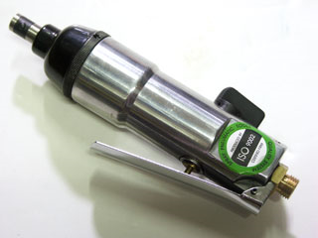 | F.V-102 | buc | 1,00 | 150,80
11 | TRUSA BIT SECURITY 1/4" 100 BUC | 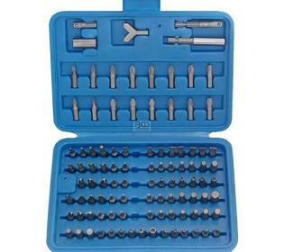 | 765 | tsa | 1,00 | 94,90
12 | TRUSA EXTRAS SUSUB 8 BUC | 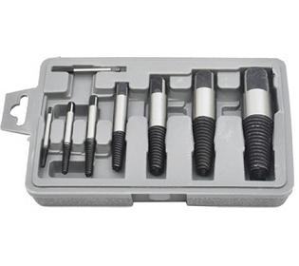 | 1897 | set | 1,00 | 67,60
13 | TRUSA TORX 1/2" - 3/8" | 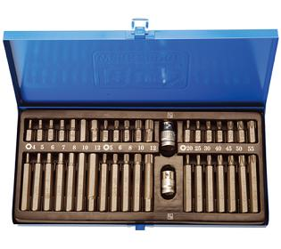 | BS-3424T | tsa | 1,00 | 279,50
14 | TRUSA TUBULARA 1/2" 5 BUC | 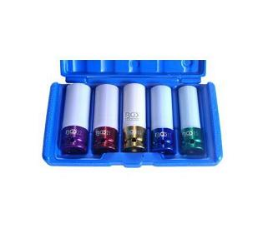 | 7199 | tsa | 1,00 | 191,10
15 | CRIC CROCODIL 3 T |  | H300 | buc | 1,00 | 482,60
16 | TRUSA TORX-HEXAGON-IMBUS 40 BUC |  | 7071 | buc | 1,00 | 150,80
17 | SET PARBRIZ |  | B8002 | buc | 1,00 | 142,53
18 | BLOCATOR SURUBURI MEDIU |  | T902 711 | buc | 5 | 30,82
19 | BT-PO 1100 EINHELL-(MASINA POLISAT) | 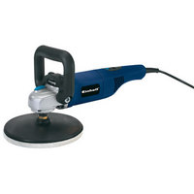 | 04250013 | buc | 1 | 276,77
20 | CHEIE CLICHET 3/8" |  | 387 001 | buc | 1 | 49,18
21 | DEGRIPANT CU GRAFIT |  | E112 | buc | 32 | 12,68
22 | DOZA VASELINA LICHIDA H4S 2002 500 ML |  | T830 017 | buc | 12 | 22,27
23 | FERASTRAU PNEUMATIC |  | XQT27 | buc | 1 | 201,80
24 | OCHELARI PROTECTIE |  | TP.1000100 | buc | 4 | 76,06
25 | PISTOL PNEUMATIC 1/2" 678 NM | 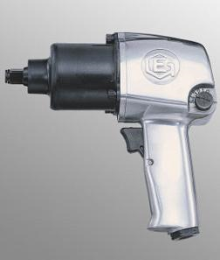 | 400500 | buc | 1 | 838,50
26 | SET CHEI CONDUCTE | 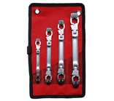 | B1785 | buc | 1 | 410,53
27 | SUPORT HARTIE |  | 4901 | buc | 1 | 66,34
28 | TRUSA EXTRAS SUSUB 8 BUC | 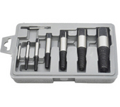 | 1897 | buc | 1 | 67,60
29 | TRUSA PRESE RULMENTI |  | S603 | buc | 1 | 407,50
30 | TRUSA SURUBELNITE IMPACT 7 BUC/TR |  | 902 | buc | 2 | 94,02
31 | ULEI PNEUMATIC |  | T901 502-1 | buc | 1 | 42,63

