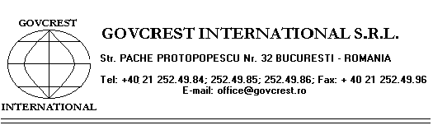

SODIUM SILICATE SOLID

CHEMICAL NAME: Sodium silicate ( Na2O x n SiO2 )
MANUFACTURING PROCESS: Silica sand melting with soda ash
Technical data | UM | Value
 |  | Type 1/3 | Type 1/2
Appearance | - | glassy granules | of 8 - 10 cm
Colour |  | blue, green, | brown
SiO2 content | % | 72 - 76.5 | 62 - 67
Na2O content | % | 21.5 - 25 | 31 - 36
Metal oxides (R2O3) content | % | 2.6 | 1.9
CaO content | % | 1.1 | 1.1
Modulus (SiO2/Na2O) |  | 3.0 - 3.7 | 1.8 - 2.2

APPLICATION:
Preparation of liquid sodium silicate.

PACKING AND STORAGE:

In 1000 kg big bags or in bulk.

HANDLING:
The product does not require any special cautions.

STORAGE:
In clean, specially arranged areas.

GUARANTEE PERIOD:
The product is guaranteed for 12 months, providing that packaging, conveyance and storage provisions are observed.

