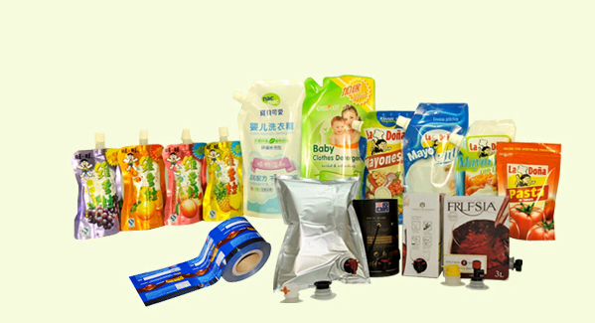
Directory
1、 Introduction
2、Box bags of Use
3、Features
4、Box bags in packaging applications
5、 The status of plant
6、Box bags filled way
7、Case packing 1 (soybean oil)
8、Case packing 2 (red wine)
9、The product specification sheet
1、Introduction:
China have 7 factory production of bags in boxes, each are for a specific company (such as McDonald's, KFC), the factory can supply more than the Taiwan market, and are for the Chinese plant, currently Taiwanese only one factory of this product, the packaging materials plant building the 100,000 grade of BIOCONTROL plant for the new purification , and using the most advanced laminating machine, cutting machine and professional box bag making machine.
We believe that professional cleaning of plant and equipment is to provide professional services basis. In the production of regional air temperature control and filtration, pollution prevention system to ensure the production of top quality products. Professional production of composite materials, including film and bag full of composite technology, we can offer a variety of material formulations to meet different product requirements. Specialized, automated bag-making equipment for the bag to provide a quality and stable products and strong production capacity. 100,000 grade of purification plant with strict production management process combination to avoid the recurrence of the process in the bag pollution, ensure food hygiene and safety.

2, Box bags of use:
Box bags are widely used in the form of fruit juice, wine, fruit juice, mineral water, edible oil, food additives, industrial, pharmaceutical, medical reagent, liquid fertilizers and pesticides.
Box in the bag is made of flexible multi-layer film and sealed in bags composed of the leading switches and boxes.
Inside the bag: The composite films made of different materials to meet the needs of different liquid packaging, offers 2 - 220 liters bag, transparent bag, single or double-volume standard products, with the standard canned port can Coding identify also can be customized size specifications.
Two types: 1 foil bag (composite film) 2 transparent bag (co-extruded film) 3 composite film bag
Leading switches: The PP, PE and other non-toxic materials, reliable sealing, flexible operation.
The form of butterfly form, spiral type, plunger type, push-button, switch mode and so on.
Can be manual, semi or fully automatic filling. Canned lines in the existing special folder bag slightly improved device configuration and control by mouth, can be realized, or semi-automatic assembly line operations. Can also purchase professional manual, semi or fully automatic, with single or double canned head equipment, the other based on user conditions and requirements of design and manufacture of specialized filling equipment and facilities.
Cartons: corrugated paper manufacturing using with high intensity, light quality, and environmental characteristics, and provide good transport protection.
Printing plate according to customer requirements.
Note: from light to avoid puncture by sharp objects inside the bag.
3. Features:
• Use non-toxic plastic, high temperature molding and radiation sterilization.
。 Sterile, non-toxic, odorless.
• Foldable, light quality, easy storage and transportation, storage and transportation of materials to reduce packaging costs.
• Environmental health, ease of recovery, simply separate the box and inside the bag, you can return to ring use.
• can be used to achieve product and other near-term shelf life period, a longer shelf life, box bags stored wine, fruit juice can be sealed 2-3 years, once opened can be stored for 2 months.
• The packaging volume of 220 liters in 2 --- packaging, and highly competitive.
• a variety of film inside the bag makes packing materials and the leading switch types and applications of liquid greatly expanded.
• gift packaging not suitable for anti-corrosion additives, cold storage
• Use simple and convenient storage

4、 Box bags in packaging applications
Globally, box bags have been widely used in food, beverage and industrial fields, the market's fastest growing form of packaging.
On wine packaging as an example: According to the survey, the global 2008 sales of box wine bags rose 41%, more consumer choice of the box in the bag of wine.
China is about 600,000 tons per year of wine production in 2010 is expected to reach 80 million tons. Currently, the average box wine bags account for 35% of the entire wine production, according to 2 liters Packing rates, China needs about one hundred million per year of wine bags. Although the Chinese box bag wine has just started, the proportion of less than 1%, and most of the packaging is also dependent on imports, but its growth rate is very fast, which for packaging companies, will be a very good opportunities. Another information should not be overlooked is the output of the Chinese rice wine 3 times wine, liquor wine production is 10 times. In the future these are likely to use the box bag. Box bag packaging costs much lower than the glass of wine, and nearly a decade, the demand for wine industry boxed products every year 8% -9% growth, so winemakers are increasingly turning to box bag.
From an environmental perspective, box bags carbon footprint 55% lower than the glass. As light weight, fuel consumption during transportation than glass bottles, plastic bottles less, more energy efficient. Experts predict that if the U.S. market, have adopted all the wine carton packaging, annual reduction of 150 tons of carbon dioxide emissions.
With increasing consumer awareness of environmental protection, more support for box wine bags.
From economic factors, the current economic downturn, consumers tighten purse, bags and boxes of wine is known to affordable, more in line with current consumer trends, the market has been respected.
In addition, according to AC Nielsen's market survey shows that U.S. wine consumption, 20% of boxes in the bag, Switzerland is as high as 65%.
Not just alcohol packaging, box bags in other fields has also been widely used. In the soft drinks market, mainly used in fruit juice, water, coffee, or tea and functional drinks.
As easy-preservation box bags, and more convenient health, and relatively low packaging costs, in the food pipeline and terminal retail market more and more use of the box in the bag.
Fresh, pure juice box bags with family pack, the role because of their good preservation and convenient way out, often times the shelf life can be the most fresh fruit juice products to consumers, it is difficult to do traditional packaging
The Drinking water in the bag using box is can not be compared with other forms of the advantages of packaging, PET bottles to bring pressure on the environment more and more obvious, and the traditional water machine can not avoid secondary pollution problems caused a serious impact on consumer the health, although there have been many fountains on the market of new generation products - bags of water, but there are also punctured leakage, repeat boil, secondary pollution, the use of a variety of problems such as inconvenience.
Box bag with a large extent avoid these problems, which are the concern of healthy people value water.
You are welcome to come visit our company to purchase, we will be happy to serve you.
5, The status of the plant: 100 000 clean room and advanced automation equipment
5、廠區現況：10萬級潔淨廠房及先進自動化設備

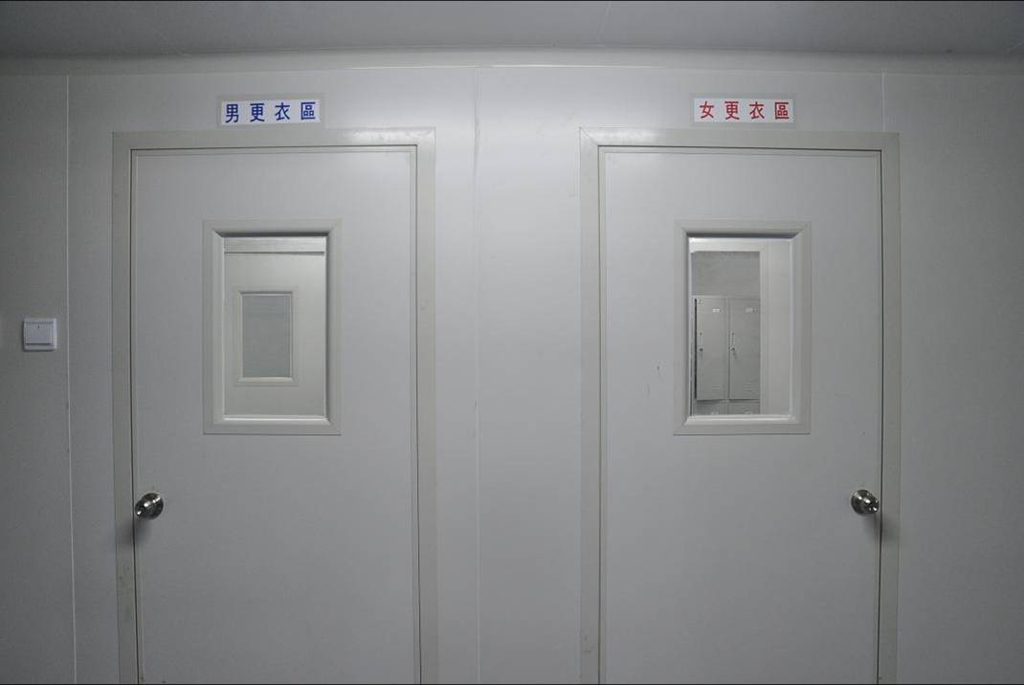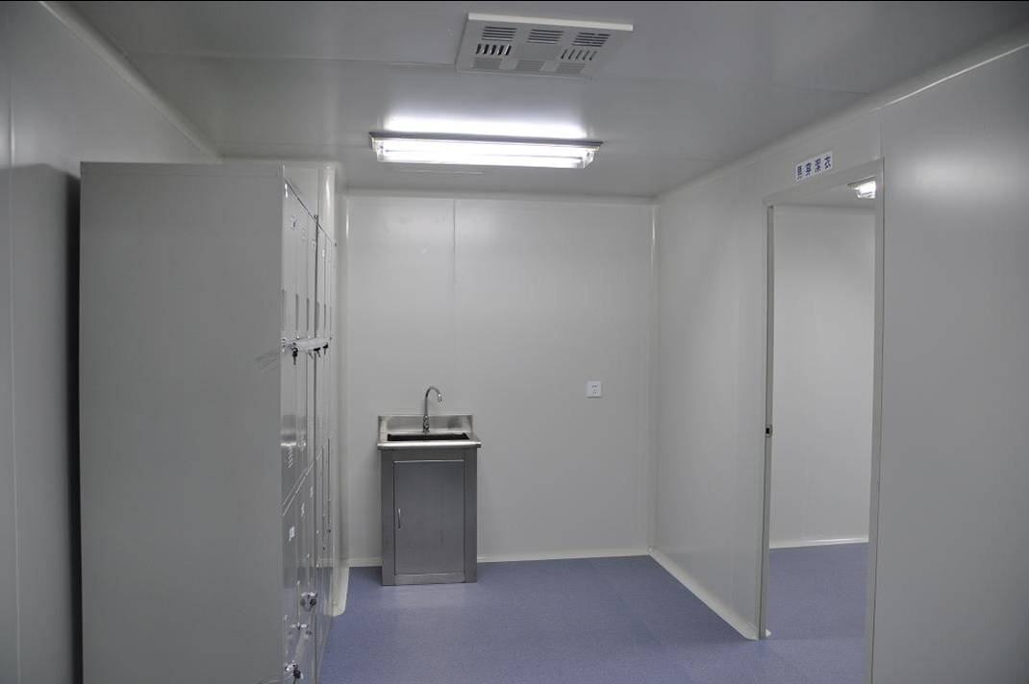
Dressing area Dressing area

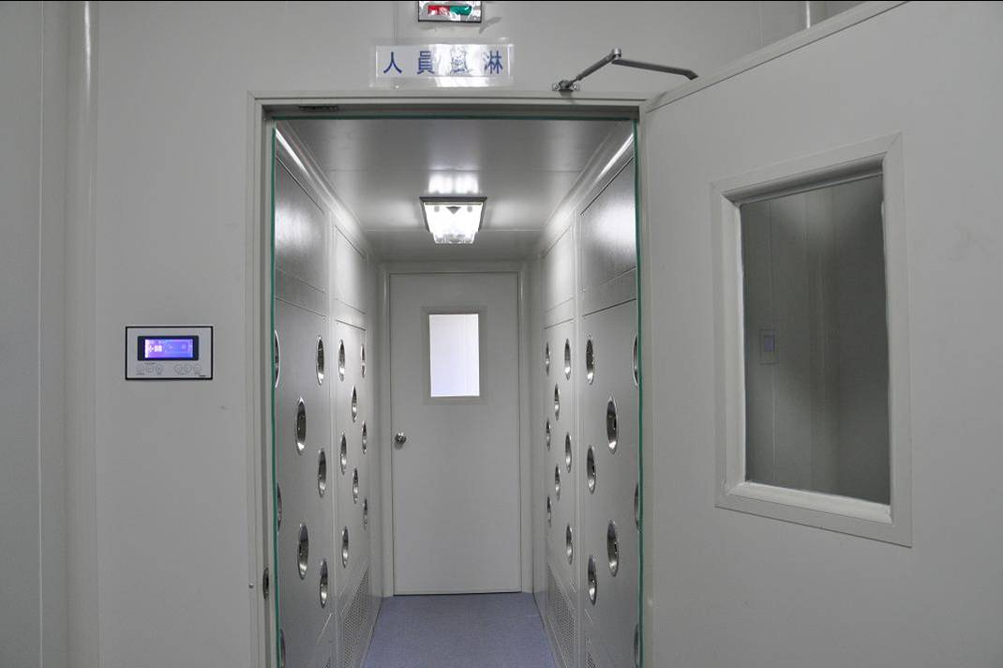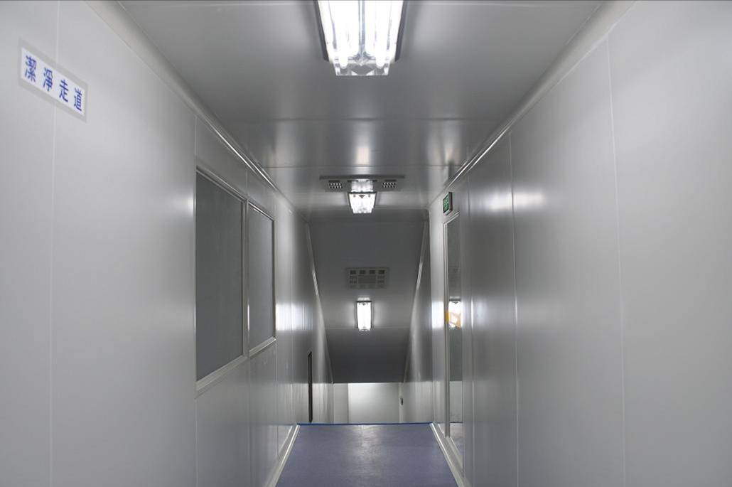

Personnel air shower entrance Staff aisle
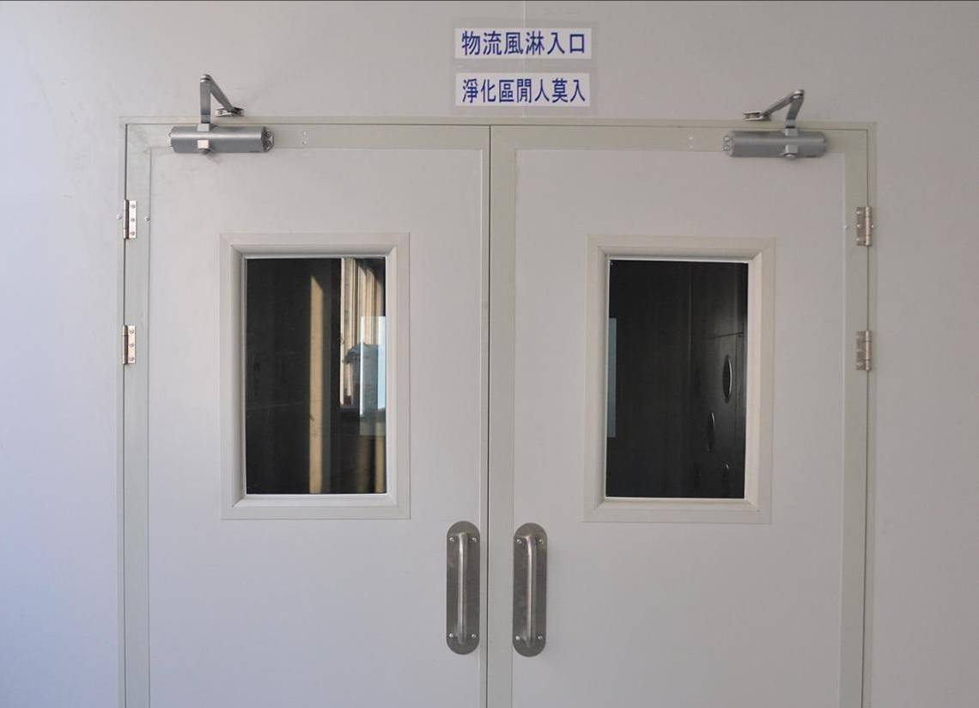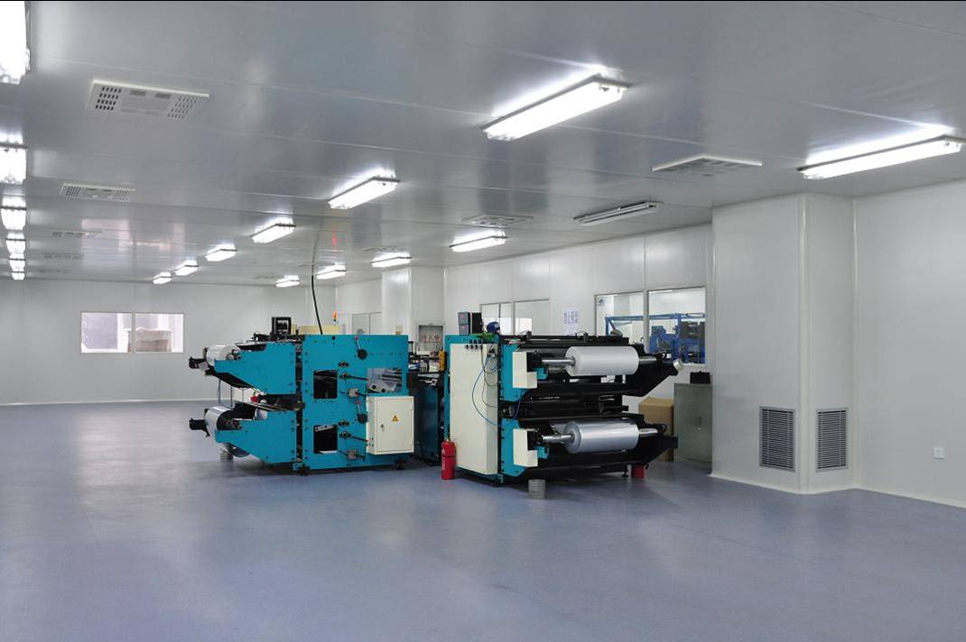
Air shower entry of raw materials Composite works
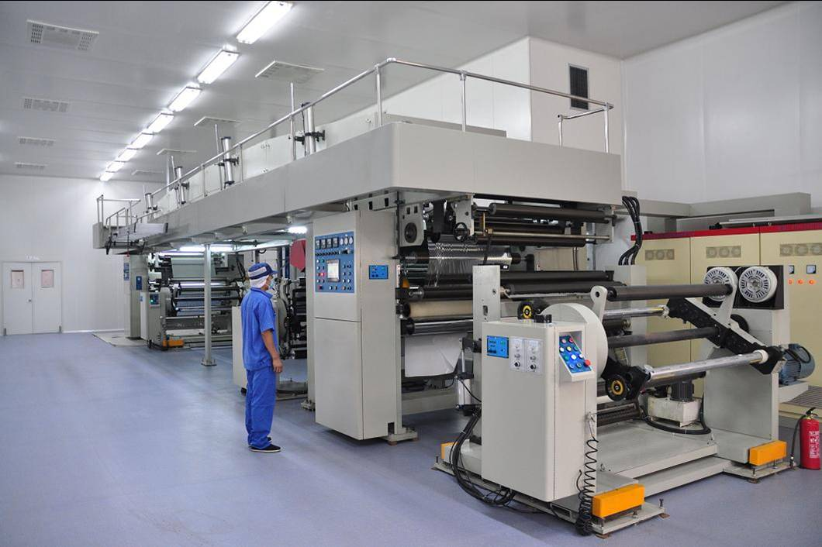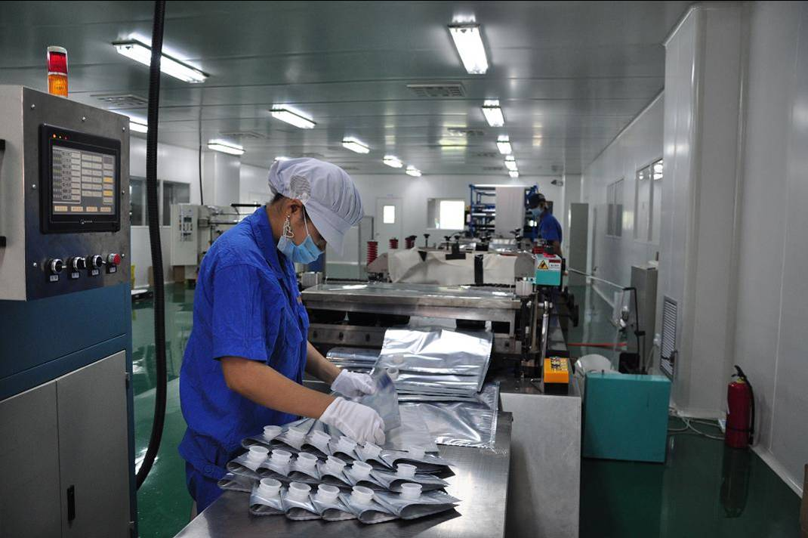
2, Bag Making: Workshop 1 Workshop 2
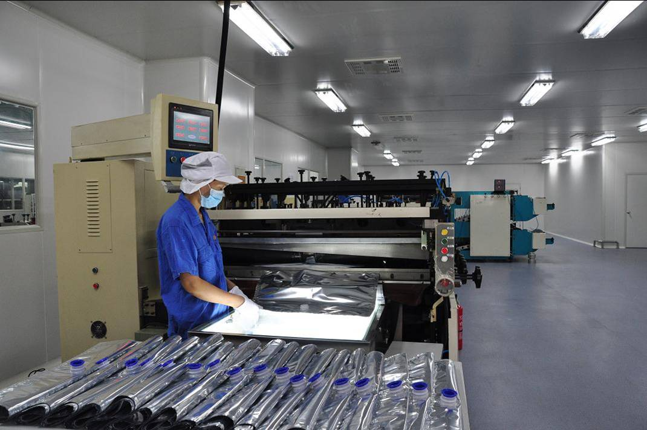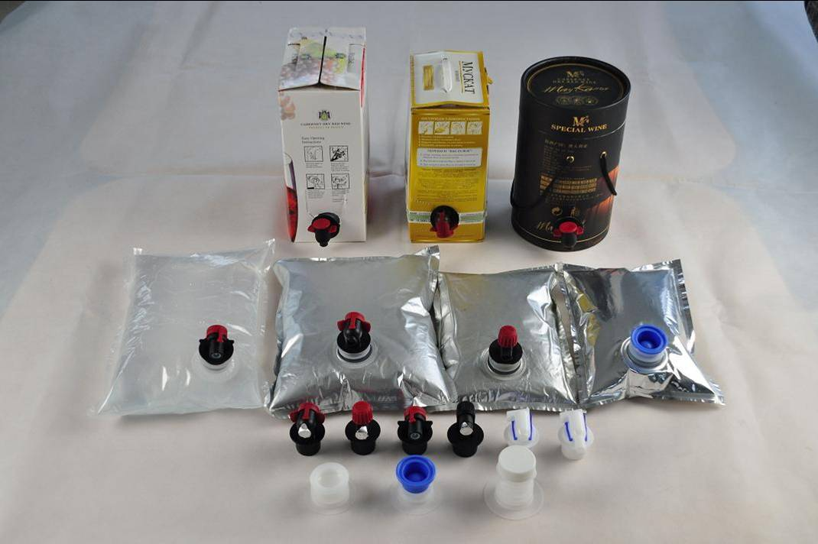
Workshop 3 products Bag

6、盒中袋充填方式：（半自動機器）

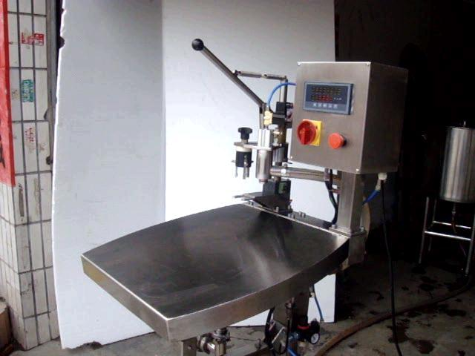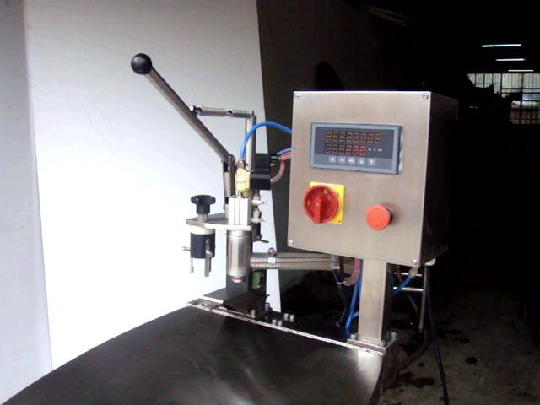

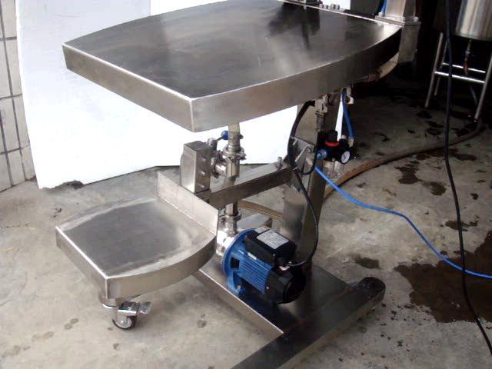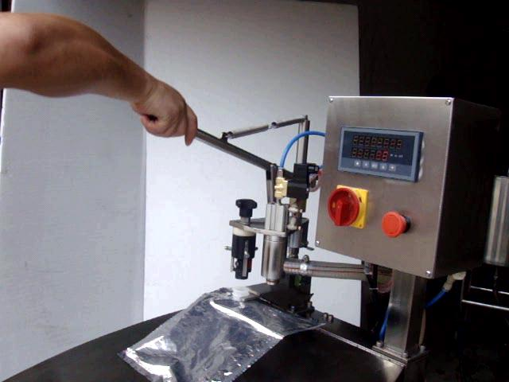
步驟 1 STEP 1

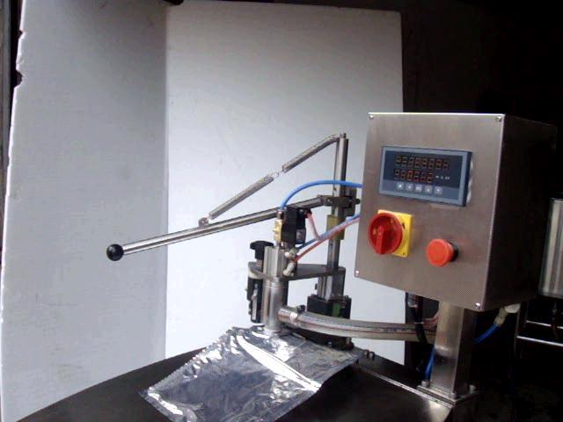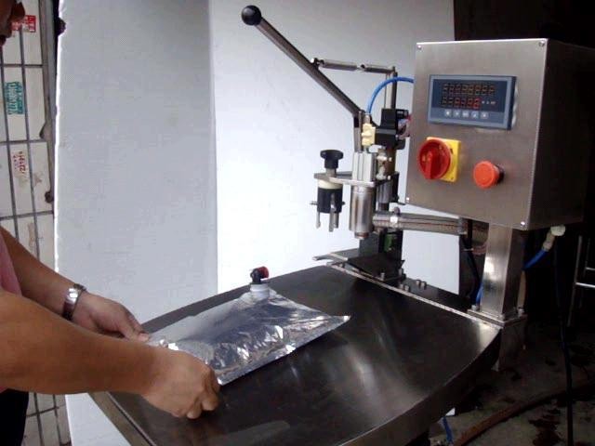
步驟2 充填 步驟3完成
Step 2 Fill Step 3 completed
7、實例包裝1（大豆油）
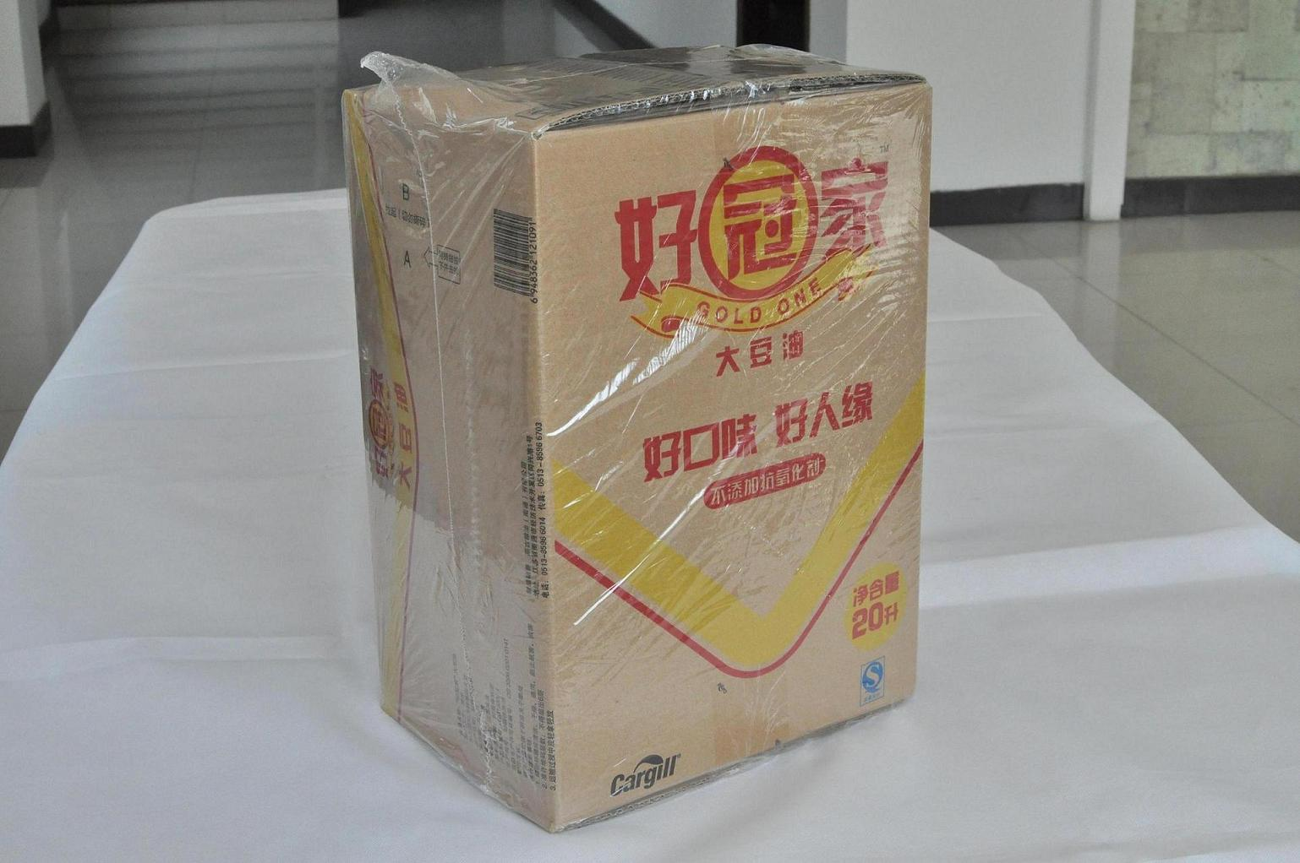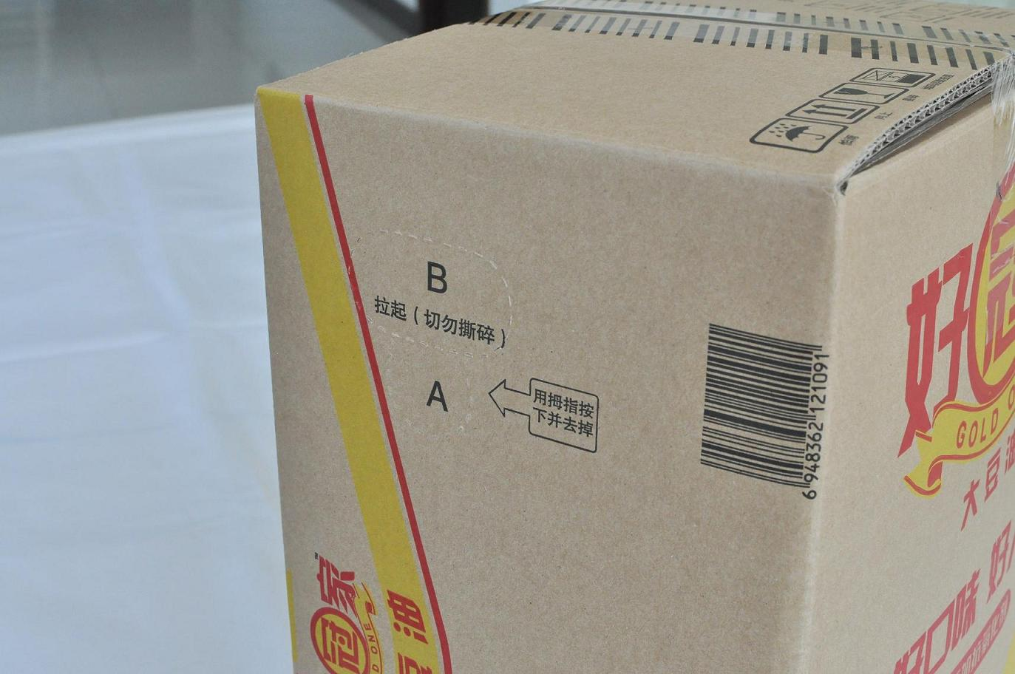
1、20Kg大豆油整體包裝。 2、紙盒側面有撕口。
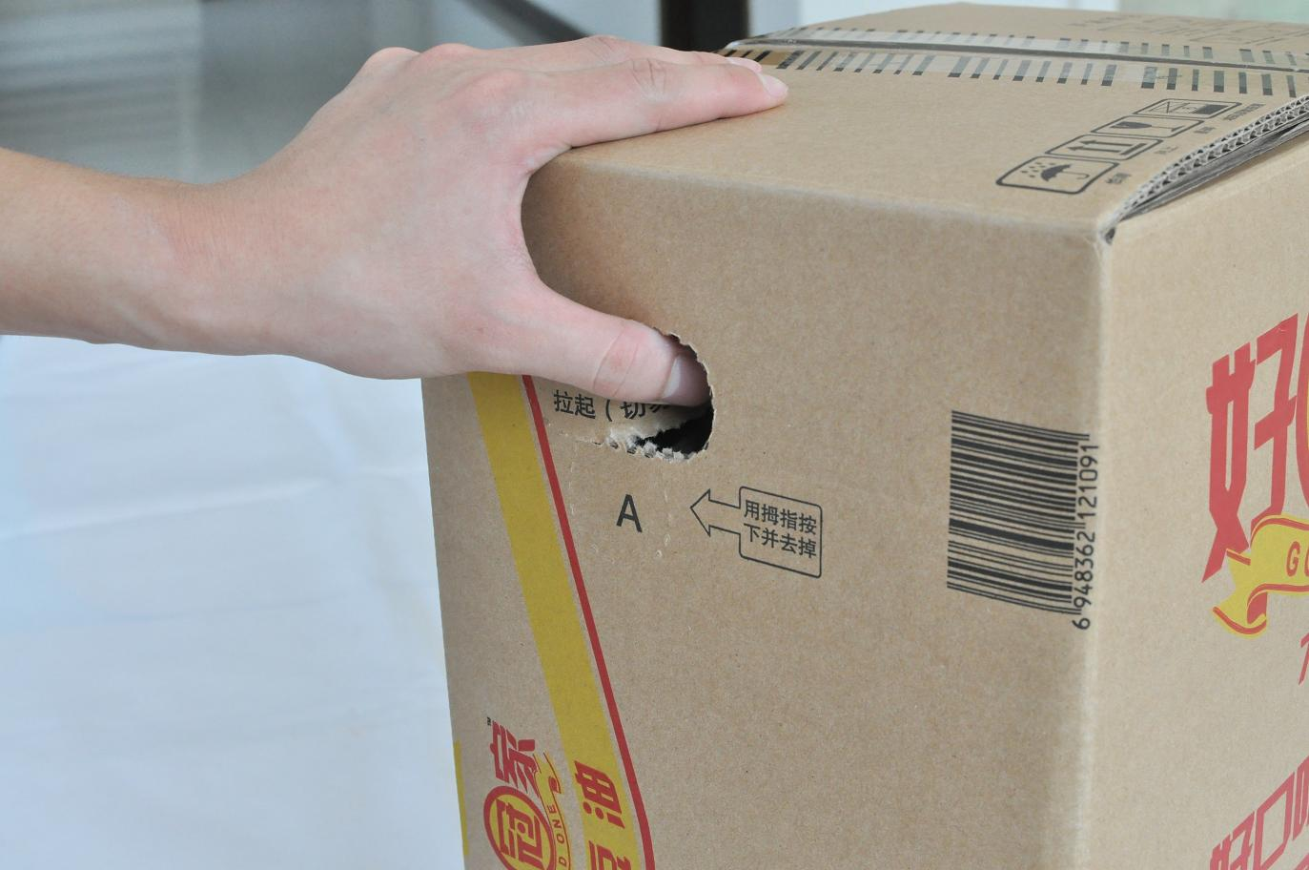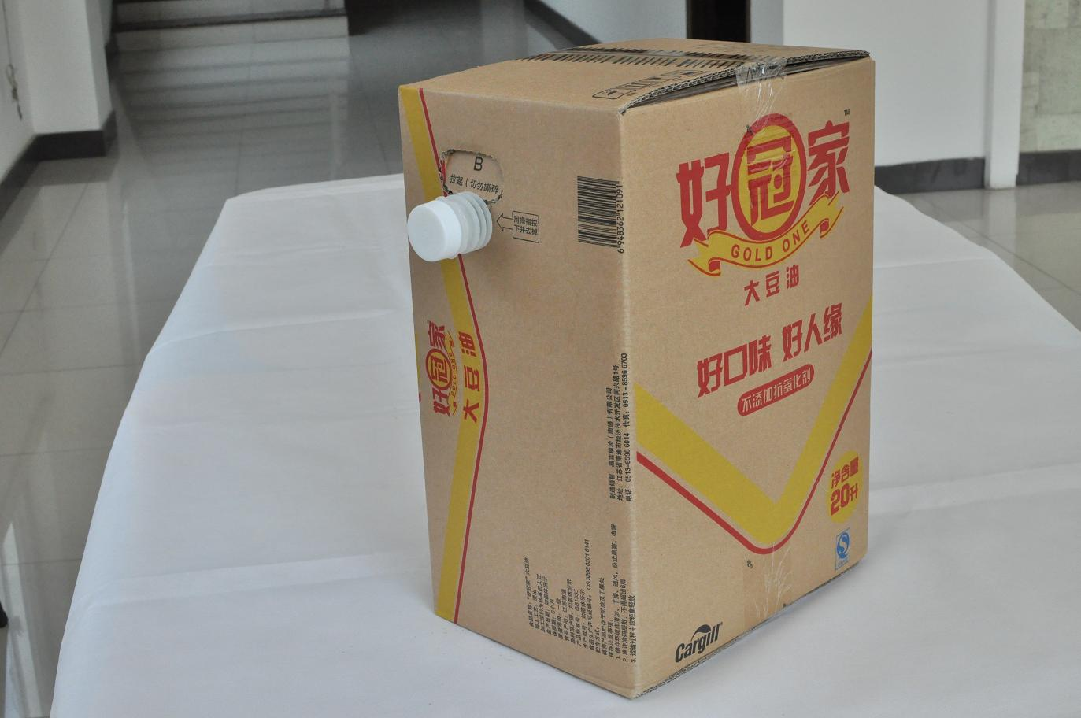
3、將撕口輕輕撕開並撕掉圓片。 4、將閥門從盒中取出並將其卡住。
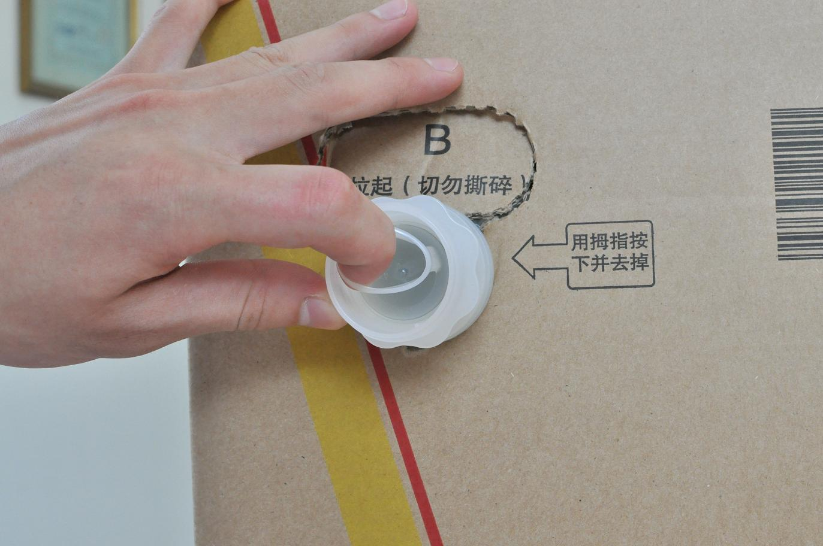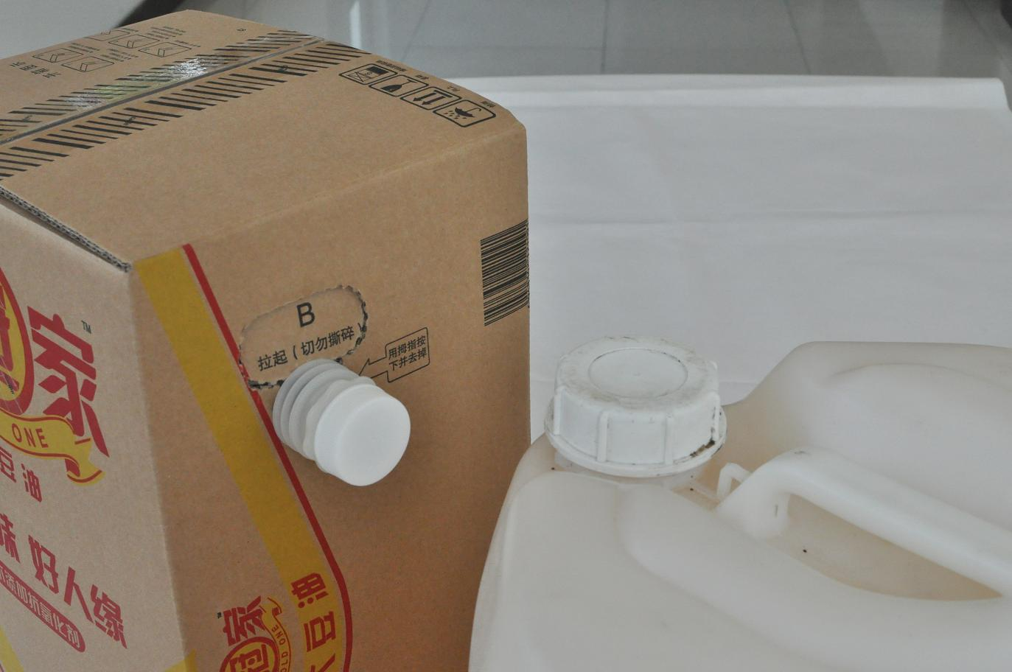
5、撕掉安全扣即可放出食用油。 6、與傳統塑膠桶相比較為清潔。
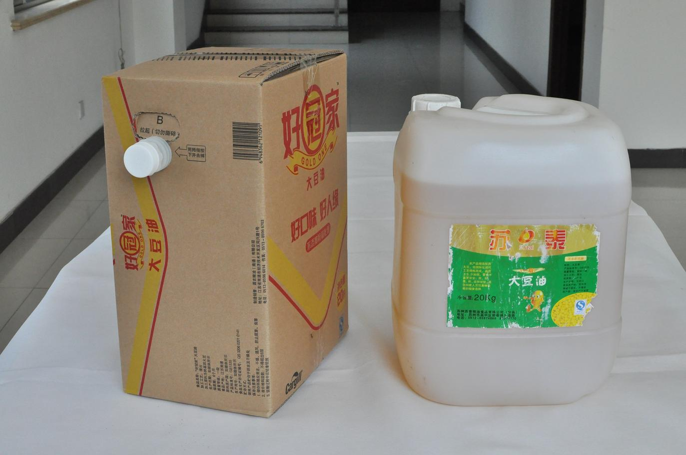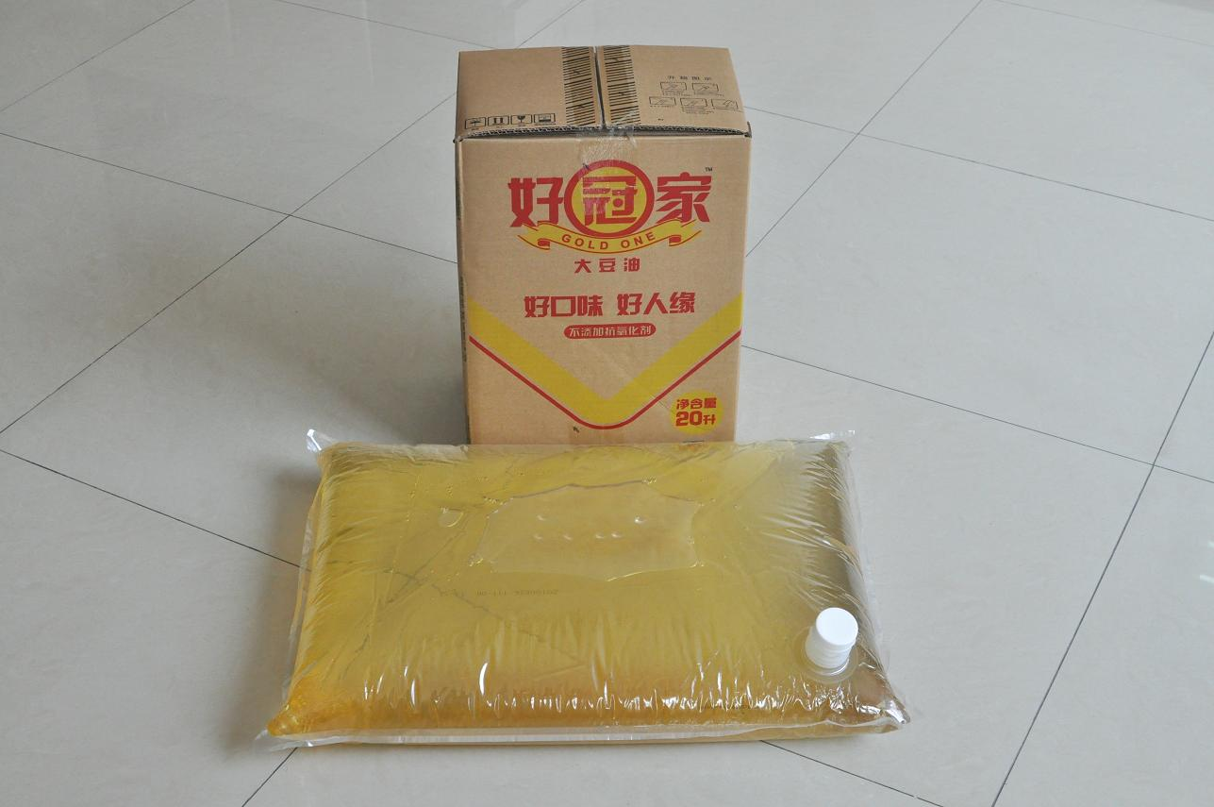
7、 8、

7, Case packing 1 (soybean oil)
1, 20Kg soybean oil as a whole package.
2, Tear the side mouth tray.
3, The tear lightly torn and torn discs.
4, Remove the valve from the box and it stuck.
5, ripping safety buckle to release oil.
6, compared with the traditional plastic barrel cleaner.
7, with the traditional 20Kg plastic bucket compared to soybean oil: occupation of smaller,
8, our products - boxes of bags.
Save transportation costs, easily stackable, cleaner, packing cost savings than traditional plastic bucket more than half.

8、實例包裝2（紅酒）

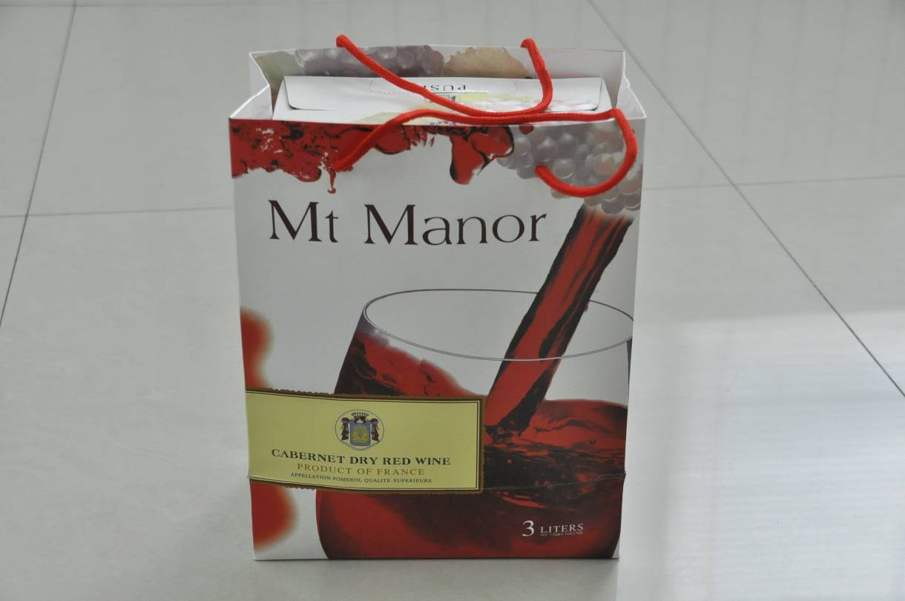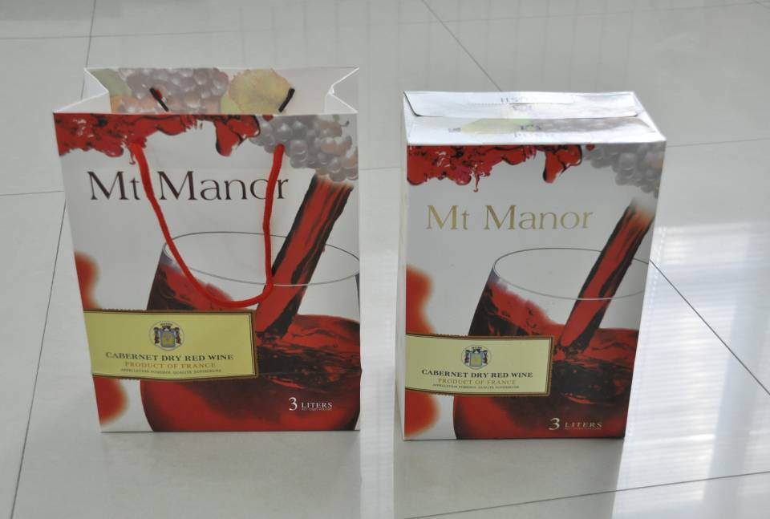
1、整體包裝（聯手提袋） 2、將紙盒從手提袋中取出

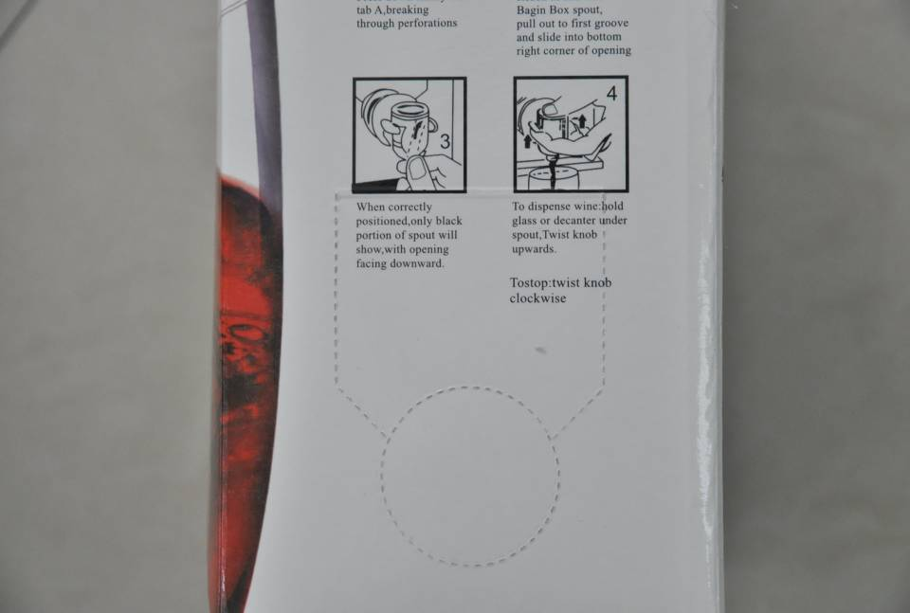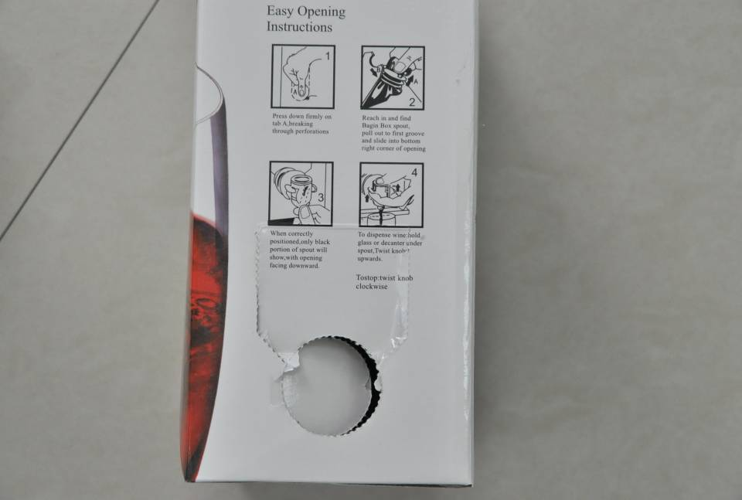
3、紙盒側面有個撕 4&5、將撕口輕輕撕開並撕掉圓片

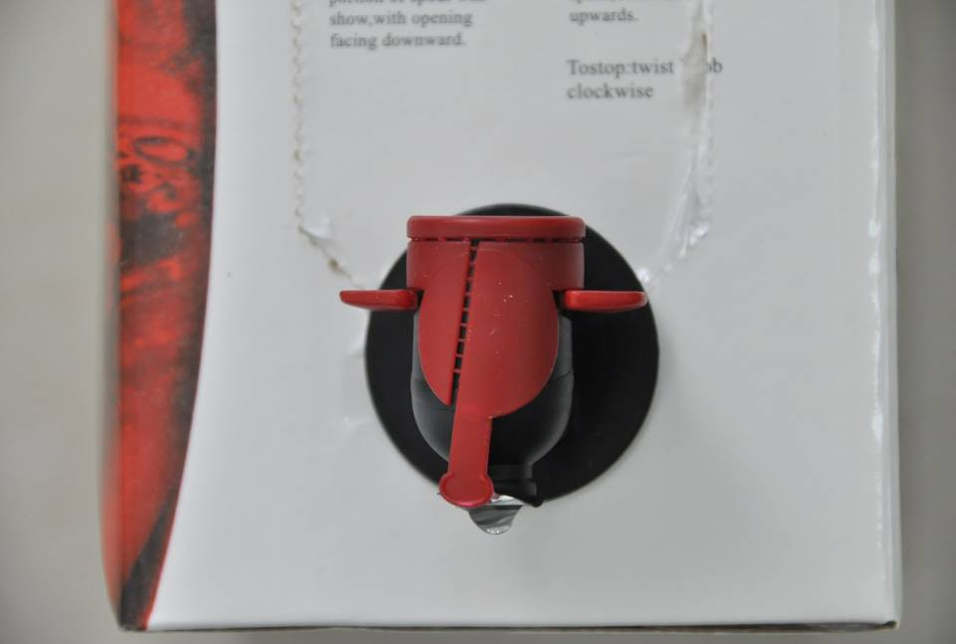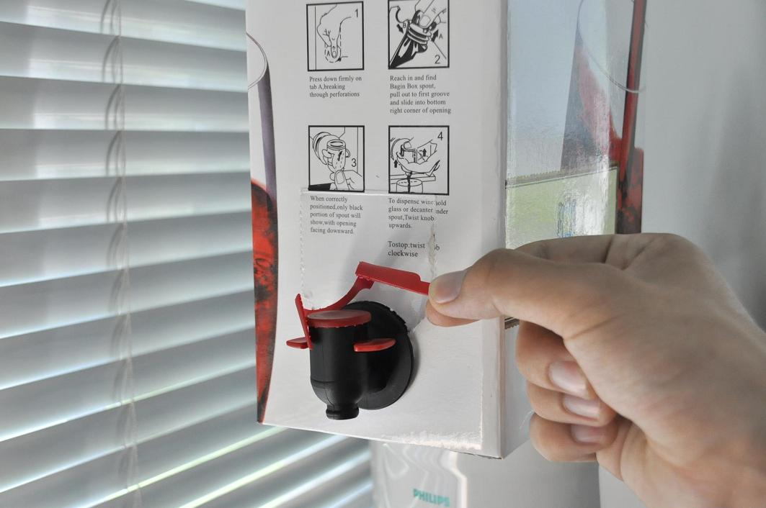
5、將閥門從盒中取出並將其卡住 6、撕開保險帶與閥門口保鮮薄膜

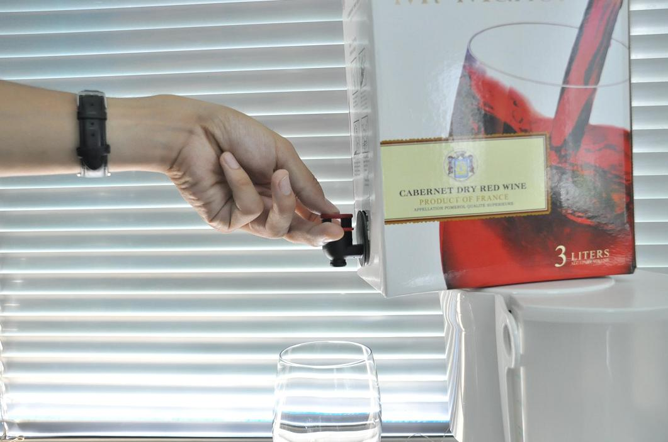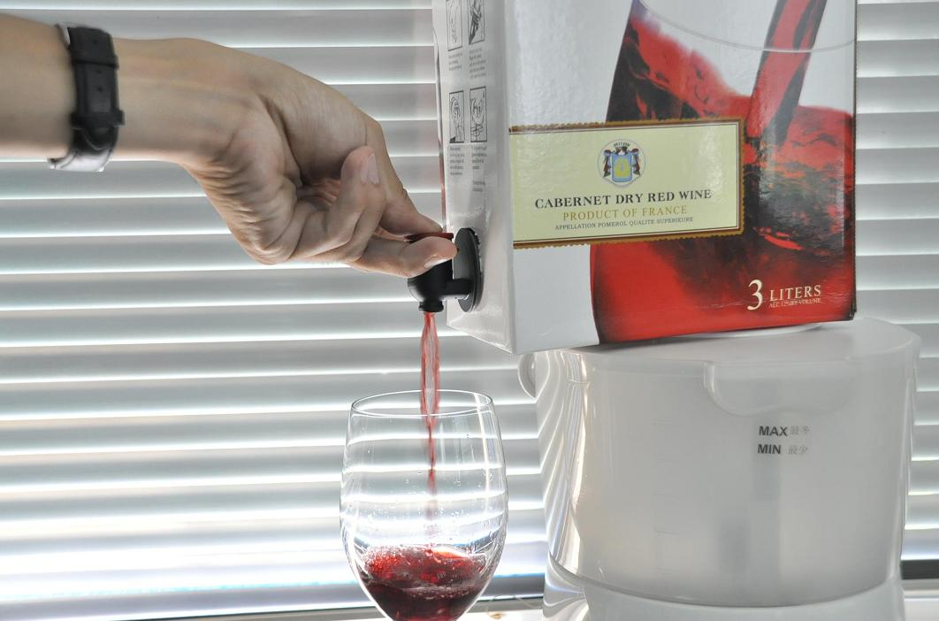
7、是指與中指扣住兩翼大拇指按壓頂端 8、開啟閥門即可放出紅酒

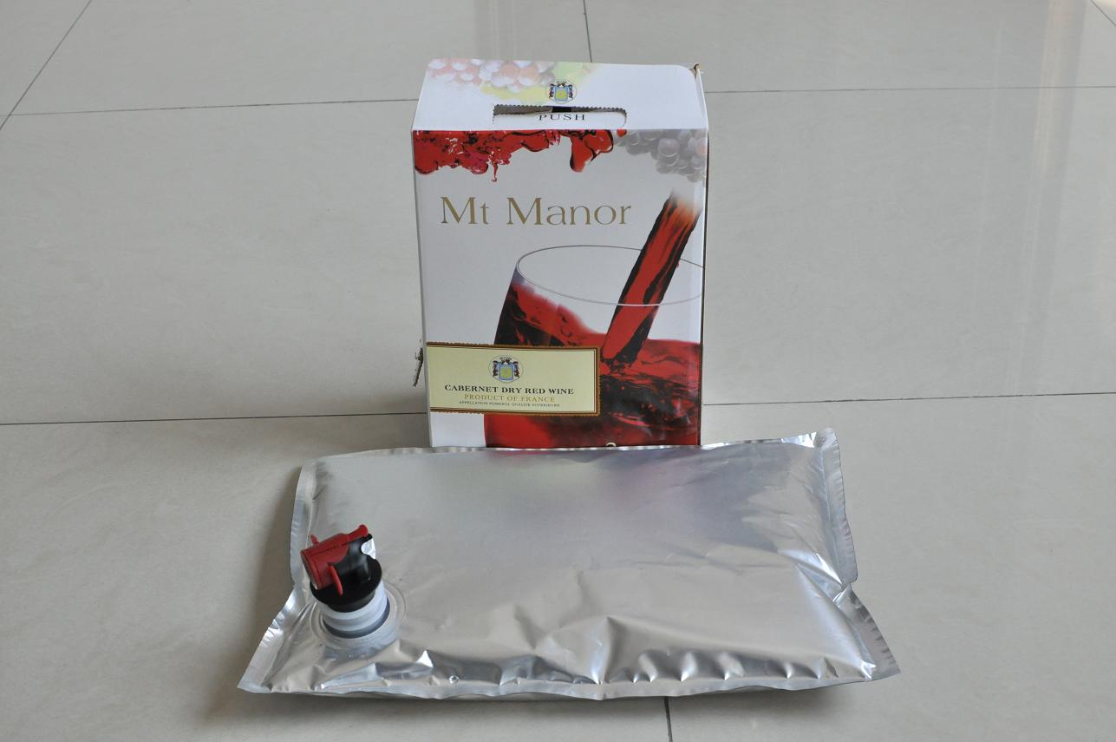
9、我公司產品——盒中袋。
8. 1, the overall package (United bag)
2, the tray removed from the bag
3, tray side there is a tear
4 & 5, will tear and tear up the wafer lightly torn
5, Remove the valve from the box and it snaps
6, torn seat belt and the preservation of the valve port films
7, Pressing the thumb and middle finger hold back the two wings of the top
8, open the valve to release red wine
9, our products - boxes of bags.
9, the product specification sheet
Bags of various sizes and material structure of liquid configuration:
First, the oil bag, liquid eggs, bags, bags of milk mixture, liquid fertilizer bags, washing fluid bags. (Valve type: boring cover, valve)

No. | Size | Materials and Structures | FOB Price  EURO/PCS
1 | 5L(330*400) 5L (330 * 400) | PA15/PE50+PE50 PA15/PE50 + PE50 | 0.322
2 | 10L(400*520) 10L (400 * 520) | PA15/PE50+PE50 PA15/PE50 + PE50 | 0.364
3 | 20L(500*620) 20L (500 * 620) | PA15/PE55+PE55 PA15/PE55 + PE55 | 0.490
4 | 22L(500*670) 22L (500 * 670) | PA15/PE55+PE55 PA15/PE55 + PE55 | 0.519
5 | 25L(500*720) 25L (500 * 720) | PA15/PE55+PE55 PA15/PE55 + PE55 | 0.561

Second, the aluminized WINE class (wine, wine, rice wine, etc.)
(valve types: butterfly valve, spiral valve, press valve, pull valve, etc.)
No. | Size | Materials and Structures | FOB Price EURO/PCS
1 | 1.5L(200*300) 1.5L (200 * 300) | PE40/VMPET12/PE40+PE50 Matt PE40/VMPET12/PE40 + PE50 | 0.392
2 | 2L(240*300),(220*320) 2L (240 * 300), (220 * 320) | PE40/VMPET12/PE40+PE50 Matt PE40/VMPET12/PE40 + PE50 | 0.407
3 | 3L(270*350),(260*360) 3L (270 * 350), (260 * 360) | PE40/VMPET12/PE40+PE50 Matt PE40/VMPET12/PE40 + PE50 | 0.420
4 | 5L(330*400),(340*390） 5L (330 * 400), (340 * 390) | PE40/VMPET12/PE40+PE50 Matt PE40/VMPET12/PE40 + PE50 | 0.49

Third, the co-extruded film wine bag (wine, wine, rice wine, etc.) (valve types: butterfly valve, spiral valve, press valve, pull valve, etc.)
No. | Size | Materials and Structures | FOB Price EURO/PCS
1 | 1.5L(200*300) 1.5L (200 * 300) | 九層共擠膜90+PE50 Nine co-extruded film 90 + PE50 | 0.448
2 | 2L(240*300) 2L (240 * 300) | 九層共擠膜90+PE50 Nine co-extruded film 90 + PE50 | 0.463
3 | 3L(270*350) 3L (270 * 350) | 九層共擠膜90+PE50 Nine co-extruded film 90 + PE50 | 0.476
4 | 5L（340*390） 5L (340 * 390) | 九層共擠膜90+PE50 Nine co-extruded film 90 + PE50 | 0.532

IV, bags of fruit juice (tomato juice, orange juice, blueberry juice, apple juice)
(valve type: bored cover)
No. | Size | Materials and Structures | FOB Price EURO/PCS
1 | 5L（330*400） 5L (330 * 400) | PE50/VMPET12/PE50+PE50 PE50/VMPET12/PE50 + PE50 | 0.519
2 | 10L(400*520) 10L (400 * 520) | PE50/VMPET12/PE50+PE50 PE50/VMPET12/PE50 + PE50 | 0.602
3 | 20L(475*650) 20L (475 * 650) | PE50/VMPET12/PE50+PE80 PE50/VMPET12/PE50 + PE80 | 0.868
4 | 25L（475*740） 25L (475 * 740) | PE50/VMPET12/PE50+PE80 PE50/VMPET12/PE50 + PE80 | 0.911
5 | 220L(960*1600) 220L (960 * 1600) | PE50/VMPET12/PE50+PE100 PE50/VMPET12/PE50 + PE100 PE50/VMPET12/PE50+PE50+PE50 PE50/VMPET12/PE50 + PE50 + PE50 | 3.222
WaKaMe Biotechnology, Inc. –
TONNY LIANG, CHAIRMAN
4th Fl., 36 Chin Chou St., Taipei, Taiwan
Phone: 02-2522-3256, Fax: 02-2521-5801
Mobile: 886-0932-941-577(Taiwan); 86-13559766345(China)
E-mail: tonny96@gmail.com; Skype: lianghouchich

