





LICHIDARE STOC
MANOMETRE PRODUCTIE GERMANIA:

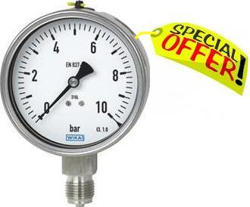
MODEL 232.50.100 WIKA GERMANIA
DOMENIUL  (bar) | Racord | Cantitate | PRET UNITAR EURO
0/1 | Radial NPT 1/2 | 3 | 30
0/4 | Radial NPT 1/2 | 3 | 30
0/6 | Radial NPT 1/2 | 2 | 30
0/40 | Radial NPT 1/2 | 1 | 30
0/60 | Radial NPT 1/2 | 2 | 40
0/100 | Radial NPT 1/2 | 4 | 40
0/160 | Radial NPT 1/2 | 2 | 40
0/250 | Radial NPT 1/2 | 2 | 40

1)

Cu stima,
PALDO GROUP INTERNATIONAL SA

