
S.C. FIDES S.R.L. Drobeta Turnu Severin
Str. Cicero nr 102, bl. XF3A, sc. 2, ap. 4, 220079
Mehedinti, ROMANIA
J25/151/1999, CUI: RO11914828
Tel/Fax: 0352/411583; Tel: 0744621903, 0730104120
e-mail: office@cantare-fides.ro
web: www.cantare-fides.ro

BALANŢE ROMANE ŞI SEMIAUTOMATE TRANSPORTABILE

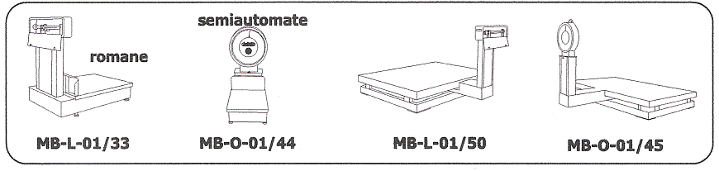

Tip | Limita  maxima (kg) | Limita  minima (kg) | Diviziune  (kg) | Platforma  (mm)
MB-L-01/10 | 110 | 2 | 0,1 | 800x800
MB-L-01/15 | 220 | 4 | 0,2 | 800x800
MB-L-01/23 | 550 | 10 | 0,5 | 800x1000
MB-L-01/33 | 1100 | 20 | 1 | 800x1000
MB-O-01/03 | 50 | 1 | 0,05 | 500x500
MB-O-01/11 | 100 | 2 | 0,1 | 800x800
MB-O-01/20 | 200 | 4 | 0,2 | 800x800
MB-O-01/33 | 500 | 10 | 0,5 | 800x1000
MB-O-01/44 | 1000 | 20 | 1 | 800x1000
MB-L-01/42 | 2200 | 40 | 2 | 2000x1500
MB-L-01/50 | 5500 | 100 | 5 | 2500x1500
MB-O-01/46 | 2000 | 40 | 2 | 2000x1500
MB-O-01/45 | 5000 | 100 | 5 | 2500x1500
BASCULE SEMIAUTOMATE STABILE

Tip | Limita  maxima. (kg) | Limita  minima (kg) | Diviziune  (kg) | Platforma  (mm)
MB-Q-03/02 | 500 | 10 | 0,5 | 1500x1250
MB-Q-03/11 | 1000 | 20 | 1 | 2000x1250
MB-Q-03/21 | 2000 | 40 | 2 | 2000x1500
MB-Q-03/35 | 5000 | 100 | 5 | 2500x1500
BASCULE ROMANE DE MASA

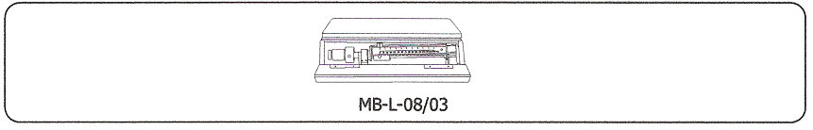

Tip | Limita  maxima (kg) | Limita  minima (kg) | Diviziune  (kg) | Platforma  (mm)
MB-L-056 M | 110 | 2 | 0,1 | 400x500
MB-L-08/03 | 160 | 2 | 0,1 | 600x550



