
S.C. FIDES S.R.L. Drobeta Turnu Severin
Str. Cicero nr 102, bl. XF3A, sc. 2, ap. 4, 220079
Mehedinti, ROMANIA
J25/151/1999, CUI: RO11914828
Tel/Fax: 0352/411583; Tel: 0744621903, 0730104120
e-mail: office@cantare-fides.ro
web: www.cantare-fides.ro

BALANŢE COMERCIALE

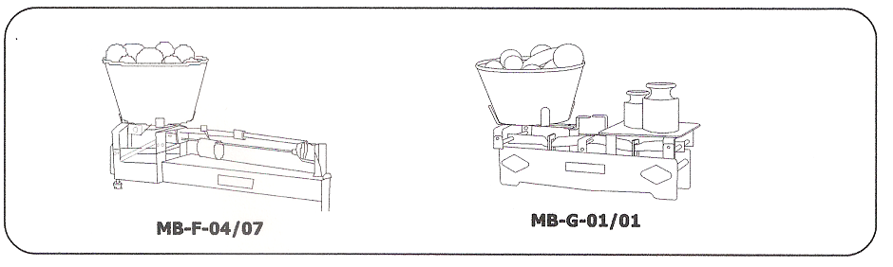

Denumire | Tip | Limita maxima (kg) | Limita minima (kg) | Diviziune  (g) | Masa neta  (kg)
Balanta romana | MB-F-04/07 | 11 | 0,2 | 10 | ~ 9,6
Balanta compusa | MB-G-01/01 | 20 | 0,2 | 10 | ~ 8
Balanta semiautomata | MB-H-06/10 | 10 | 0,1 | 5 | ~ 20
Balanta semiautomata | MB-H-09/15 | 1 | 0,02 | 1 | ~ 14,3
Balanta semiautomata | MB-H-09/20 | 2 | 0,04 | 2 | ~ 15,8

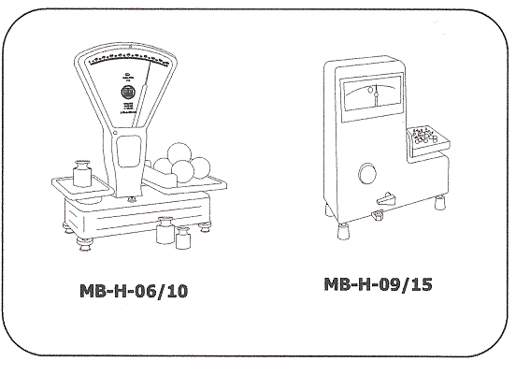
Greutati de lucru
(cu buletin de
verificare)
10 g
20 g
50 g
100 g
200 g
500 g
1 kg
2 kg
5 kg
Set greutati

Set greutati
1 – 500 g (12 piese)
Set greutati
10 – 500 g (8 piese)

