Hefei Bajin Trading Co., Ltd.
Tel:0086-551-344-6270, 0086-13805609249 Fax:0086-551-214-2380 ext. 1
Shenzhen Bajin Technical & Development Co., Ltd.
email: shui-muer@126.com shui-muer@bajin.biz
http://www.bajin.biz
Tel/Fax:0086-755-61289864, 0086-13923788016
ESD RUBBER MAT
The two-layers construction rubber mat is used for the human, the turnover box, the sack, the primary device and other goods static electricity which eliminates and the mat contacts. Smooth, the curl, moistly is not affected, and can effectively resist flattens, chemistry goods and thermostable, are easy to be clean and the maintenance.
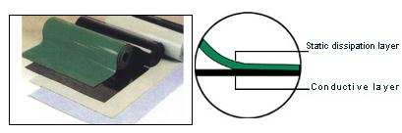
Specifications
Resistivity of surface layer | 10⁶-10⁹Ω
Resistivity of bottom layer | 10³-10⁵Ω
Bulk Resistivity | 10⁵-10⁸Ω
Abrasiveness loss | ≤0.02g/cm2
Time for static dissipation | <0.1s

Description
Size | 10m*1.2m、10m*1.0m 10m*0.9m 10m*0.8m 10m*0.6m
Color | Green/Black Blue/Black Gray/Black Yellow/Black Black/Black
Thickness | 2.0mm, 2.5mm , 3.0mm ,4.0mm ,5.0mm

Important: While the information contained herein results from extensive testing on these materials and/or information supplied by other manufacturers, accuracy and reliability of such tests and information cannot be guaranteed, thus requiring limits on warranty. User assumes all liability regarding damage or loss arising from use of product. User shall determine the appropriateness of these materials for intended application and assumes total liability in the event of aforementioned damages.

