STATIA EPURARE SAF 300

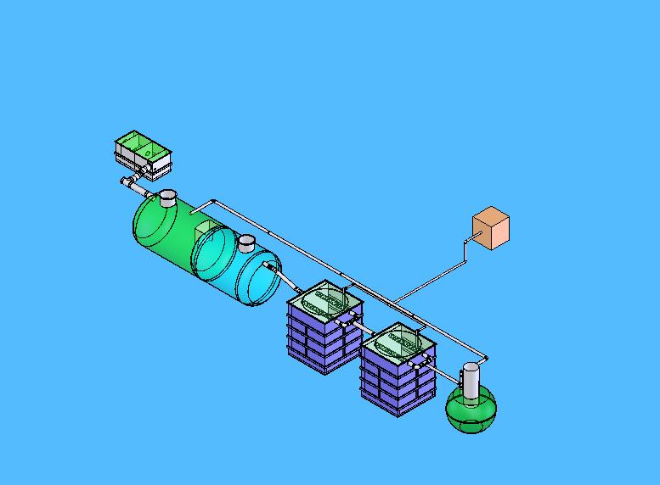

CARACTERISTICI TEHNICE

PARAMETRII AFLUENT
DEBIT APE UZATE.................................40m³/zi
INCARCARI CBO5..................................300mg/l (maximum)
INCARCARI SUSPENSII SOLIDE........300 mg/l(maximum)
CEILALTI INDICATORI CONFORM ...NTPA 002/2002

PARAMETRII EFLUIENT
INCARCARE CBO5.........................................20 mg/l
INCARCARE MATERII IN SUSPENSII......30 mg/l
PARAMETRII DE EPURARE SUPERIORI FATA DE NTPA 001

COMPONENTELE STATIEI EPURAE SAF 300
1. SEPARATOR GRASIMI...............................................................2 m³
2. BAZIN ECHILIBRARE DEBIT SI DECANTOR PRIMAR.....25 m³
3. AERATOR NS.................................................................................2x8 m³
4. TANC SEPTIC.................................................................................3.6 m³
5. BLOC DE COMANDA SI AUTOMATIZARE

