Use this free
Business Plan Template
For Spa Business Owners
to get started on your journey

Easy to use DIY-Business Plan
Get started using a business plan template is always the fastest way to write your business plan, but as you know, you can't just fill in the blanks along with a template. You will need a collaborative tool that guides you on every step of your planning.

DIY business templates you can easily help you write a professional business plan with automated financial forecasts. You can also find useful:
100+ Sample business plans

Get access to hundreds of sample business plans covering almost all industries to kick start your business plan writing. This helps you to get an idea how the perfect business plan should look like.
View Sample Business Plans
Step-By-Step Guide

You'll receive step-by-step fill in templates as soon as you select any business plan template. We made business planning easy with prompt help and examples on every step of your business plan writing.

Conduct accurate financial projections

Do not worry about not having accounting skills. With DIY Business Templates, Simply enter your sales and costs figures, and the provided excel spreadsheets will prepare all of your monthly/quarterly and yearly financial projections.

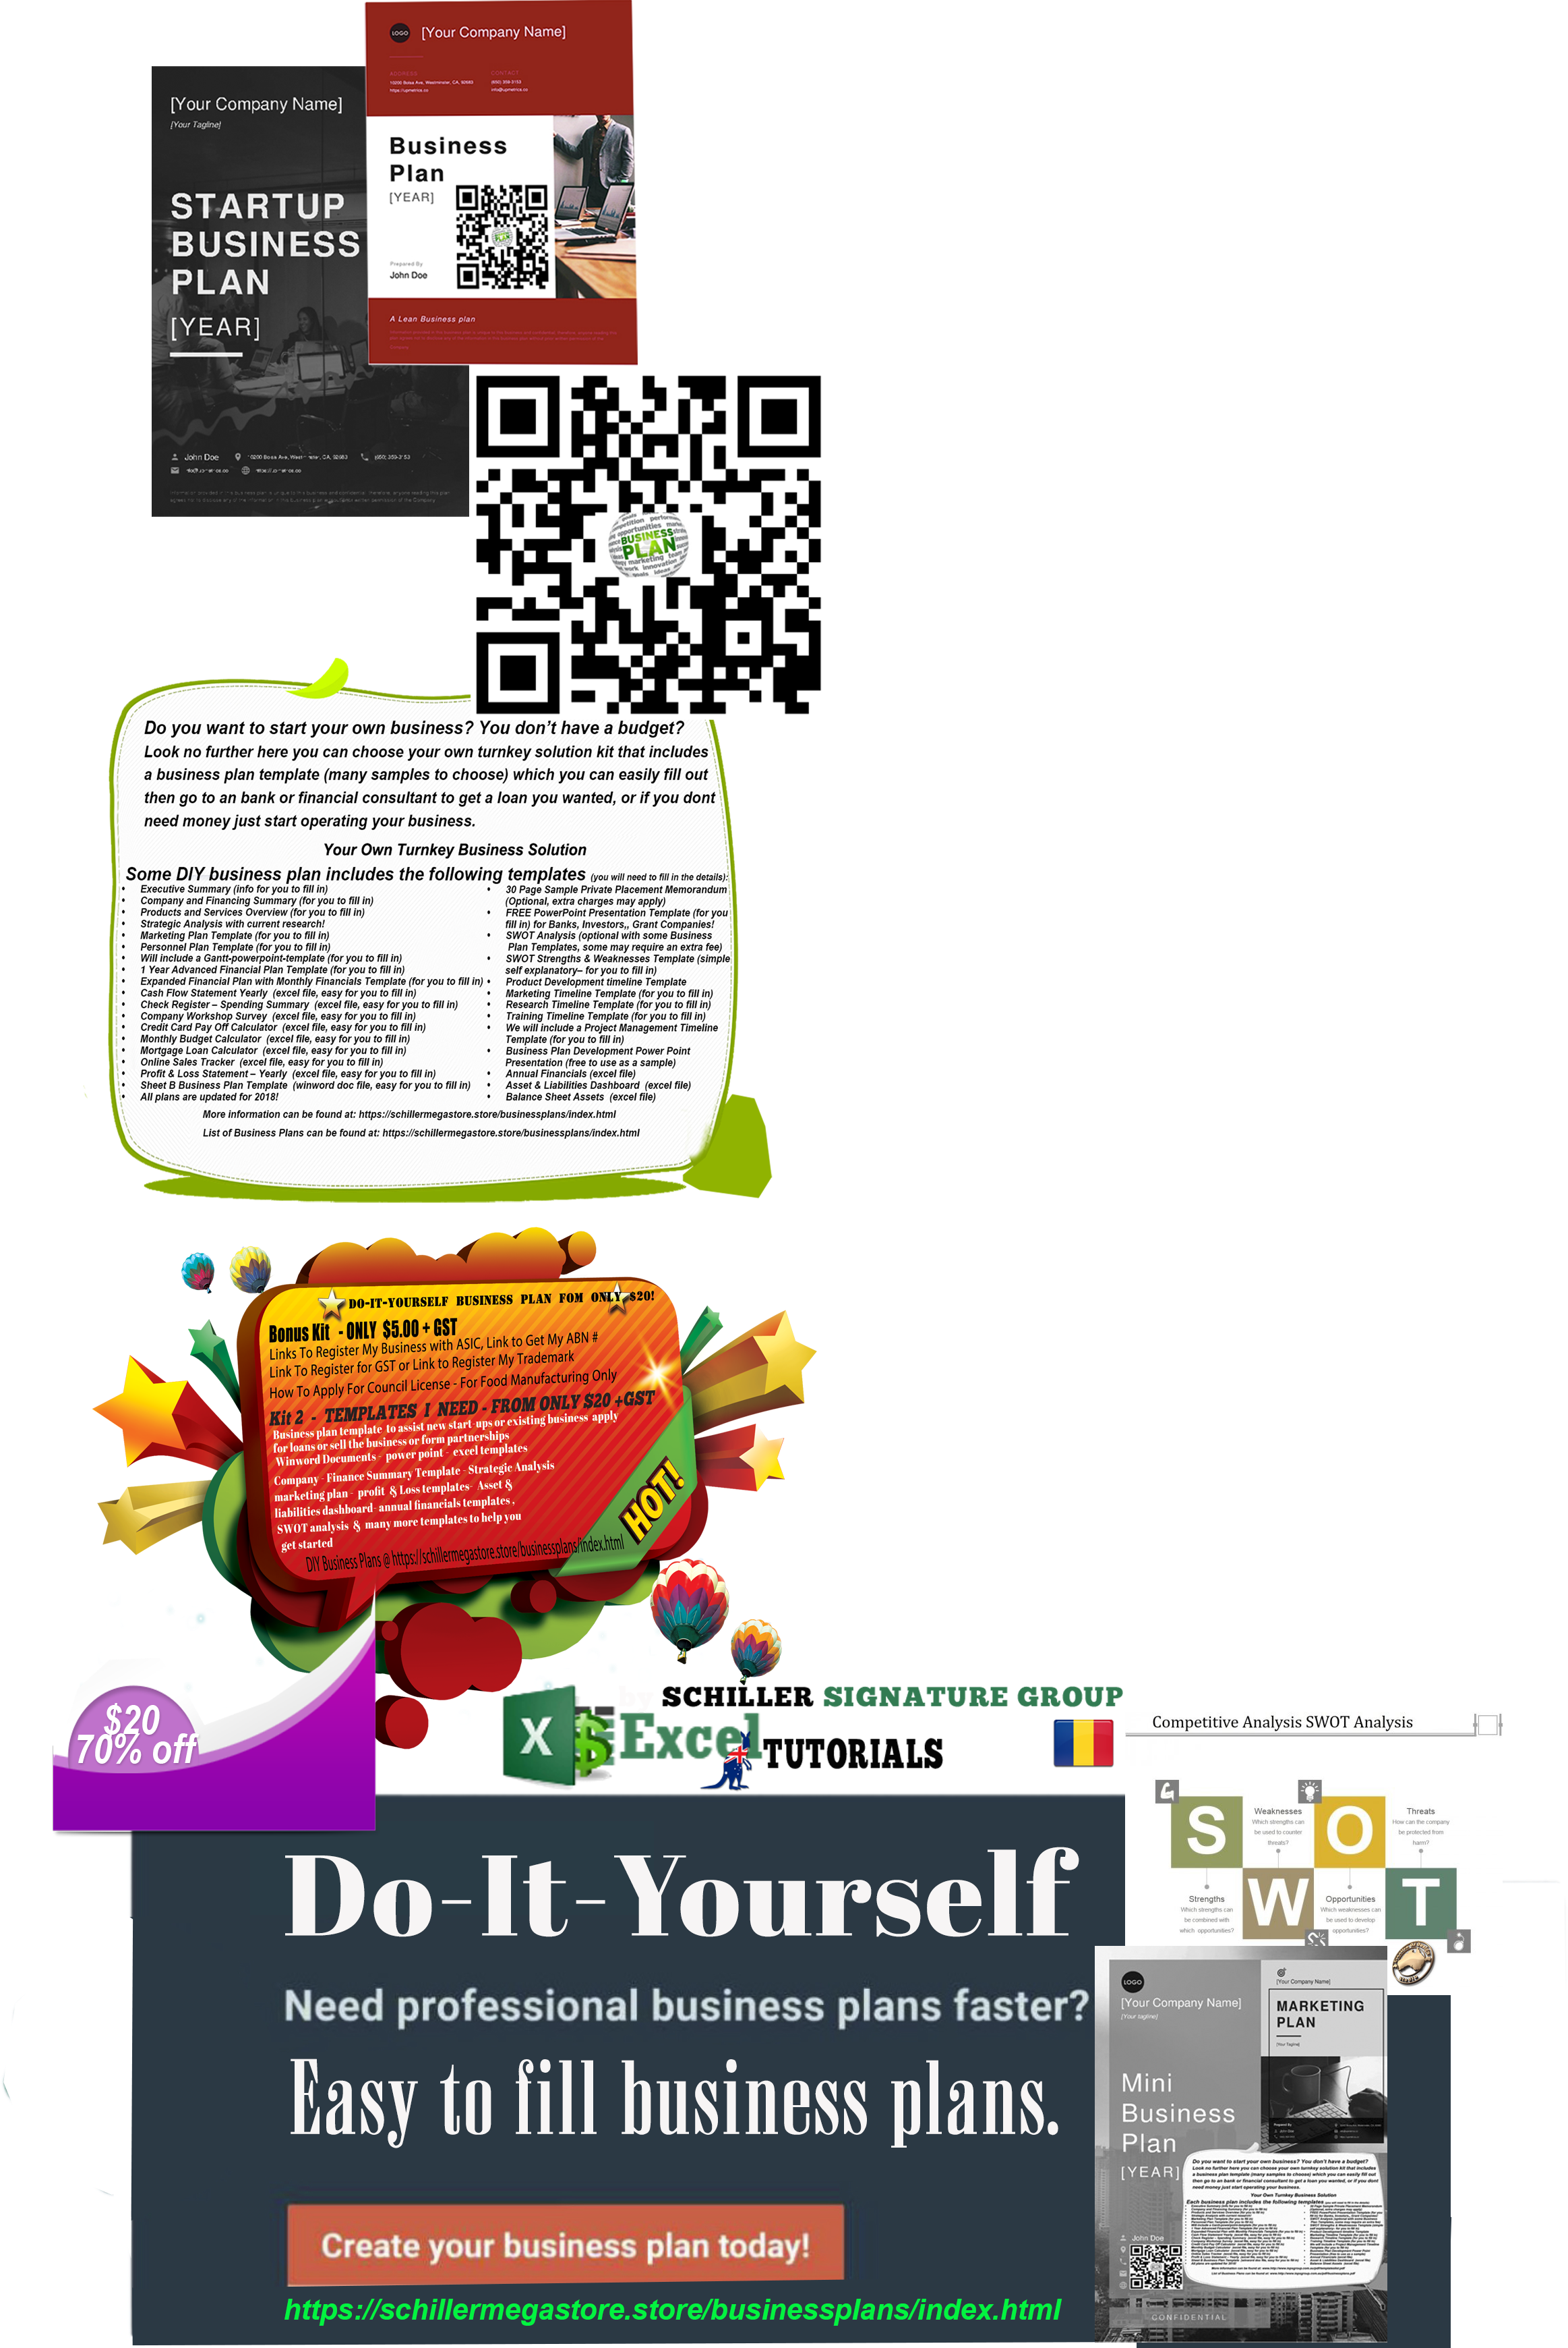
Executive Summary

Business Overview
Provide a brief overview of your business here. Where will you be located? What type of services will you offer? This will be your “elevator pitch.”
Mission and Culture
What is the mission/vision of your business? What are your values? What is important to you?
Target Market
Who is your ideal customer? Why would that audience be attracted to your spa?
Services and Offerings
What kind of services will you offer? Provide a description of all the services you plan to offer at your spa.
Market Overview and Competitive
What does your market look like? What are the demographics of your area/location?

What types of competitors are currently in your market area?

What makes your spa different and better than your competition? Why would someone visit your spa versus another in your area (e.g., services differentiation, location, are you and your staff more skilled? Will you offer something unique, etc.)?

What are some of the challenges you might face in your market (e.g., lots of competition, difficult parking, location challenges, market demographics such as highly transient, etc.)?
Organization and Management

Staffing
What are your staffing goals?

Will you be the manager? Or do you have plans to hire a manager? What will trigger your timing for hiring a manager?

Who will have keys to your spa?

Have you created an employee or contractor “handbook” that outlines your expectations for staff?

Will you be hiring practitioners/therapists? Will they be employees or independent contractors?
Note: Please consult local legal counsel for advice on the best approach for your location.

Will you provide staff incentives (bonuses, discounts on services and/or merchandise)?

What will be your measure of staff success (retail sales, client retention, new clients, etc.)?

How will you pay your staff? Will it be a flat rate? Hourly?
Software
What management software will you be using? We recommend getting your spa management software set up prior to your open date so you can become proficient in managing the software and reports before you open.

How will you be trained on the software to ensure you are using all the features to your maximum benefit?

How will you ensure your staff knows how to use the software properly?

Bookings
How will your customers sign up for appointments at your spa?
Credit Card Processing
How will you manage payments for appointments, memberships, and retail products?

What kind of Point-of-Sale solution will you have? Will you have a mobile credit card processor?

Pricing and Retention Strategies

Pricing
What are your pricing strategies?

Will you charge cancellation fees?

Will you offer memberships? What is your membership pricing strategy?

Will you offer specials or multiple services discounts?
Client Retention
What strategies will you have in place to retain clients?

What are your retention goals?

What percentage of your clients do you want to be members?

Brand Identity
Marketing and Sales
What is your brand identity (include colors, imagery, fonts)?

Who will help you develop your branding? Will you handle and develop your marketing efforts? Or will you hire a marketing professional?

Have you confirmed your name/brand does not conflict with others in the market?
Website
Who will build your website? Who will maintain it? When will your website go live? Plan to have it up 90 days before opening.

Does your spa management software integrate with your website so your clients can book appointments and memberships directly from your website?

What search terms will clients use to find your spa? Are you using those terms on your website so clients can find you?

Does your spa management software allow clients to book apppointments with you on Google?
Social Media
Who is going to set up your social media channels?

What social channels are you going to use (Facebook, Instagram, Twitter, etc.)?

Who is going to manage and monitor those channels on a daily basis (post new content, respond to questions, reply to feedback–both positive and negative)?

Will you pay for sponsored social media posts?

Advertising
Where will you advertise? Local papers? Online? Social media ads?
PR and Influencer Marketing
Can you reach out to local press with unique ideas?

Can you partner with other businesses in your area to promote your business and/or events?

Are there local events you can participate in?

Are there influencers in your community that can help you get the word out?
Opening Marketing Strategy
What are your launch plans? How will you initially get clients to come to your business?

Will you offer any pre-opening specials (e.g., special intro offers if sign up occurs before opening)?

Equipment and Retail

Equipment Needs
List the equipment you will need
Double click on the chart to input into the Excel spreadsheet

Retail Needs
Will you be selling produts? Food? Water? Branded items? Calculate your costs here.
Double click on the chart to input into the Excel spreadsheet

Financial Projections

Start-Up Costs
List the costs you will need to start up your spa
Double click on the chart to input into the Excel spreadsheet

Funding
How will you fund your business? Do you need to secure additional funding?

Ongoing Costs
Estimate your ongoing costs to run your spa
Double click on the chart to input into the Excel spreadsheet

Key Performance Indicators and Future Vision

Success Measurements
How will you measure success? What metrics will you use to measure progress and success (e.g., revenue, appointment capacity)?
Set defined goals and make sure you measure and record progress each month.
Breakeven Analysis
What are your breakeven goals?
Double click on the chart to input into the Excel spreadsheet
Future Vision
What is your future vision for your spa? Where do you see your spa in 1 year? 3 years?
Do you plan to open additional locations? Expand? Add new services?

DIY Business Plans Template Kit has everything you need to start or run your business and achieve your goals.
Visit http://schillerstore.store/businessplans/index.html for more business plans.

This plan is to be used for informational purposes only and does not constitute legal, business, or tax advice. Each person should consult his or her own attorney, business advisor, or tax advisor with respect to matters referenced in this plan. We assumes no liability for actions taken in reliance upon the information contained herein. © DIY Business Plans By SCHILLER, OJ Creative Desig Studio, 2022.

