**ROMANIA, a secret jewel in the heart of Europe**

An incredible journey in a splendid country, still intact and in some ways even unknown. The few stereotypes through which Romania has been told so far have given rise to a series of prejudices that have kept this country out of responsible tourism circuits.

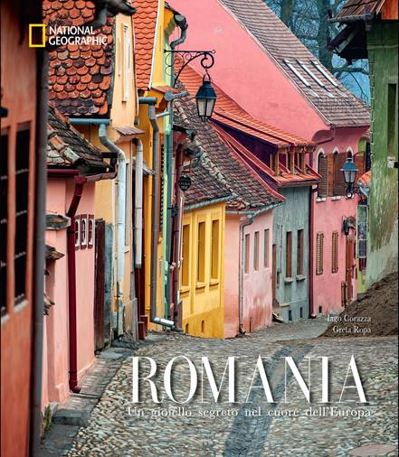

At the same time, however, these prejudices have contributed in preserving a large number of unique cultural, ethnic & social identities, which today makes Romania such a special place to visit and travel. In addition to the heritage of Transylvanian Gothic architecture, Romania captures travelers through the forests and woods of the Maramures region, also called the wood district.

The vastness of the Danube Delta allows visitors to discover an extraordinary variety of flora and fauna, which make it an excellent naturalistic destination. The splendid frescoed monasteries are a World Heritage Site and castles like Bran or Peles, beautifully preserved, pay tribute to the mastery of Romanian artisans towering in the forests.

Romania is the beating heart of a Europe that is still intact and in some respects unknown. Somehow, fortunately, it managed to preserve the spectacular identity intact.

