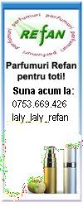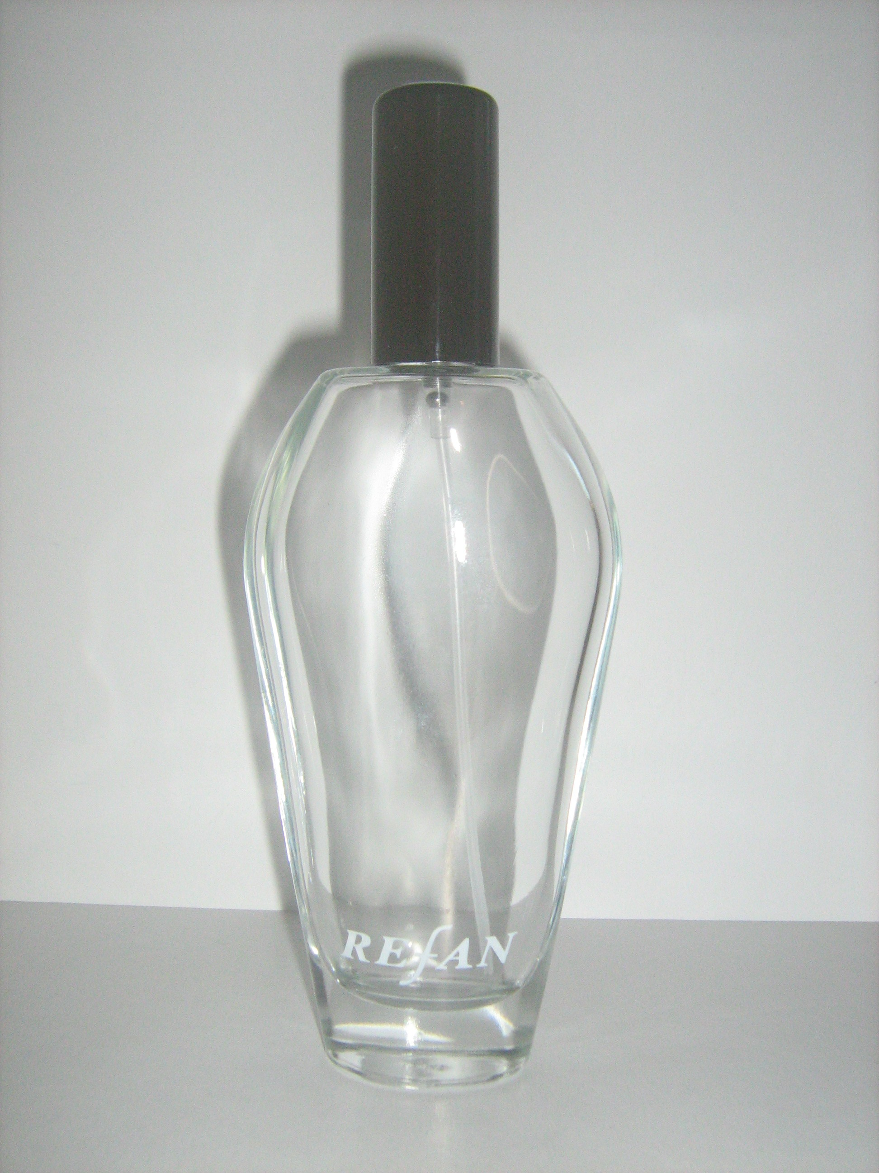
PARFUMURI REFAN pentru FEMEI 88 Parfumuri
COD  REFAN | CORESPONDENT PARFUMURI REFAN | Categorie
101 | CHANEL 5 / Chanel | Floral - Aldehyde
102 | VERSENSE / Versace | Floral - Proaspat
103 | OCEAN LOUNGE / Escada | Floral - Fructat
104 | LOVE OF PINK / Lacoste | Floral - Fructat
105 | VERSUS / Versace | Floral - Narcotic
106 | BE DELICIOUS / Donna Karan | Floral - Proaspat
107 | OPIUM / Yves Saint Laurent | Oriental - Aromat
108 | PALOMA PICASSO / Paloma Picasso | Lemnos - Oriental
109 | MAGIE NOIRE / Lancome | Oriental - Floral
110 | VENEZIA / Laura Biagiotti | Oriental - Lemnos
111 | GUCCI ENVY ME / Gucci | Floral - Fructat
112 (005) | RUE PERGOLESE / Ulric de Varens | Floral - Proaspat
113 | CASMIR / Chopard | Oriental - Vanilat
114 | Emporio Armani Diamonds For Women/GIORGIO ARMANI | Oriental - Floral
115 | GABRIELA SABATINI / Gabriela Sabatini | Floral - Lemnos
116 | ESCADA TAJ SUNSET / Escada | Lemnos - Fructat
117 | BOSS ORANGE / Hugo Boss | Oriental - Lemnos
118 | POISON / Dior | Floral - Narcotic
119 | IDOLE D'ARMANI / Armani | Oriental - Aromat
120 | WOMANITY / Thierry Mugler | Lemnos - Floral
121 | NINA / Nina Ricci | Floral - Fructat
122 | BURBERRY WEEKEND / Burberry | Floral - Narcotic
123 | EDEN / Cacharel | Floral - Narcotic
124 | Ricci Ricci / Nina Ricci | Floral - Fructat
125 | PREMIER JOUR / Nina Ricci | Lemnos - Floral
126 | L'IMPERATRICE / Dolce & Gabbana | Floral - Fructat
127 | CHANCE / Chanel | Lemnos - Fructat
128 | MOON SPARKLE FOR HER / Escada | Fructat - Floral
129 | LA LUNE / Dolce & Gabbana | Lemnos - Fructat
130 | ROSE THE ONE / Dolce & Gabbana | Floral - Fructat
131 | DOLCE & GABBANA / Dolce & Gabbana | Floral - Aldehyde
132 | ACQUA / Missoni | Floral - Fructat
133 | ESCAPE / Calvin Klein | Floral - Marin
134 | VERSACE POUR FEMME / Versace | Floral - Fructat
135 | POEME / Lancome | Floral - Narcotic
136 | BRIGHT CRYSTAL / Versace | Floral - Fructat
137 | Aqua Di Gio / Armani | Floral - Proaspat
139 | ANGEL / Thierry Mugler | Oriental - Vanilat
140 | COOL WATER GAME WOMAN / Davidoff | Floral - Marin
141 | PLAY / Givenchy | Oriental - Floral
142 | ORGANZA / Givenchy | Oriental - Floral
143 | OMNIA GREEN JADE / Bvlgari | Floral - Citrice
144 | BEAUTY / Calvin Klein | Floral
145 | KENZO JUNGLE ELEPHANT / Kenzo | Oriental - Aromat
146 | L’EAU PAR KENZO / Kenzo | Floral - Marin
147 | 1881 / Cerutti | Floral - Spring
148 | HUGO DEEP RED / Hugo Boss | Oriental - Lemnos
150 | THE ONE / Dolce & Gabbana | Oriental - Floral
151 | HYPNOSE / Lancome | Oriental - Lemnos
152 | COOL WATER / Davidoff | Floral - Marin
153 | EUPHORIA / Calvin Klein | Oriental - Floral
154 | VERY IRRESISTIBLE / Givenchy | Floral - Fructat
155 | BE DELICIOUS FRESH / Donna Karan | Fresh
156 | MAGIC WOMEN / Bruno Banani | Floral - Fructat
157 | FUNNY / Moschino | Floral - Fructat
158 | BLACK XS POUR ELLE / Pacco Rabanne | Floral - Fructat
159 | CAT DELUXE / Naomi Campbell | Lemnos - Floral
160 | JEANINE LANVIN / Lanvin | Floral - Fructat
161 | MIDNIGHT POISON / Dior | Oriental - Lemnos
162 | OMNIA / Bvlgari | Oriental - Aromat
163 | RUSH 2 / Gucci | Lemnos - Floral
164 | GUCCI GUILTY / Gucci | Floral - Garoafa
165(002) | BU STAR (Blue) / Sarantis  ( fostul cod 116 (002)* REFAN pana la 09 nov 2011 ) | Lemnos - Fructat
166 | COCO MADEMOISELLE / Chanel | Lemnos - Fructat
167 | HUGO XX / Hugo Boss | Lemnos - Floral
168 | HUGO WOMAN / Hugo Boss | Floral - Fructat
169 (001) | C-THRU AQUAMARINE / Sarantis | Floral - Fructat
170 | ARMANI CODE /Armani | Floral - Narcotic
171 | ESCADA MARINE GROVE / Escada | Floral - Fructat
172 | ANGE OU DEMON / Givenchy | Oriental - Floral
173 | HYPNOTIC POISON / Dior | Oriental - Lemnos
176 | AMOR AMOR / Cacharel | Floral - Fructat
177 | STELLA / Stella Maccartney | Floral - Spring
178 | EMPORIO ARMANI / Armani | Oriental - Vanilie
179 | FLORA BY GUCCI / Gucci | Floral - Fructat
180 | JASMINE NOIR / Bvlgari | Floral - Lemnos
181 | SECRET OBSESSION / Calvin Klein | Oriental - Floral
182 | ADDICT / Dior | Oriental - Vanilie
183 | SILK TOUCH / Max Mara | Floral - Spring
184 | SI LOLITA / Lolita Lempicka | Oriental - Aromat
185 | ESCALE A PORTOFINO / Dior | Floral - Citrice
186 | NAOMI CAMPBELL / Naomi Campbell | Oriental - Lemnos
187 | J’ADORE / Dior | Floral - Fructat
189 | LIGHT BLUE / Dolce & Gabbana | Floral - Fructat
190 | CALVIN KLEIN IN2U HER / Calvin Klein | Fresh - Oriental
191 | ECLAT D'ARPEGE / Lanvin | Floral - Fructat
192 | 1 MILLION / Paco Rabanne | Floral - Fructat
193 | NOA / Cacharel | Floral - Lemnos
195 | I LOVE LOVE / Moschino | Floral - Fructat
196 | GUCCI RUSH / Gucci | Lemnos - Fructat
197 | LACOSTE POUR FEMME / Lacoste | Lemnos - Floral
198 | KOBAKO / Bourjois | Oriental - Vanilie
199 | BU WILD (YELLOW) | Floral - Fructat

PARFUMURI REFAN pentru BARBATI - 43 Parfumuri
COD  REFAN | CORESPONDENT PARFUMURI REFAN | Disponibilitate | Categorie
201 | COOL WATER / Davidoff | Aromatic - Fresh
202 | Emporio Armani Diamonds For Men/GIORGIO ARMANI | Oriental - Aromatic
203 | ZINO / Davidoff | Oriental - Lemnos
204 | KENZO FOR MEN / Kenzo | Lemnos - Acvatic
205 | JACOMO DE JACOMO / Jacomo | Oriental - Aromat
207 | EGOISTE / Chanel | Lemnos - Aromat
208 | FAHRENHEIT / Dior | Lemnos - Floral/Mosc
210 | HOT WATER / Davidoff | Oriental - Lemnos
211 | BLACK XS / Paco Rabanne | Oriental - Lemnos
212 | PLAY / Givenchy | Lemnos - Aromat
213 | CHAMPION / Davidoff | Floral
214 | JOOP! HOMME / Joop! | Oriental - Aromatic
215 | BLUE JEANS / Versace | Oriental - Aromatic
216 | BURBERRY SPORT MEN / Burberry | Citrice - Aromatic
217 | CHROME / AZARO | Aromatic - Citrice
218 | FAHRENHEIT 32 / Dior | Oriental - Lemnos
219 | 1 MILLION / Paco Rabanne | Lemnos - Aromat
220 | DOLCE & GABBANA / Dolce & Gabbana | Aromatic - Rustic
221 | HOT PLAY / Lacoste | Lemnos - Aromatic
223 | ONLY THE BRAVE / Diesel | Oriental - Lemnos
225 | OPIUM POUR HOMME / Yves Saint Laurent | Oriental - Aromat
226 | ACQUA DI GIO / Armani | Aromatic - Fresh
227 | LE MALE / Jean Paul Gaultier | Oriental - Aromatic
228 | HUGO / Hugo Boss | Aromatic - Rustic
230 | SCULPTURE / Nikos | Oriental - Aromatic
233 | BOSS IN MOTION / Hoss Boss | Oriental - Aromatic
234 | ROMA UOMO / Laura Biagiotti | Oriental - Lemnos
235 | GUCCI BY GUCCI SPORT POUR HOMME / Gucci | Aromatic - Fresh
236 | ANGEL (A*MEN) / Thierry Mugler | Oriental - Lemnos
237 | HIGHER / Dior | Aromatic- Fresh
239 | BOSS ELEMENTS / Hugo Boss | Aromat - Picant
240 | BVL POUR HOMME / Bvlgari | Lemnos - Aromat
242 | DIAVOLO / Antonio Banderas | Aromatic - Rustic
245 | Euphoria / Calvin Klein | Lemnos - Aromatic
246 | AQUA POUR HOMME / Bvlgari | Aromatic - Fresh
247 | ARMANI MANIA / Armani | Lemnos - Floral
250 | EMPORIO HE / Armani | Lemnos - Floral
251 | ARMANI CODE / Armani | Lemnos - Aromatic
252 | THE ONE GENTLEMAN / Dolce & Gabbana | Oriental - Aromat
253 | JOOP! JUMP / Joop! | Oriental - Aromatic
254 | LIGHT BLUE POUR HOMME / Dolce & Gabbana | Aromatic - Fresh
255 | 212 / Carolina Herrera | Lemnos - Floral
257 | BLEU DE CHANEL / Chanel | Aromat - Rustic
258 | GUCCI RUSH / Gucci | Lemnos - Aromat
261 | BALDESSARINI / Hugo Boss | Oriental - Lemnos
262 | ALLURE HOMME SPORT / Chanel | Lemnos - Aromat
263 | THE ONE FOR MEN / Dolce & Gabbana | Oriental - Lemnos

