H.264 NETWORK Embeded DVR

(8304/8308)

USER MANUAL

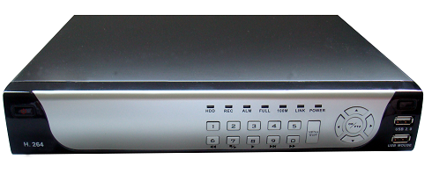

CONTENT
1 INTRODUCTION 3
1.1 PREODUCT INTRODUCE 3
1.2 PRODUCT FEATURE 3
1.2.1 SPECIFICATION 3
1.2.2 BASIC WORKING PARAMETER 5
1.3 ENTIRONMENT ADAPTABILITY 5
2 DEVICE OPERATION 6
2.1 REMOTE KEY INSTRUCTION 6
2.1.1 REMOTE CONTROL 6
2.1.2 MOUSE OPERATION 7
2.1.3 MENU TREE 9
2.2 SYSTEM OPERSTION 10
2.2.1 USER LOGIN 10
2.2.2 GUI OPERATION 11
2.2.3 BASIC SETUP 15
2.2.4 ADVANCE SETUP 19
3 IE OPERATION 27
3.1 FEATURE 27
3.2 USER LOGIN 27
3.3 OPERATION INTERFACE 28
3.3.1 LIVE 28
3.3.1.1 PTZ CONTROL 28
3.3.1.1.1 ZOOM 29
3.3.1.1.2 PTZ PRESET 29
3.3.1.2 PLAY 29
3.3.1.3 OTHER OPERATION 29
3.3.2 REPALY 30
3.3.3 SETUP 32
3.3.3.1 RECORD 32
3.3.3.2 ALARM 33
3.3.3.3 PTZ 34
3.3.3.4 NETWORK 34
3.3.3.5 SETTING 35
3.3.3.6 HOST INFO 36
4 DVR INSTALLATION 37
4.1 PRODUCT OVERVIEW 37
4.2 HDD INSTALLATION 42

INTRODUCTION

PREODUCT INTRODUCE
DVR-8304/8308 is developed base on HI3511 hardware platform. 8304 is 4channel CIF resolution digital video recorder and 8308 is 8channnel DVR. Both of them have local recording, playback, support trible code remote network surveillance, data backup, parameter setting, motion detection, I/O alarm setting, PTZ and USB mouse.

PRODUCT FEATURE
- H.264 compression
- Two USB interface, USB2.0 for data backup, USB1.1 for mouse operation.
- 3.5” SATA HDD.
- Special file system for secureity.
- 16 nature translucence GUI, note for menu selected
- optimized four channel simultaneously playback, (8ch just support one channel playback)
- double level user management
Support the live view, parameter setting and copy playback video via network.

SPECIFICATION
Item | Device | performance index
System | Language | Chinese/English
System | GUI | Graphic menu
System | password | user password, administrator password
Video | Video in | 4ch complex video input 1.0V p-p,impedance75Ω,BNC
Video | Video out | 2ch complex video output 1.0V p-p,impedance75Ω,BNC
Video | Video display | 1/4channel switch/8ch 1/4/9 switch
Video | Video standard | PAL,25f/s,CCIR625line,50scene  NTSC,30f/s,CCIR525line,60scene
Audio | Audio input | 4ch audio input,impedance600Ω,RCA
Audio | Audio output | 1ch audio output,impedance600Ω,RCA
Audio | Basic electricity output | Linearity electricity
Audio | Record style | Audio video recorded simultanously
Audio | Audio compression | ADPCM
Picture proceeding and store | Picture compression | H.264,  (VBR)/(CBR)
Picture proceeding and store | Picture resolution | CIF/HD1/D1
Picture proceeding and store | Streaming style | ISO14496-10
Picture proceeding and store | Audio style | ADPCM
Picture proceeding and store | Video code rate | CIF: 384Kbps ~ 768Kbps,8 leavel optional, 1 is highest,8 is lowest  HD1: 512Kbps ~ 1024Kbps,8 leavel optional,1 is highest,8 is lowest  D1: 512Kbps ~ 1024Kbps,8 leavel optional,1 is highest,8 is lowest
Picture proceeding and store | Audio code rate | 32KB/s
Picture proceeding and store | Data storage | Support all kinds of storage HDD
Alarm | Alarm input | 4 alarm input
Alarm | Alarm output | 1 alarm output
Connector | Servial interface | Support 1 RS232
Connector | Servial interface | Support 1 RS485
Connector | Network interface | RJ45,10M/100M
USB | Mouse | USB1.1,
USB | Thumb drive | USB2.0
VGA | VGA | 1 VGA （optional）
Software | PC playback | Playback video file
Software upgrade | Support USB,network firmware upgrade
ohters | voltage input | AC:110~240V
ohters | Voltage output | DC:19V@3A
ohters | Voltage input | +12V@1A
ohters | Power | 6W without HDD
ohters | Working tempreture | -10----60℃

BASIC WORKING PARAMETER
item | parameter | remark
Voltage input | 19V | DC 19V.
Voltage outputfor camera | 12V（+/-0.2） | 12V, 1A.
Video impedance input | 75Ω | 75Ωeach channel.
Video output | 1Vp-p | 1Vp-p CVBS signal
I/O | 0—2V | Low voltage alarm
I/O | 5V-30v | Hight voltage alarm
RS232 |  | serial port, for extend use
RS485 |  | Connect to PTZ, (Pelco-D,Pelco-P)
SATA HDD |  | One SATA with all capability

ENTIRONMENT ADAPTABILITY
For the saftly using DVR and prolong device life, please pay attention on following detail:
- When installing device, please comply all the electric product safty criterion;
- Power and ground:
  - Do not touch the power and DVR with a wet hand
          - Do not drop liquid on DVR
          - Do not put others on DVR
          - Please using soft dry cloth when clean DVR, do not using chymistimpregnant
          - When the power line connects with jack, even don’t startup device. There is still have voltage
          - If you do not use device for long time, please take the power line away from jack.

DEVICE OPERATION
In device operation, the enter key on remote control has the same function with mouse left click.

REMOTE KEY INSTRUCTION

REMOTE CONTROL
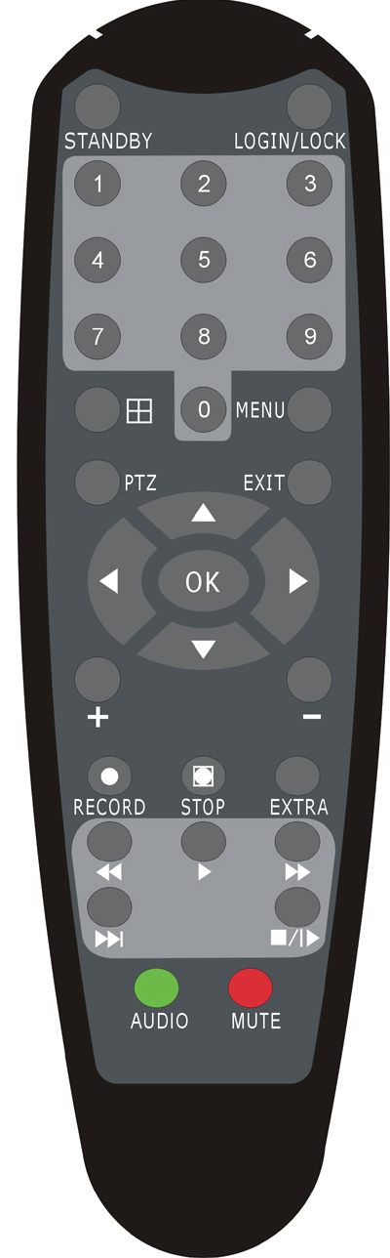
Handheld IR Controller Key Functions:
【0－9】keys: During setup, number keys are used to input values.
For viewing channels 1,2,3 and 4, use 1,2,3 and 4 on numeric keypad respectively.
【＋】,【－】keys: During setup, plus and minus are used to select next or previous values.
▲,: Up, Down directional keys: Move selection up and down in setup menu.
,: Left, Right directional keys: Move cusor left or right in setup menu.
【OK】: During setup, select and save entry
During Playback and preview, displays the channel name, text number, driver name, event sensor item and time, year/month/date, time, GPRS/GPS info on the screen.
【PLAY】:Starts/Resumes playback from any other mode (FF, RR, Frame by Frame etc)
【SLOW】:Reduces playback speed to 1/2X、1/4X、1/8X、1/16X mode. Press PLAY to return to normal playback speed.
【PAUSE/STEP】:Freezes playback to single frame and can advance one frame at a time. To advance the frame press Pause/Step to move frame by frame. Press EXIT to return to normal playback speed.
【FWD】: Fast forward the video while playback. X2, X4, X8 modes available. PressFWD to switch, press 【PLAY】to return to normal speed;
【REV】: Reverse the video while playback,2X,4X,8X four modes are available. Press REW to switch, press【PLAY】 to return to normal speed;
【STANDBY】: Reset the MDVR to Power on and Power off mode. (Standby and start up);
【LOGIN/LOCK】: If the security is enabled in the setup, use LOGIN/LOCK key to enter the user setup. It is important to remember the password due to without restoration function. Log in（to enter into “User ID select” and “Password” input interface）and lock functions（To exit setup and operation）
【EXIT】: Exit to the preview or return to the last menu;
【RECORD】:Start manual record
【STOP】: Stop manual record (can’t stop timer record and normal record)
【MENU】:Enter into setup interface and setup the system parameters
【PTZ】:PTZ control, press this key to enter into PTZ control interface when at single live view;
【EXTRA】【AUDIO】【MUTE】for future use.

MOUSE OPERATION
You can use mouse to make operation of the menu except IR remote controller. (The operation usage is the same as PC Windows).Please inserts the mouse into USB1.1.

Click right key | Enter into main menu: Click the right key on the live view.
Click right key | Exit the present menu: It won’t save the settings if you click the right key to exit.
Click right key | Exit the playback interface: Click the right key to exit when you are playback.
Click left key | Click the left key to enter into the setting interface.
Click left key | Click the left key to zoom in the window on the live view and playback video. Double click the left key can exit to the live view and playback multi-window interface.
Click left key | 1. Volume adjustment, color adjustment, PTZ setting and VGA border operation.It is for setting the single channel for volume adjustment, PTZ control and color adjustment.If it is multi-window, please use the left key to select the single window.  2. The remark when click the left key for volume adjustment,color adjustment,VGA border is as follow:  a. There is and on the PTZ setting to adjust parameter, click it can make the setting for PTZ.  b. There is a sticker to show the volume on the volume adjustment interface.Move the mouse to the corresponding position and click the left key,The right side of sticker will show the volume ,click “x”to exit;  c. Color adjustment and VGA border operation can refer to the volume adjustment interface operation.
Click left key | When there are many options in the option frame,click left key to ball out down-pull menu.
Click left key | To click the left key on the playback interface can make >> means forward, << means rew, >>I means Slow play, I> means frame play,> means Play, X means exit.
Click left or right key | 1. In the input frame, click the left key or right key can activate the keyboard. Click the right key can make the switch of Chinese and English on the soft keyboard.The number, symbol, english can be input by clicking the mouse.  2. Pingyin also can be input by the softkeyboard when enter Chinese, the method is the same as IR remote controller.You can use the left/right key to turn over the page when check on Pingyin/Chinese word.  3. When input number, click the right key, the number soft keyboard will bob up firstly, and then use the left key to select the corresponding value.Also click the left key to exit the number keyboard.
Mouse move | 1. Press the left key to move the mouse can adjust the parameter on the volume, color, VGA border interface.And the corresponding parameter will be display at the same time.  2. In the Motion Detection setting interface, you can use the left key to drag the frame to set the motion detection area.

MENU TREE
You can control the DVR by a lot of menu operation.This tree will show you the menu structure and it will be in details in after chapter.

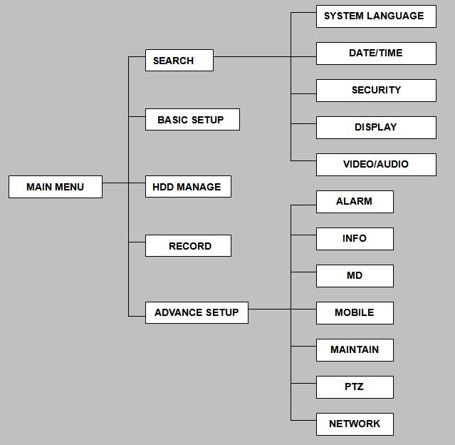

SYSTEM OPERSTION

USER LOGIN

START-UP
Connect the DC19V/3A adapter to DVR. When start up the DVR, 【POW】LED will be on and 4 images will be display on the screen. If it has setup ignition recording or time recording, the system will record automatically and the corresponding LED will be on, the system work normally.
Remark: If there is no HDD in device, or device didn’t read the new HDD, it will display an 【H】 in live view, so please format it when connect a HDD for the first time.

SYSTEM LOGIN
When you login, you will find the window as follow if the password is enabled, Input device ID and user password via numeric key-board, and you can access to main menu via press 【Apply】
Remark: default device ID is: 00000, and the password is :user password is oooooo and Admin password is 020818, in order to manage the device more convenience, please setup the user password and change the device ID in the base setup. You can setup user and admin password, Administrator has all authorities, operator has limited authorities who they can only watch, playback, please change the unit ID and default password in time for system security.

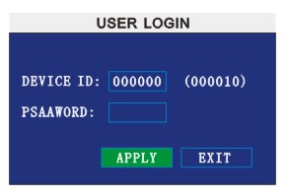
DEVICE ID: You just need to enter the unit ID as the right frame.
PASSWORD: enter the admin password or user password.

GUI OPERATION
The main menu include “SEARCH”,”RECORD”,”HDD”,”BASIC”,“ADVANCE”,and“EXIT”.
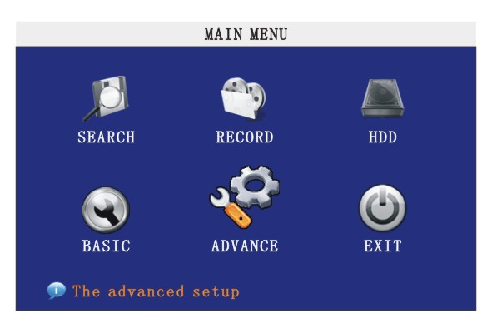
Remark: You must after pressing “APPLY”to make the setting for submenu valid.It will no use when exit directly.This DVR have a special feature is: when you move the mouse to everwhere, there will have the explanation information showed autoly.

RECORD SEARCH
Move the cursor to 【RECORD SEARCH】（Icon highlighted when selected）,press【Enter】to enter into the setting interface.
DATE:You can adjust the checking date and time,press【Enter】 【+】/【-】 or input the number directly to adjust the year,month,date.After finishing the time setting,move the cursor to “SEARCH” and press”APPLY”,can see the recording status of this date.As follow:
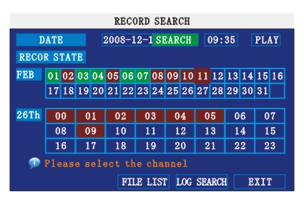
Intruction:
1. MONTH: It will show all the recording status in this month. Green means normal recording, Red means alarm recording, Grounding means no recording. Click any date in this frame can search the recording status of that day, the searching result will be showed in the below date frame.
2. DAY: It will show all the recording status in this day, you can playback the record file in this period via click the corresponding period.
PLAY:You can press 【Enter】 【+】/【-】 or input number directly to setup playback time.After setting,move the cursor to “PLAYBACK”, and then press”APLLY”to enter into video playback of that time.Also you can select any period of time in the video status frame after searching,press”APLLY”to enter into the video playback of this period.
FILE LIST: Enter into the video file list interface of the selected date.
LOG SEARCH: Enter into the log seaching interface.

1. FILE LIST
Setup the searching date, after pressing “SERACH”,move the cursor to “FILE LIST” and press”APPLY”to enter into the video file list of this date.
TYPE: There are all,normal and alarm,totally 3 options.Press【Enter】or 【+】/【-】to select.

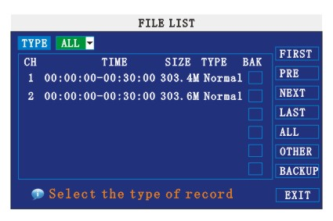
Instruction:
1. 【FILE LIST】,“CHANNEL”is the recording file which belong to which channel, “SIZE” is display the size of this file（Unit:MB）, “TYPE” is display the type of recording file,there are two types: normal and alarm,press“BACKUP”button can export the selected files to USB storage;
2. After moving the cursor up and down and select the files, and press【APPLY】to enter into playback interface. If the all channels have recording files, it will playback all windows at the same time.
3. If setup as “on” in the【RECORD TIME】in 【BASIC SETUP】, it will show the date/time when playback record file;If setup as “off”it will not display time.
4. When playback,can press【SLOW】to play slowly;press【FORWARD】and【REVERSE】to speed、reverse play; also can press【PAUSE/STEP】to pause and frame by frame play; Press【Exit】to exit from playback and return to the former menu;
5. When finished playback files, it will return to the file list interface.

2. BACKUP
You can use USB for backup, should insert USB device into the USB2.0 port before backup files. And it is support USB OTG.
You can select the recording file by direction keys or 【＋】、【－】, and press【Enter】means selected OK（There is a “√” at the end of the selected recording files）and press 【Enter】again the “√” will disappear that means cancel the select, we can start export the recording files after selecting, and press【BACKUP】to start to backup, as follow:

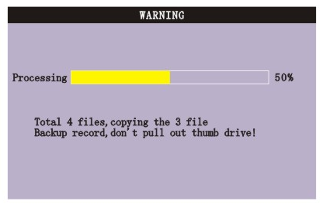
Instruction:
1．When the space in backup device less than recording file, the system will prompt “Space no enough”.
2．You can move USB device directly when backup finished.

RECORD SETUP
Move the cursor to 【RECORD】（Icon highlighted when selected）,press【Enter】to enter into the setting interface. Press【Confirm】 and enter into the setup interface, and you can use direction keys and cursor to change the options.

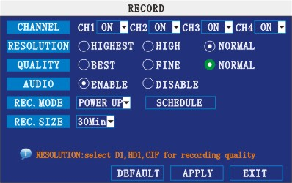

CHANNEL: ON: Means the channel enable for recording.
RESOLUTION:Setup resolution and code rate for recording, there are HIGEST, HIGH, NORMAL three options, corresponding to D1、HD1、CIF resolution.
QUALITY: There are BEST, FINE ANDNORMAL three option, corresponding HIGHEST, HINGAND NORMAL data stream standard
AUDIO: ON: Means enable the audio recording for all channels, OFF: Means disable audio recording
REC.MODE:
POWER UP: Means the device will start recording when it startup.
TIME: Recording as the schedule, you can setup the schedule as you want as follow.
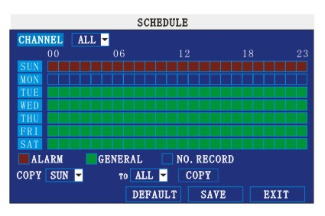
CHANNEL: You can select all channels or just one channel to setup schedule.
WEEKLY: You can setup each as you want. There are ALARM, NORMAL, NO REC three modes, if you select this, there will have a √ in the frame, that means when you select the period of the day it will record as this mode, and you can just setup one day, then copy the setting to all other days. Different color means different record mode: Red means alarm record, green means normal record, grounding means no record.
RECORD SIZE: There are 15min, 30min, 45min, 60min four options, that means it will pack as the mode you selected
Scroll to APPLY and press ENTER to save the new settings.

HDD MANAGE
Move the cursor to 【HDD】（Icon highlighted when selected）,press【Enter】to enter into the setting interface, and you can use direction keys and cursor to change the options.
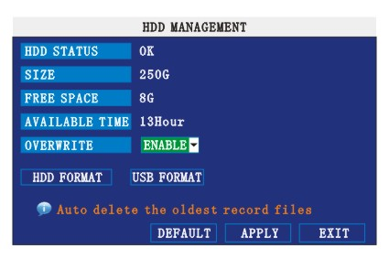
HDD STATUS: There are three status available, normal, un-format, No HDD. If HDD can not run normally（including unformat and no HDD）, there is a 【H】display on video live view.
OVERWRITE:ENABLE: means when HDD space less than 4G, it will delete HDD earliest recording file, and it will stop deleting when the space is 10G; DISABLE:means when HDD space less than 500M it will stop recording, and an prompt will display in live view “please shutdown and replace HDD”
FORMAT:Move cursor there to select device and press【APLLY】 to start format

BASIC SETUP
Move cursor to select “BASIC SETUP” (The big icon means selected)and press【ENTER】to enter into the system language setup interface.
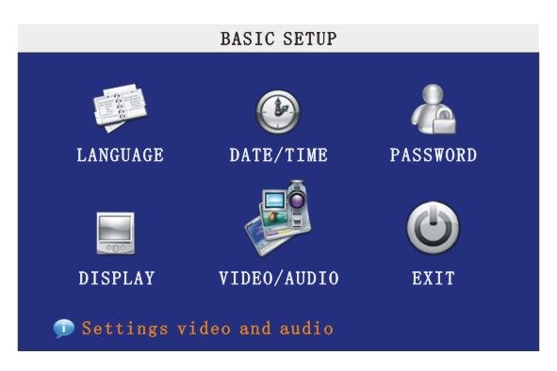
Basic setup includes system language, time/date, security, display, video/audio and exit six options.

SYSTEM LANGUAGE
Move cursor to select “system language” (The highlighted when selected)and press【ENTER】to enter into the system language setup interface.
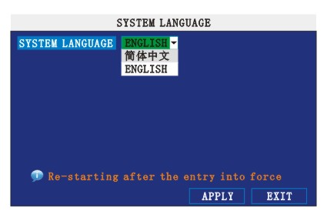
System language have Chinese and English two options, you can setup the language you want in here.
Remark: The device will restart when you setup system language success.

TIME SETUP
Move cursor to select “date/time” (icon highlighted when selected)and press【ENTER】to enter into the date/time setup interface.
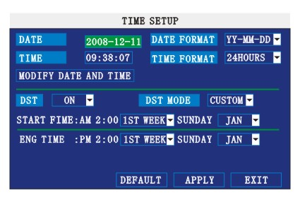
DATE: Setup system date via numeric key.
DATE FORMAT: Press ENTER to switch between the date patterns, there are YY-MM-DD and MM/DD/YY two options.
TIME: Setup system time via numeric key.
TIME FORMAT: Press ENTER to switch between the date patterns, there are 12 HOURS and 24 HOURS two options.
Remark: You must move the cursor to the 【MODIFY TIME AND DATE】 and press 【APPLY】 to save it, otherwise it won’t save the modify if you exit this interface.
DST: haven’t finished yet.

SECURITY
Move the cursor to【SECURITY】（Icon highlighted when selected）, press【Enter】to enter into the setting interface.
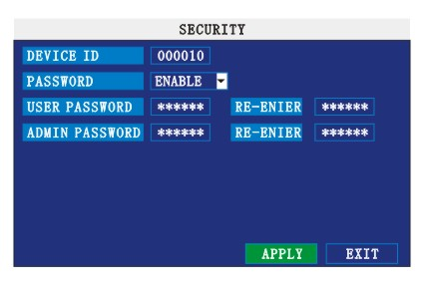

DEVICE ID:Press【+】/【-】or number key to setup the unite ID
PASSWORD:Press【APPLY】 to start or close user password. If it is “ENABLE”, you must input password when log in, otherwise, you can enter into main manu directly.
USER PASSWORD:Press 【+】/【-】or numbe keys to setup user password.
ADMIN PASSWORD:Press【+】/【-】or press number keys to setup admin password.

DISPLAY SETUP
Move the cursor to【DISPLAY SETUP】（Icon highlighted when selected）, press【Enter】to enter into the setting interface.
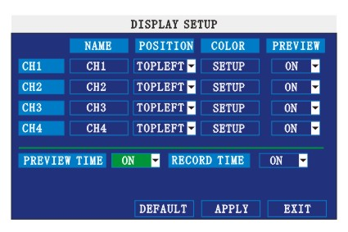
NAME: press【Enter】to enter into the setting interface.
POSITION:press【Enter】 to switch name location,there are 5 options:bottom left, top left, bottom right, top right and OFF.
COLOR:press【Enter】to enter into setting interface, as following:
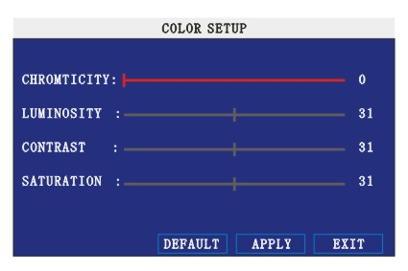

Press【Enter】or【+】【-】key or directly drag the cursor to set colors,including chroma,brightness, contrast and saturation, press【APPLY】to save the parameters.
PREVIEW: ON: Means the channel is allowed to view the live mode, OFF means not.
PREVIEW TIME: ON: Means insert clock in live view, OFF means not.
RECORD TIME: ON: Means insert clock in record file, OFF means not.

VID/AUD SETUP
Move the cursor to【VID/AUD SETUP】（Icon highlighted when selected）,press【Enter】to enter into setting interface.
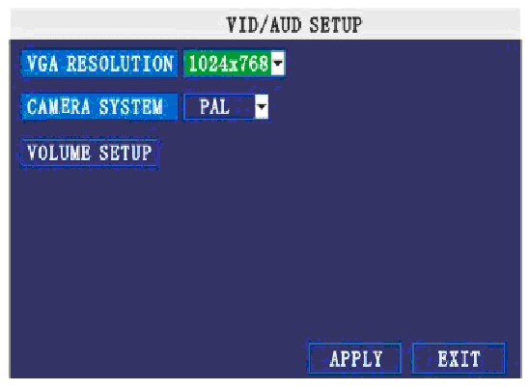
VGA RESOLUTION:press【Enter】key to setup the VGA resolution, there are
1024*768、800*600 and 600*480 three options.
CAMERA SYSTEM: press【Enter】to switch camera system, has PAL and NTSC two options
VOLUME SETUP: move cursor to【VOLUME SETUP】,press【Enter】to enter into volume setup interface, press【+】【-】or number keys or directly drag the cursor to adjust volume.
Remark: it will restart if you modify the camera system.

EXIT
Move the cursor to【EXIT】（Icon highlighted when selected）,press【Enter】to back to main menu.

ADVANCE SETUP
Move the cursor to【ADVANCE SETUP】（Icon highlighted when selected）,press【Enter】to enter into setting interface.
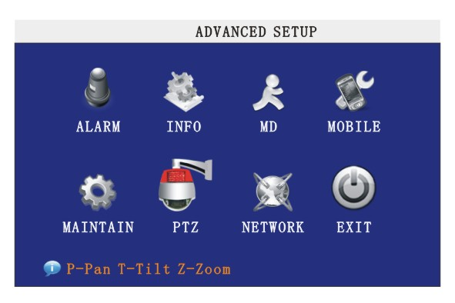
Advanced Features include Alarm settings, system information, Motion detection, mobile phone monitoring, system maintenance, PTZ and network setting.

ALARM SETUP
Move the cursor to【ALARM SETUP】（Icon highlighted when selected）,press【Enter】to enter into setting interface.
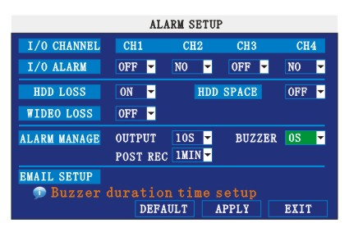
I/O ALARM: Each channel has an I/O status, that is, when an alarm triggered, it will activate the corresponding channel to start alarm recording.
N.O: indicate I / O input level from high to low effective
N.C: indicate I / O input level from low to high effective
HDD LOSS:ON means it will trigger a alarm if there is no HDD, and it will display an 【H】
On the bottom left of channel 1 in the live view
HDD SPACE: ON: If the space less than 500M, there is a remark in live view: No enough space, please change HDD after shutdown.
VIDEO LOSS: ON: when one channel has no video input, it will display “video loss”in live view.
ALARM MANAGE: There are alarm output, buzzer and post REC three items.
OUTPUT: when an alarm triggered, the alarm output time will be:
0 second、10 seconds,20 seconds,40 seconds and 60 seconds
      - BUZZER:buzzer calling time setup when alarm triggered: 0 second,10 seconds,20 seconds,40 seconds and 60 seconds
      - POST REC.:post recording time setup: 30 seconds,1 minute,2 minutes and 5 minutes
EMAIL SETUP: not finished yet.

SYSTEM INFO
Move the cursor to 【SYSTEM INFO】（Icon highlighted when selected）,press【Enter】to enter into setting interface, at this interface mainly display system hardware features and firmware version, include : device type, software version, MAC address、serial number.
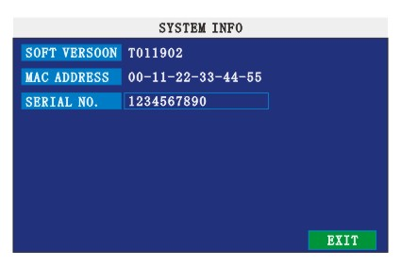

MOTION DETECT
Move the cursor to【MOTION DETECT】（Icon highlighted when selected）,press【Enter】to enter into setting interface.
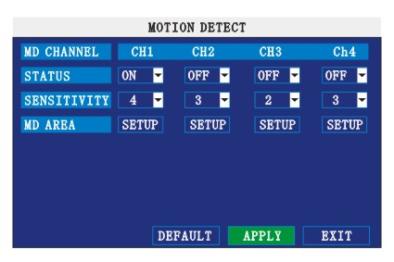
STATUS:Each channel has corresponding channel switch, press 【Enter】to turn on or turn off the motion detection for each channel..
SNESITIVITY:each channel has corresponding sensitivity setting,including four standards high,higher,medium and low, press【Enter】key to switch
MD AREA: each channel has corresponding regional motion detecting setting,move the cursor to corresponding【setting】,press【Enter】to enter regional setting interface, red area means it have activated motion detection, transparent block means it have not activated motion detection.
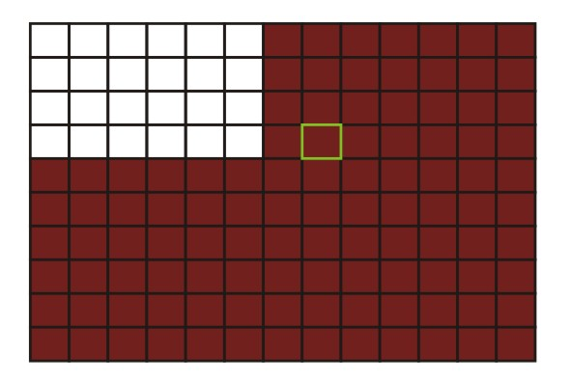
Move the direction key on romote control to make cursor move in the small pane, green frame means the cursor has moved to this pane, press【Enter】to select or cancel motion detection of this small pane, when setup finished, press【exit】to back to MD setup interface, it will save automaticly.
Remark:
IR Operation: press [Menu] key to select or cance all the screen.
Mouse operation: click left and drag the frame to setup the region for motion detection.

MOBILE
Move the cursor to【MOBLE】（Icon highlighted when selected）,press【Enter】to enter into setting interface.
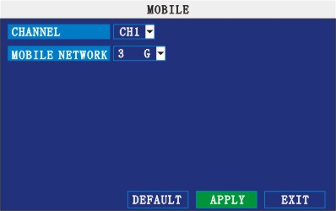
CHANNEL: select the channel for mobile view, and press [Enter] to switch different channels.
MOBLE NETWORK: Select different mobile network from the options of 3G, 2.5G and 2.75G, and press [Enter] to switch different network.

SYSTEM MAINTAIN
Move the cursor to 【SYSTEM MAINTAIN】(icon highlighted when selected), and press【Enter】 to enter into system maintain setup interface.
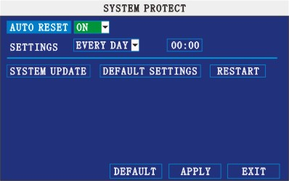

AUTO RESET: When switch is on, you can setup the time for device to restart.
SYSTEM UPDATE: Copy the update file to the root directory of the thumb driver, and insert it into USB 1.0, then press [Enter] to upgrade the firmware, and it will display the process of the system upgrading, as following:

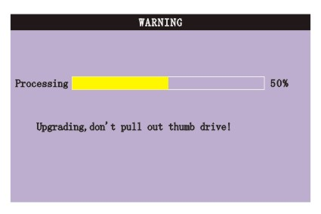
DEFAULT SETTINGS: Restore all the settings as the factory setting.

PTZ SETUP
Move the cursor to【PTZ SETUP】（Icon highlighted when selected）,press【Enter】to enter into setting interface, you can setup the parameters for each channel separately.
CHANNEL: The channel of PTZ connected.
PROTOCOL: select the protocol of different PTZ, there are two protocols to switch, and the default is Pelco-D
BAUD RATE: select the different baud rate for your PTZ, there are 1200, 2400, 4800, and 9600
DATA BIT: there are 5,6,7,8 options to select, default setting is 8.
STOP BIT: there are 1and 2 to select, the default setting is 1.
VERIFY: there are None/Odd/Even/Mark/Space to select, the default setting is none.
ADDRESS: Fill the code of respective PTZ

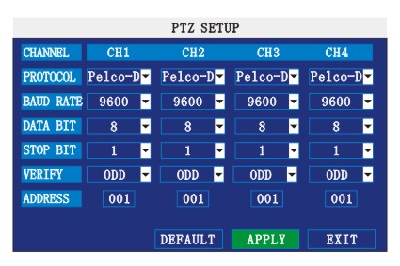

NETWORK SETUP
Move the cursor to [NETWORK SETUP] (icon thighlitend when selected), and press 【Enter】 to enter into setting interface .
TYPE: There are PPPOE, DHCP & Static three options.

      - STATIC
Select [Static] in the type, and press [Enter] to enter into the interface as followings

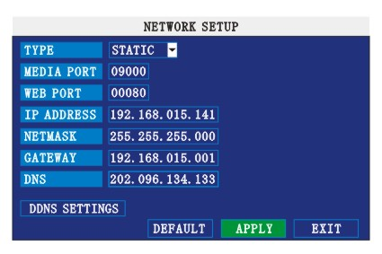
MEDIA PORT for future use
WEB PORT: setup the port of IE browser via HTTP.
IP ADDRESS: setup the IP address, and press [Enter], [+], [-] or number keys to change the value.
NETMASK: press [Enter], [+], [-] or number keys to change the value.
GATEWAY: press [Enter], [+], [-] or number keys to change the value.

      - DHCP
Select the DHCP, and enter into the interface as followings.
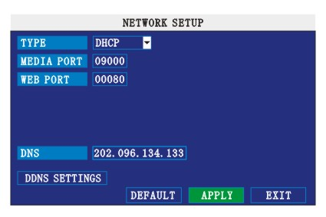

MEDIA PORT: the communicate port between PC and DVR, recommend use default port.
WEB PORT: setup the port of IE browser via HTTP.
PPPOE username and password: fill the username and password of the internet service offer, and apply it and reboot the system. After rebooting, the device will save it and set the PPPOE as default network type. If succeed, the IP address will be automatically config as dynamic IP of WAN.

      - PPPOE
Select the PPPOE, and enter the interface as followings

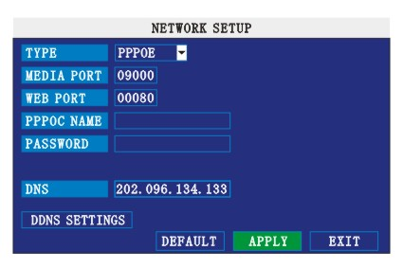

MEDIA PORT: the communicate port between PC and DVR, recommend use default port
WEB PORT: setup the port of IE browser via HTTP.
PPPOE username and password: fill the username and password of the internet service offer, and apply it and reboot the system. After rebooting, the device will save it and set the PPPOE as default network type. If succeed, the IP address will be automatically config as dynamic IP of WAN.

DNS: press [Enter], [+], [-] or number keys to change the value.
DDNS: move the cursor to it and press [Enter] to enter into the interface as followings.

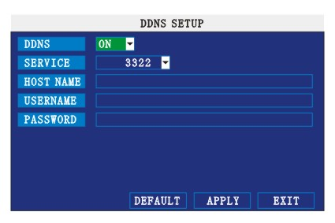

DDNS: There are [ON/OFF], and if there is a DDNS service, please setup it as ON.
SERVICE: There are 3 serviceS to select, 3322, dyndns, perfecteyes.
HOST NAME: Input the name of the host server.
USERNAME: Input in the name of the user.
PASSWORD: Input the password.

Application of DDNS
You should Register a host name, user name and password from DDNS manufacture, now we are take 3322 for example, to show you how to register.
Please type in the IE address as follow: to Register a new user.
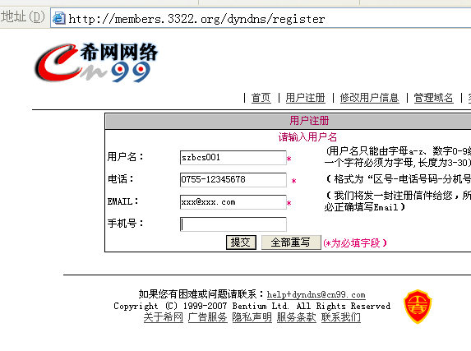
- Fill out all the information then submit.
- Minutes later, you will get a mail from 3322, which include the primary password for the user you just register.
- Then please login http://members.3322.org/ with the new user and password, click “domain name management” to enter into the operating interface, then select “new” under the Dynamic DDNS.
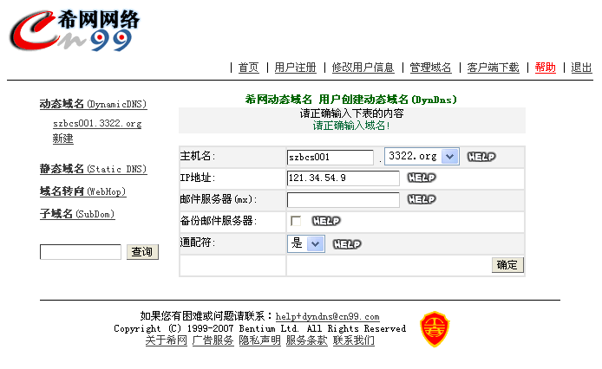
- Create a mane you need, then press apply; now you have Registered a host name success.

For example:

1, Network: ADSL, only one DVR need to connect to internet.

- Make sure the DVR has connected to ADSL modem success; the LED is flashing means success.
- Network type: PPPoE
- Input media port and web port, default value is 9000 and 0080
- Type in the PPPoE user name and password from internet manufacture.
- Fill in the IP of DNS sever, such as：202.96.128.166
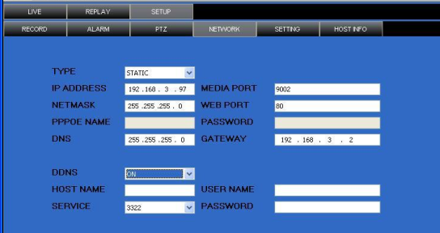
- Since the public IP will change after restart, please use DDNS function, and mapping the public IP to a fixed domain name, as the picture.
- Save and restart device, it will connect to internet via PPPoE mode automatically, if success, it will got a dynamic public IP.
- ping xxx.xxx.xxx.xxx(The public IP of DVR) to check whether the network is ok, and ping xxx.xxx.xxx（the domain name of DVR）to check whether the DDNS settings is ok.
- Open IE browser, and type in the domain name of DDNS (if WEB port is not 80, you should add a port, such as:http://members.3322.org:8088 )
Please download the IE control, then enter into login interface, the default setting has no password.

2. Network: ADSL, a number of DVR need to connect to internet.

  - Make sure your ADSL router support a number of DVR to connect to internet at the same time.
- Connect DVR to ADSL router correctly as the manual.
- Start-up the PPPoE functions of ADSL router, and start to dialing to connect to internet.
- Please turn off the DHCP function of the router; the network mode of both DVR and pc should be static. Remark: All the sub mask, gateway and DNS of DVR, PC and rout should in the same net field, as follow:
Setup of the ADSL router：
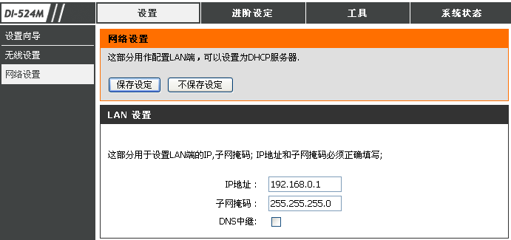
DVR Setup：
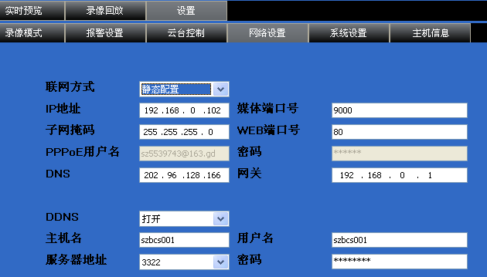

PC network setup：
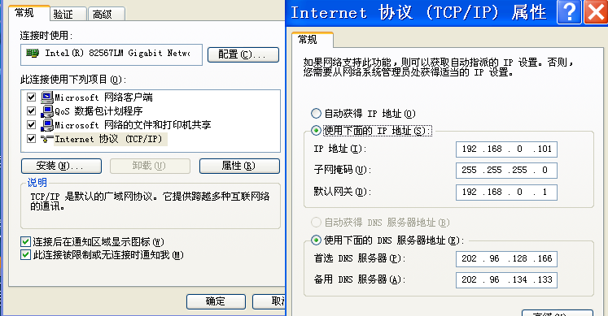
- Please check if the PC can access to internet via open a IE web.
- Type in the IP of DVR in IE address to check if can access to DVR.
- Mapping the port in the ADSL router, please open the DVR media port and WEB port for remote IE client in here.
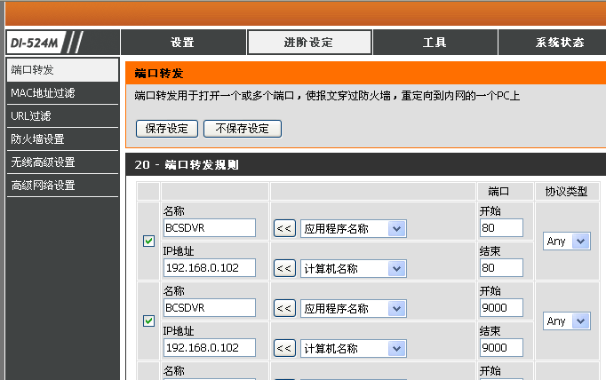
- Please use a remote PC to ping xxx.xxx.xxx ( the domain name of the DVR) to check if the DDNS setup is ok.
- Open IE browser, and type in the domain name of DDNS (if WEB port is not 80, you should add a port, such as:http://members.3322.org:8088 )
- Please download and install the IE control, then enter into login interface, the default setting has no password.

3. Network: Enterprise special internet line and the router have fixed public IP, DVR need to connect to internet.
- Make sure the connection between DVR and router is correct.
- Network type please select static
- Please setup the IP address, sub mask gateway and port as the manual.
- Ask the Administrator to open the media port and WEB port in the router.
- Try to use a LAN PC to access to DVR via type in the local IP of DVR + port (for example: http:// 192.168.3.97:8088).
- Try to use a WAN PC to access to DVR via type in the public IP of the router + port (for example: http:// 58.60.231.218:8088).

IE OPERATION

FEATURE
Through the IE browser of OS and install the software, you are able to do the network operation remotely, which is much more convenient. DVR support C/S, B/S, and visit in LAN and WAN, also support IP and domain name visiting.

Remark: Operating system Windows XP, Windows Vista and Browser IE6.0, IE7.0 is recommended

USER LOGIN
Input the DVR local IP in IE browser, when changed the port, you should add the port number after IP address, e.g. if DVR local IP is 192.168.3.97 (LAN) and the port is 8088, you should input http:// 192.168.3.97:8088. The default port is 8088, and directly input http:// 192.168.3.97 to access the login interface as following.

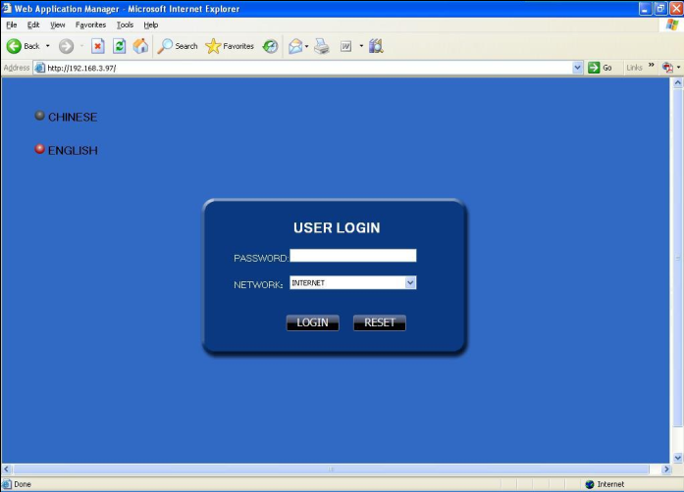
Select English interface in the top left side. Input username and password to enter into the system. The username and passport is same as the ones set in DVR.
PASSWORD: Administrator has all authorities, operator has limited authorities who they can only watch, playback, please change the unit No. and default password is blank.
NETWORK: LAN/WAN
Remark: If you connect the device in WAN, the IP should be a public IP.

OPERATION INTERFACE
There are Liveview, Playback and Setup options in the main interface, please press them to access it.

LIVE
Click to enter into the interface as followings 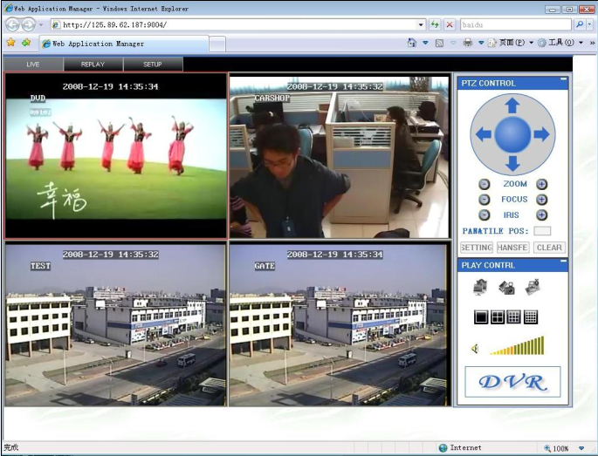

PTZ CONTROL
Change the focus, preset aperture to control the PTZ.

Click  to up/down/left/right control movement of the PTZ. When hold on the one direction key, the PTZ will keep circling as that direction after user press the stop key in the center of the wheel.

ZOOM
Click to zoom in and out.
Click to focus
Click to change the size of aperture

PTZ PRESET
Setup preset point.
You can control it via the below three buttons:

PLAY
Move cursor to the icons, it will highlighted when selected
Open all windows.
Capture picture, save in local disk, the default save path is C:/DVR
Quickly start all channels’ recording video, here the left up corner of each channel have normal recording video symbol 【R】, click icon to switch between singal screen/quad/nine/16 spllit.
Volumn adjust button

OTHER OPERATION
1. Select one channel at preview screen (the selected channel’s frame will be change to RED), double click left key, enter to the selected channel single screen display.
2. Click one Chanel via left key at preview screen, then click right key, will occur window shortcut Menu, see below picture
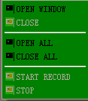
You can open, shut down and start this channel’s record via shortcut menu.
3.Click right key at one live view screen, click” open all windows” or “ close all windows”, will quickly open/close all windows.

REPALY
Click to enter into remotely playback interface, which is to playback the record file in DVR.
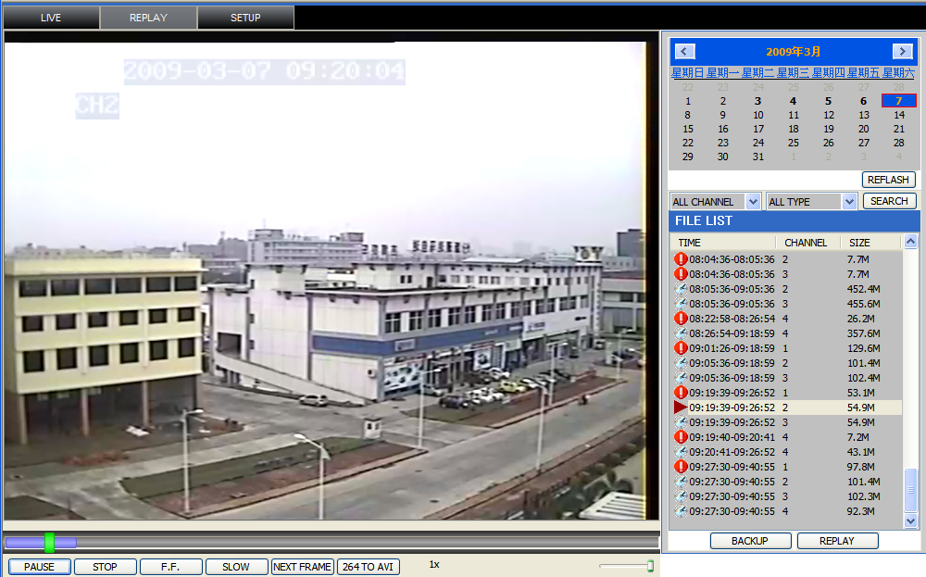
Click right up of calendar interface and, to setup the month for searching, click” refurbish”, at the calendar interface will display the recording information of current month
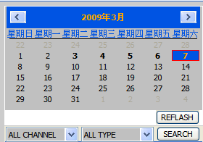

The highlighted date means that day have recording video, RED FRAME means the date is system date, click the date will search that days’ recording file list. For example, the above picture display 2008, Dec. 3rd,4th,5th,6th,8th,9th,10th,11th,12th,17th,18th have recording video, and system date is 18th, Dec, 2008, currently search date is 17th, Dec.
At the below of calendar select channel and type, click SEARCH, the result will display, as follow.
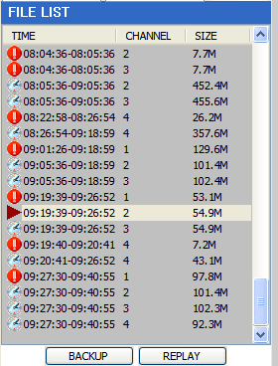
Double click one item of listed recording video, the recording video will playback, meanwhile the file icon will change to , and will occur the below picture play buttons:
The above purple progress bar shows download progress, green progress bar shows playback progress
Switch between pause/play
Stop play
Fast play
Slow play
Pause at next frame
Convert H.264 file to H.avi file, click this button access into file convert setting interface, as follow.
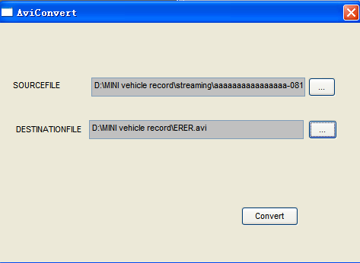
SOURCE FILE: Click to setup the H.264 file to convert
DESTINATION FILE: Click to setup the directory for saving avi file
After setting, click , file convert start, the convert progress bar (see below picture) will see the progress of convert.
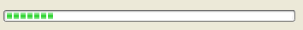

SETUP
Click to enter into setup interface, this interface include record, alarm, PTZ, network, setting and system information six menus.

RECORD
Click to enter into setup interface; you can check the parameter settings as in GUI of DVR.
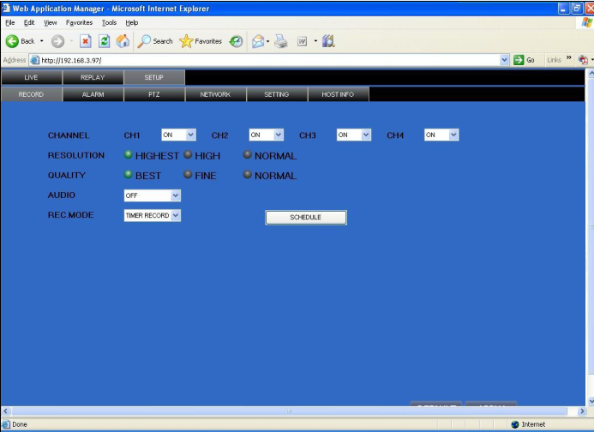

ALARM
Click to enter into setup interface; you can check the parameter settings as in GUI of DVR.
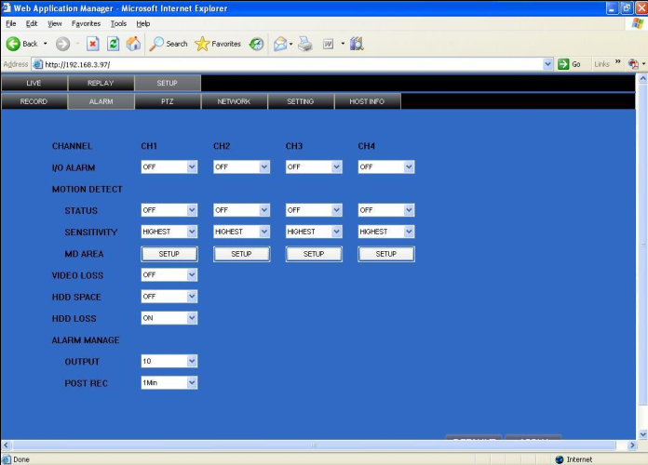

PTZ
Click to enter into setup interface; you can check the parameter settings as in GUI of DVR.
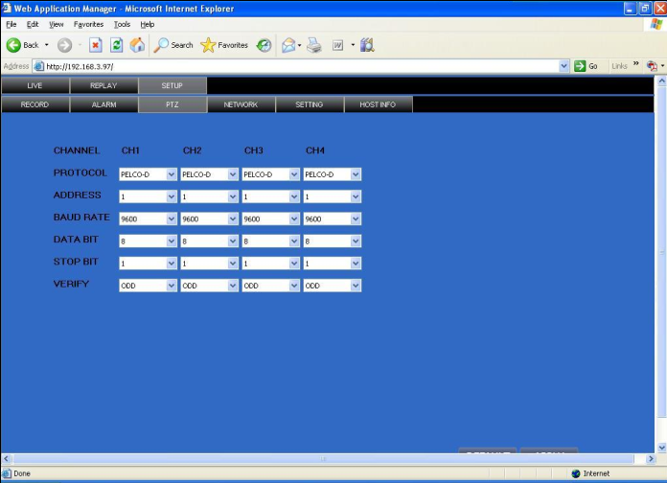

NETWORK
Click to enter into setup interface; you can check the parameter settings as in GUI of DVR.

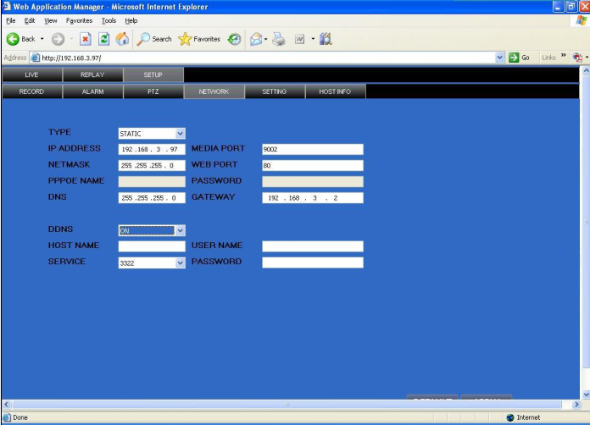

SETTING
Click to enter into setup interface; you can check the parameter settings as in GUI of DVR.

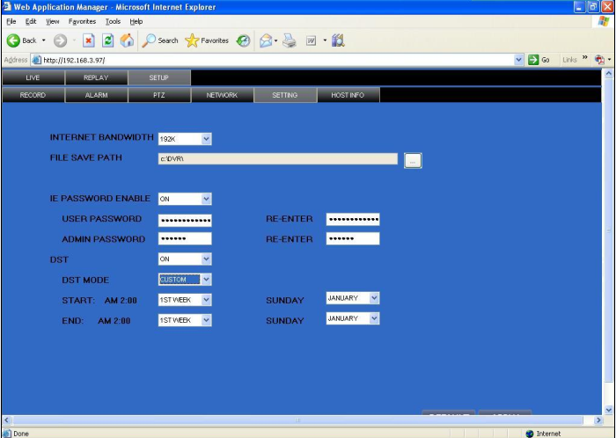
BANDWIDTH: Set the amount of bandwidth in kbps (128k、192k、256k、384k、512k、1024k) that you want to allocate for traffic that matches internet,this bandwidth not include audio.

Remark: the normal ADSL network is between 256k and 384k

FILE SAVE PATH: capture picture and recording video save path.
IE PASSWORD: setup the password when you login IE
DST settings you can check as DVR setting.

HOST INFO
Click to enter into system information interface (see below picture), this interface shows HDD status, remain record time, firmware version, MAC Address, and all the information is fixed.
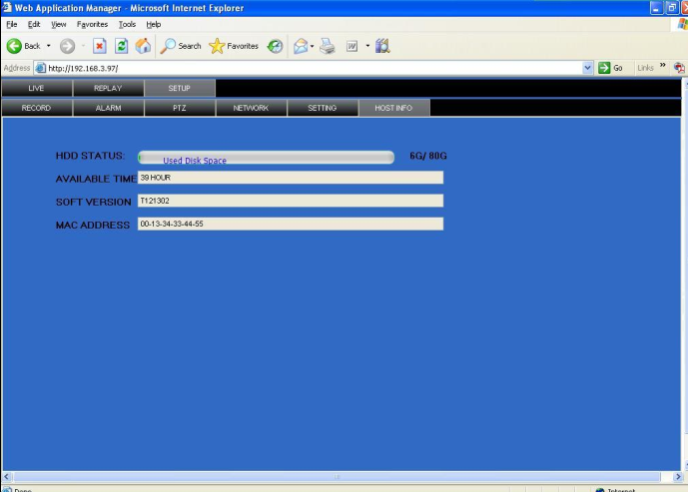

DVR INSTALLATION

PRODUCT OVERVIEW
1. Product Photo

2. The Definition of Bottons and Connectors on Front Panel

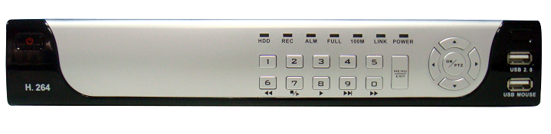

Buttons on Front Panel

＃ | Button | Name | Description
1 | Power | STANDBY | POWER/OFF, boot up DVR or shutdown DVR
2 | Control Keys | Navigation | During the setting for GUI, use these bottons for choosing differents items on menu. And also control the direction of PTZ.
2 | Control Keys | ENTER | Confirm
2 | Control Keys | SETUP | Entre into the setup menu
2 | Control Keys |  | For vision to be Singnal image or QUAD
3 | Status LED | REC | recording
3 | Status LED | ALM | Alarming
3 | Status LED | ERR | Error indicator
3 | Status LED | FULL | LED flashing means HDD is full
3 | Status LED | HDD | HDD status (on means HDD normal)
3 | Status LED | 100M | ON means 100M network transmission
3 | Status LED | LINK | ON means network connection is OK
3 | Status LED | POW | POWER
3 | Receiver | IR | Receiver for remote control signal
4 | USB | USB2.0 | for download and upload data
5 | USB | USB1.1 | for mouse connect

3. The definition of buttons and connectors on frear panel

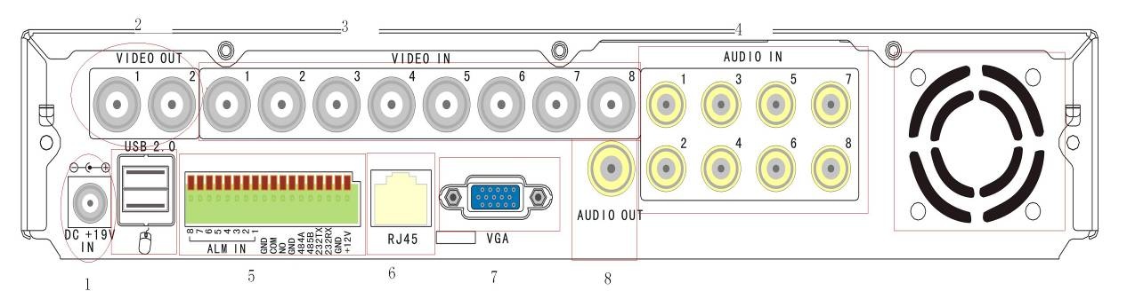

Connectors on Rear Panel

Item | Physical connector | Connector description
1 | POWER input | DC 19V/3A
2 | Video output | Two video output for connecting TV or monitor (BNC)
3 | Video input | For connectiong analog video signal input (BNC)
4 | Audio Input | For connecting aidio signal
5 | Alarm Input | I/O alarm input, 4 for 4CH DVR and 8 for 8CH DVR
5 | Alarm Output | I/O output for alarm
5 | RS485 | RS 485 for connecting PTZ
5 | RS232 | For connecting PC
5 | +12V | Power supply for DC relay and the current is 1.0A (make sure short circuit can not happen)
6 | Network | For connecting Ethernet
7 | VGA | For connecting VGA monitor
8 | Audio Output | For connection audio output
9 | Fan | Please check the fan function for diary maintance and change new one if the fan has some problems

4. Connectors for Alarm
Peel off the color skin of the cable and then insert the cable into the slot on the rear panel DVR (The connection part for alarm).

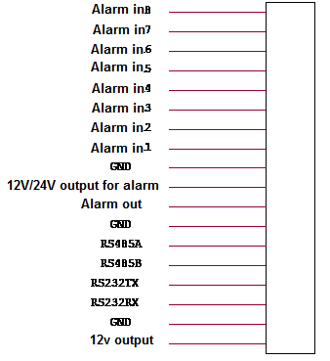

5． Alarm Input and Output

There are 8 sets alarm input connector and 1 set output for this DVR. Alarm input is for connection IR annunciator, fog sensor. The connection diagram of DC alarm inout as following:

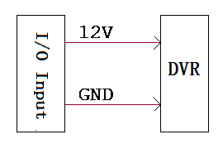

Connection diagram of AC alarm input as following:

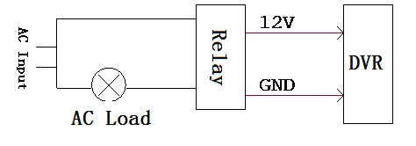
The connection diagram of alarm output as following:

RELAY
220V AC
12V
24V
DVR I/O output

COM
NO

6. System Network Diagram

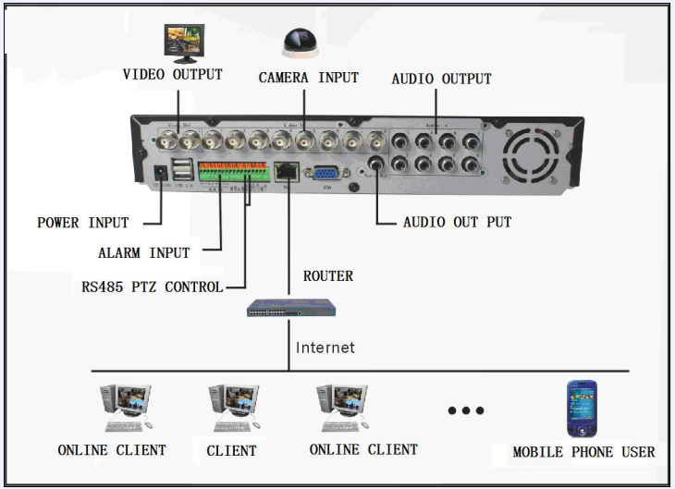

HDD INSTALLATION
Please installation the HDD as the following steps:
1）Uninstall the DVR and then you will see one HDD plate as following.
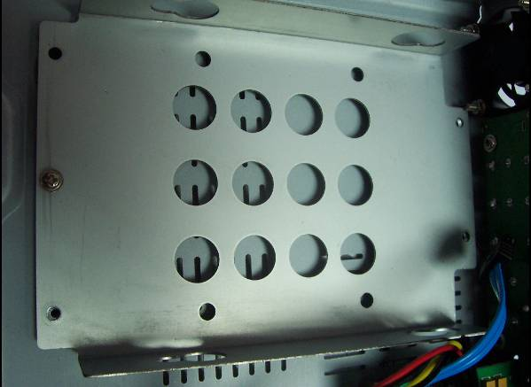

2）Take out the anti-vibration mat and screws from the accessories box

.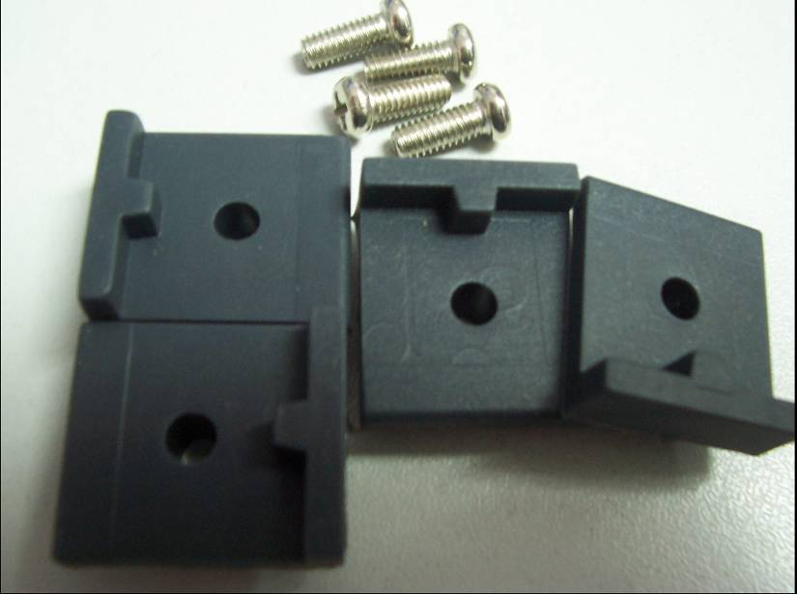
3）Take off the HDD plate and then install the anti-vibration mat on the plate and then screw on it.

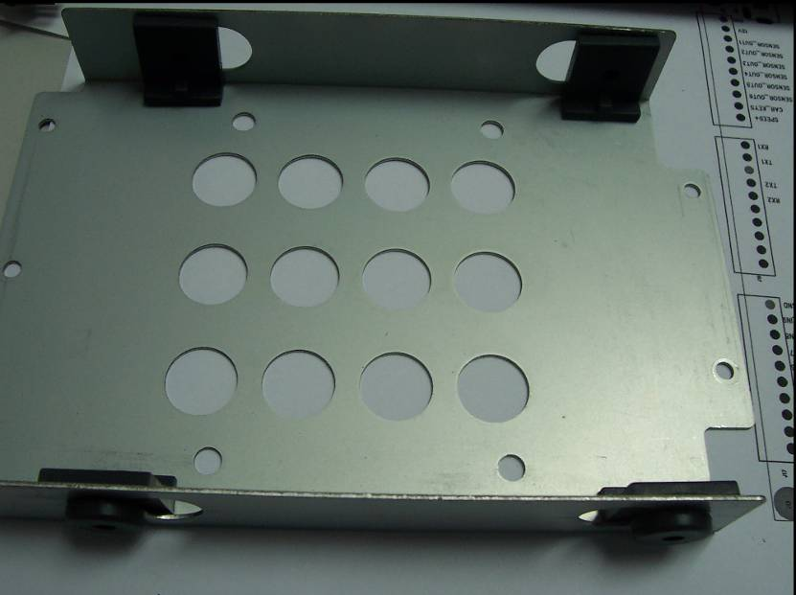

4）Install the HDD on HDD plate as the following photo indicate and then screws around.

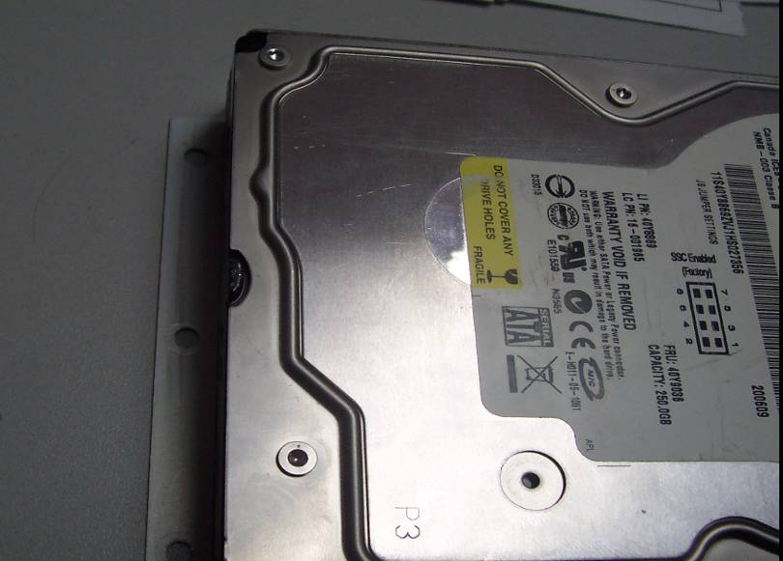
5）Fix the HDD plate on the DVR device and then cover the DVR and screw.

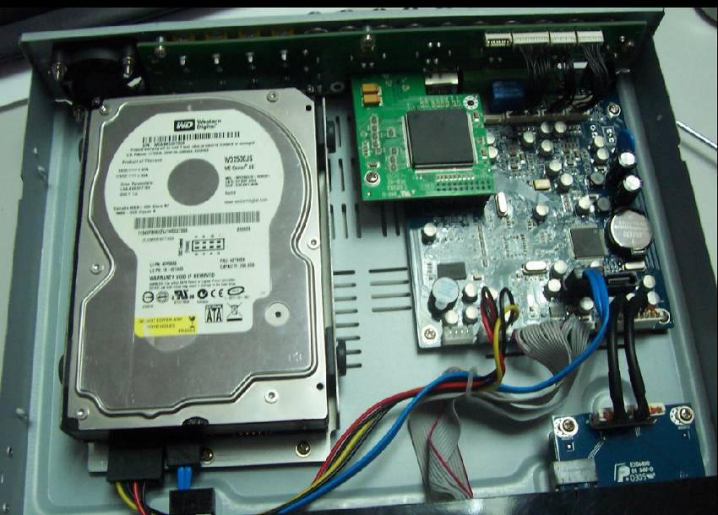
Remark: Please format the new HDD before record.

FAQ
  - Q:After connect power supply, device can’t start-up normally
A:
    - Power supply is incorrect, “+” and “-” are jumbled.
    - The connection between DVR and power is unstable.
    - Power supply has broken
    - Firmware upgrades error.
    - Main board has broken.

  - Q: Device always shutdown automatically or crash.
A:
    - Power supply is unstable or too low.
    - HDD or IDE port has broken.
    - The power is not enough.
    - Video input not stable.
    - The connection between main borad and others is unstable.
    - Hardware may have something wrong.

  - Q:No video output
A：
    - Please check the power of video input whether is ok.
    - Please make sure the vedio cable connection to DVR is ok.
    - Please check the brightenss of video whether is 0, and then try to restore default setting.
    - No video signal input or too weak.
    - Live view is OFF in DISPLAY menu.
    - Hareware has broken.

  - Q: Device is not recording and showing an “H” in live view.
A:
    - Make sure you are using DC 19V power adapter for DVR.
    - Make sure the HDD has formatted in device.
    - The power line or date line may have broken.
    - HDD has broken.
    - The SATA interface has broken.

  - Q: What is the meaning when show a “R”“M”“I”“H” in live view.
A：
    - “R” means device is recording now.
    - “M” means this channel has triggered motion detect.
    - “I” means this channel has triggered I/O alarm.
    - “H” means no HDD or HDD is full.

  - Q: Some problems about real time video, such as video color, brightness distortion and so on.
A：
    - Please select the correct video type, NSTC or PAL.
    - The impedance between DVR and monitor is not match.
    - The transmit distance is too long and the signal has much attenuation.
    - The setting for color and brightenss is incorrect.

  - Q: No audio output.
A：
    - Please check the audio input whether is ok.
    - Make sure you have opened audio input switch.
    - Hardware broken.

  - Q: Live view has audio, but no audio in playback.
A：
    - Audio record switch is not open.
    - Make sure the mute switch in playback is off.

  - Q: Date/time is incorrect.
A：
    - Didn’t prss “MODIFY SYSTEM DATE/TIME” when you changed the date and time.
    - The battery may have something wrong, please replace it.

  - Q: Can’t control PTZ.
A：
    - The PTZ may have something wrong.
    - The setting about decoder, connection, and installation is incorrect.
    - The connection is wrong.
    - The settings for PTZ in DVR is incorrect
    - The protocol between DVR and PTZ is not match.
    - When connect a number of encoders,a 120 Ohm resistor is required to offset the reflection and impedance matching, otherwise the PTZ control will be unstable
    - Distance is too long.
  - Q: Why can’t stop recording by prss “stop recording” in the right key menu of the mouse?
A：The “stop recording” is to stop manual recording, can’t stop ignition REC and timer REC.

  - Q: A/V storage of each channel.
A：
    - Audio storage of each channel is about 14Mbyte.
    - Video storage of each channel.
Recording time:60 Minutes
Resolution | Quality | DVD Video input | Camera video input
（D1） | Best | 454M | 426M
（D1） | Fine | 353M | 361M
（D1） | Normal | 246M | 238M
（HD1） | Best | 472M | 466M
（HD1） | Fine | 359M | 342M
（HD1） | Normal | 245M | 244M
（CIF） | Best | 354M | 337M
（CIF） | Fine | 250M | 234M
（CIF） | Normal | 194M

  - Q: Motion detecting function is not working.
A：
    - The MD area didn’t setup.
    - Sensitivity is too low.

  - Q: Copy record files and USB backup error.
A：
    - When the file you selected is much larger than the storage of the backup device, which will occur error.
    - The buckup device is not compatible with DVR.
    - The backup device may have broken.

  - Q: I/O alarm is not working.
A：
    - The setting for alarm is incorrect.
    - The connection is incorrect.
    - I/O PWL input is incorrect.
    - One I/O alarm input is in two circuitrys at the same time.

  - Q: The IR control can’t control DVR.
A：
    - The distance between IR control and DVR is too long or the angle is incorrect.
    - The battery may have use up, please try abother one.
    - The IR control or the front panel of DVR has broken.
  - Q: Can’t login IE browser.
A：
    - Make sure the network is ok, and check the LINK/100M LED whether is ON; try to ping the IP of DVR to check the network.
    - Windows XP or Vista and IE 6.0 or IE 7.0 is recommended.
    - Please install ActiveX control when you login.
    - Make sure your display card drive is ok.

  - Q: The video of IE live view is not clear or no video.
A：
    - If you are access to DVR via internet, please select WAN when you login, and select the correct bandwidth for your network in Setup>>System setup>>network.
    - Please try to close the window then open again.

  - Q: Why there is a box says “Other user is configing” when sutup in IE client?
A： Maybe there is an clinet or user operating GUI, so please make sure the DVR is at live view status and no one is setting in DVR.

