ED 1000PI | create printable version
Strung universal pt regimuri grele de lucru

- heavy industrial machine with cast iron machine bed
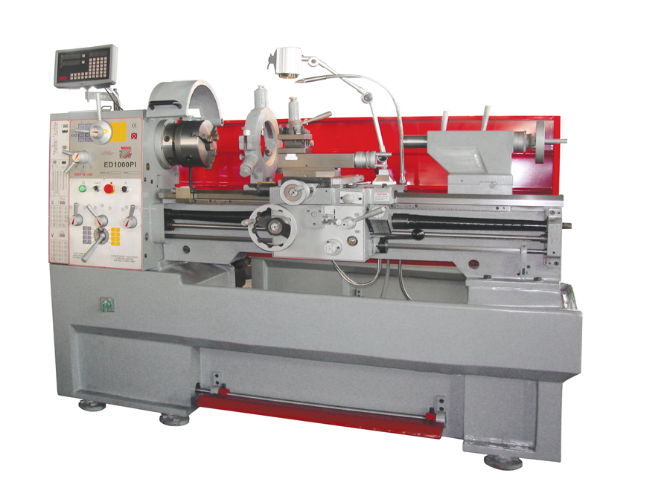
- wide (250mm) and inductively hardened as well as grinded machine bed
- lead screw cover ensures a long durability
- handy and easy operation via clearly designed control panel
- removable bridge allows large turning diameters
- all gliding machine elements can be fine adjusted via V-ledges
- professional CAMLOCK D1-6 retainer
- tail stock can be eccentrically adjusted for special works
- oil bath gear lubrication with hardened, grinded gear wheels
- huge spindle bore (DM-5mm)
- food brake as well as an automatic brake system of the spindle
- machine can handle a wide range of different threads without changing to different thread gear wheels
- halogen lamp and cooling system standard
inclus in dotare standard: universal cu 3 bacuri Ø200mm, universal cu 4 bacuri Ø250mm, platan frontal Ø350mm, reductie MT6/MT4, disp. automat cu arc pt filetare, suport scule pt. 4 cutite, dispozitiv de racire cu pompa, lampa halogen, set roti dintate de schimb, scule pt service, aparatoare mobile pt. protectie universal, aparatoare protectie stropire, disp. frinare la picior, 2 fixed centre points MT4, steady rest aperture 15-160mm, follow rest aperture 14-70mm, stand, revolving fence with fine adjustment function,
accesorii: sistem de afisaj numeric 3-axis DRO, set scule pt strunjire 16mm, mandrina port burghiu MT4/B16, trusa de masurare si trasaj
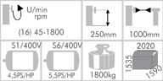
Diametrul maxim de strunjire peste ghidaje batiu | 410mm
Diametrul maxim de strunjire peste masa mobila | 250mm
Diametrul maxim de strunjire fara placutele de sub universal | 590mm
Diametrul alezajului din universal | 52mm
Distanta maxima la strunjire intre virfuri | 1000mm
Turatia arborelui principal | De la 45 la 1800 rot/min
Nr trepte de viteza | 16 trepte
Conul capului rotativ din universal | MT6
Sistemul de retinere si prindere in capul rotativ | Camlock ASA D1-6”
Gama de avansuri longitudinale | 0,05 – 1,7mm/rot.
Gama de avansuri transversale | 0,025 – 0,85mm/rot.
Cursa maxima de avans longitudinal | 120mm
Cursa maxima de avans transversal | 210mm
Filet normal– metric (39 pasi) | 0,2 – 14mm/r
Filet englez - Inch (45 pasi) | 72 – 2Gg/1
Filet trapezoidal (21 pasi) | 8 – 44
Filet modular (18 pasi) | 0,3 – 3,5
Conul papusii mobile | MT4
Cursa pinolei papusii mobile | 120mm
Dimensiune support port cutite ( 4 pozitii) | 20mm
Putere motor principal | 5.5CP/4.5kW, 3faze 400V
Putere motor auxiliar
Dimensiuni de gabarit ( lungime x latime x inaltime) | 2020x1590x1535mm
Greutate neta | 1800Kg.

