
The standard equipment allows you to produce end bards with different designs on round, square and flat bars and tubes.
For cold forming we have to consider the tensil strength (45 Kg/mm2 maximum), the type and the diameter of the material.
For hot forming we have to use a gas forge to get the appropiate temperature.
Production:
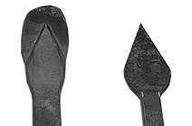
MATERIAL CAPACITIES
Grooved end bars (cold) | Up to 10x10mm.  3/8" x 3/8" | Up to 10mm.  3/8" | Up to 20x5 mm.  3/4" x 0.25"
Forged end bars | Up to 20x20mm.  3/4" x 3/4" | Up to 20mm.  3/4" | Up to 30x10mm.  1 - 1/4" x 3/8"
Embossed Central bars | Up to 20x20mm.  3/4" x 3/4" | Up to 20mm.  3/4" | Up to 30x10mm.  1 - 1/4" x 3/8"
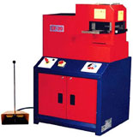
Plain and grooved end bars.
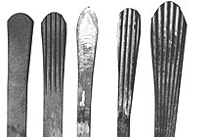
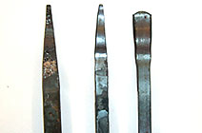
Wavy end bars
Arrow points
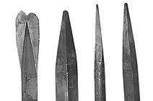
Pyramidal end bars
Wide end bars
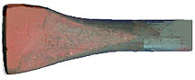
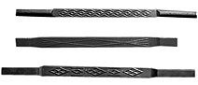
Embossed central bars with different designs

