ROLLFORMERS
CONNECTIONS
These machines MUST be connected by a qualified electrician. Wiring is completely installed except for the power supply. Once connected, check that the rolls are rotating in the correct direction . Reverse the motor leads if necessary.

LUBRICATION
There are grease nipples at the starter end of the machine. These should be greased approximately every week with a medium bearing grease or more often, dependant on frequency of operation. Also we recommend that the machine should be checked regularly for any damaged or worn parts and the side plate bearings and forming rolls should be sprayed with a medium oil.

ISOLATE MACHINE FROM MAINS BEFORE REMOVING ANY GUARDS

MATERIAL
Depending on the machine you have, please see the table below for the minimum and maximum thickness of metal that can be used
If very short lengths are required , form a longer length first and cut after forming .
Please note that we can not recommend the use of plasma cut material on these machines, as this could result in serious damage to the machine and will invalidate any warranty.

Before forming any metal, other than rollforming quality mild steel, please check with the manufacturer about capacities and settings.

All the capacities given below are for Rollforming quality mild steel
MODEL:- | 16s (1.6) | 20s (1.00m) | ‘ S ‘  CLEAT | BUTTON PUNCH
Pittsburgh Lock | 0.8 -1.6mm | 0.5 -1.0mm
Double Seam | 0.8 -1.6mm | 0.5 -0.8mm
Drive Cleat | 0.5 -1.0mm | 0.5 -0.8mm
Plain Seam | 0.5 -1.0mm
Standing Seam | 0.5 -1.0mm
Right Angle Flange | 0.8 -1.2mm | 0.5 -0.8mm
Button Punch |  |  |  | 0.5 -1.0mm
Flat ‘S’ Cleat |  |  | 0.5 0.7mm
Small Pittsburgh Lock | 0.5 -0.8mm
Safe Edge | 0.5 – 1.0mm
DIAL GAUGE ( 16g / 1.6mm machine only)
- Screw the dial gauge completely down i.e. clockwise.
- Turn the gauge one complete turn anti clockwise until “S” is facing.
- The dial gauge is now set for 20swg (1.00mm)
- For thicker gauges turn the dial anti clockwise
- For thinner gauges turn the dial clockwise.
Please note that the markings on the dial gauge are only approximate and should you find the metal not exiting the machine, then slightly turn the dial anti clockwise.
Incorrect setting of the dial gauge could result in damage to the opening roll.

IMPORTANT
The opening rolls fitted to these machines, by virtue of design and work it as to do, are vulnerable to damage if care is not taken. The dial gauge as to be set correctly and the sheet at the in feed end must be flat, particularly if a notch has been cut. Any curling up at this stage may cause the metal to strike the opening roll causing damage.
OPERATION
Place the metal to be formed against the in feed guide fence. Slide the metal into the forming rolls ensuring the material is held against the fence until the tail end of the sheet as passed into the machine. Support the sheet when the material is exiting the machine. If the knock over edge is to small or to large, the in feed guide will have to be move to suit your requirements. Before moving, note the position. After making any adjustments to the in feed guide fence, make sure that the exit guide fence does not obstruct the exit of the material. ( Please see ‘Guide fence Settings’ )
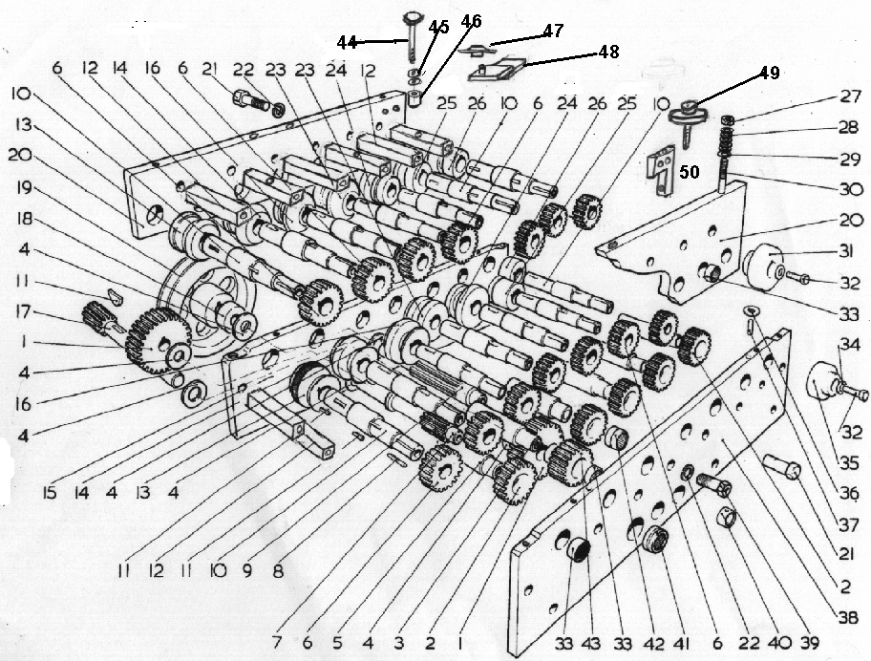
16s ROLLFORMER
1. Large drive gear |  | 2. Narrow idler gear
3. Wide idler gear |  | 4. Glacier washer
5. Narrow idler gear |  | 6. Forming roll shaft gear
7. No.3 drive shaft |  | 8. Key
9. No.1 drive shaft |  | 10. Forming roll shaft
11. Key |  | 12. Spacer
13. Forming roll |  | 14. Forming roll
15. Left hand bottom side plate |  | 16. Forming roll
17. No. 2 drive shaft |  | 18. Pulley spacer
19. Top head spacer |  | 20. Top side plate
21. Side plate bolts |  | 22. Locking washer
23. Forming roll |  | 24. Forming roll
25. Forming roll |  | 26. Forming roll
27. Locking nut |  | 28. Spring washer
29. Plain washer |  | 30. Pressure stud
31. Auxiliary rolls |  | 32. Locking screw
33. Side plate bearings |  | 34. Locking screw
35. Auxiliary rolls |  | 36. Shims
37. Dowel |  | 38. Right hand bottom side plate
39. Grease bolt |  | 40. Drive shaft bearing
41. Drive shaft bearings |  | 42. Idler gear bearing
43. Wide idler gear |  | 44. Large pressure stud
45. Spring washer |  | 46. Saddles
47. Opening roll |  | 48. Opening roll bracket
49. Dial gauge |  | 50. Dial gauge bracket
FLANGING ATTACHMENT
1. Top plate |  | 2. Bevel gear
3. Bevel pinion gear |  | 4. Bevel gear pinion shaft
5. Main drive shaft |  | 6. Bearing
7. Dial gauge |  | 8. Locking handle
9. Dial gauge screw |  | 10. Dowels
11. Swing head bracket |  | 12. Flanging block
13. Side plates |  | 14. Oilite bush
15. Bevel gear |  | 16. Oilite bush
17. Knurled roll |  | 18. Knurled shell
19. Lifter button |  | 20. Locking nut
21. Bearing

GUIDE FENCE SETTINGS

5 Station Machine ( 20s Machine )
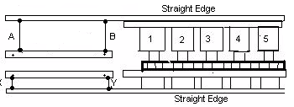
7 Station Machine (16s Machine)
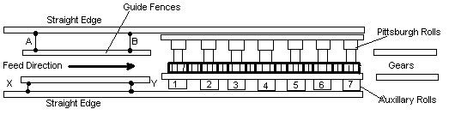

9 Station Machine
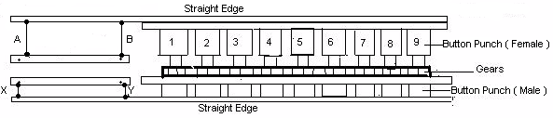

9 Station Machine Double Extended Shaft
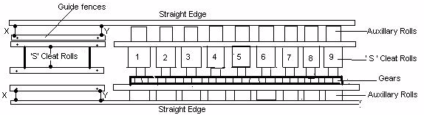
 |  | 20swg (1.00mm ) | 16swg (1.6mm )
Pittsburg Lock |  | 2.437 (62mm) | 3.062 (77.5mm)
Double seam (acme) rolls |  | 1.031 (26mm | 1.250 (32mm)
Right angle flange rolls |  | 1.00 (25mm) | 1.250 (32mm)
Standing seam
Auxillary Pittsburgh lock rolls |  |  | 2.000 (50mm)
Drive cleat rolls. Strip width |  | 2.125 (54mm)
Button punch ( female ) rolls |  | A = 3.187 (81mm) & B = 3.125 (79mm)
Button punch ( male ) rolls |  | X = 1.00 (25mm) & Y = 0.938 (24mm)
S ' Cleat rolls. Strip width |  | 3.625 (92mm)
PLEASE SEE ‘MATERIAL’ FOR MAXIMUM METAL THICKNESS

Guide Fence Settings (continued )

Press a straight edge up against the auxiliary rolls or against the side plates and set the guide fences to the sizes given above. The dimensions given are only approximate and may be slightly different to your requirements. For example. If the knock over edge on the pittsburgh lock is to big, reduce sizes A & B until the required size is reached.
After re-setting any guide fences, first test with a piece of scrap material. If the material runs off it may be necessary to slightly adjust the pressures. If the material still runs off, then lightly increase A or X. After making any adjustments to the in feed guide fences, DO NOT forget to adjust the exit guide fences. All dimensions are approximate.
___________________________________________________________________________________

