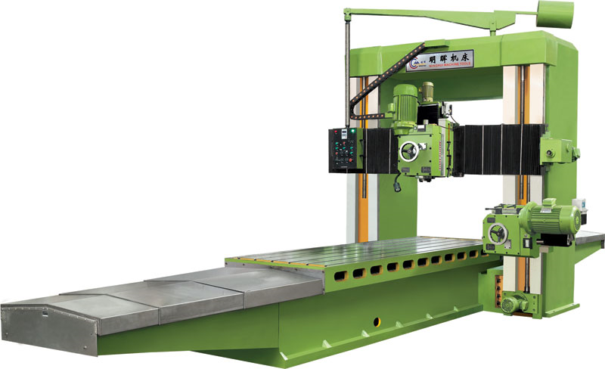Standard Accessories 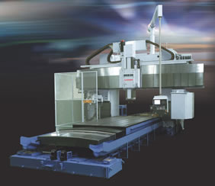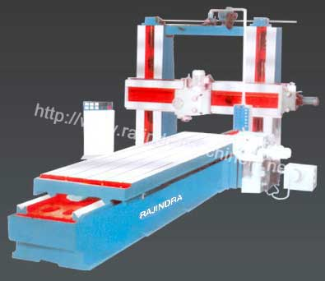

Spe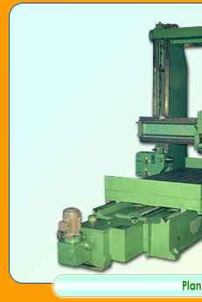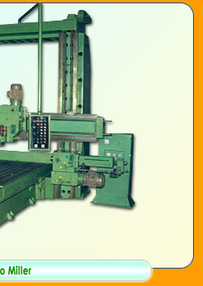cial Accessories a

t Extra Cost
Stepless table feeds & rapid system
Speed range covers both carbide & H.S.S. tools
Fixed or swivel head up to 45°
Suitable for Milling, Drilling, Facing, Boring & Grinding
Safety clutches for electrical & mechanical interlocking is provided for preventing trouble due to faulty operations
Automatic lifting & lowering of cross rail
Forced lubrication for guideways & gearboxes
Rapid operation to cross traverse of the milling head.

Extra Milling head on cross rail
Boring head on either of side columns
Grinding head on cross rail
Automatic locking of the cross rail
Extra milling head on either or both the columns
Bellow covers to the guideways
Optical read out
Right angle milling attachment.
Digital Read out..

Plano Miller Special  Type Milling Head | Plano Miller for machining  of Lathe Beds

Technical Specificaion of the Milling Head
Model | 3 KW | 5 KW | 7.5 KW | 10 KW | 15 KW
Spindle Taper | ISO-40 | ISO-40 | ISO-50 | ISO-50 | ISO-50
Spindle Speeds | 6 No. | 9 No. | 9 No. | 9 No. | 12 No.
Speed Range | 70 to 400rpm | 57 to 368rpm | 45 to 300rpm | 45 to 300rpm | 45 to 370 rpm
Quill Travel | 100 mm | 100 mm | 130 mm | 130 mm | 150 mm
Spindle Dia. | 80 mm | 85 mm | 100 mm | 120 mm | 150 mm
Head Swivel | + 45° | + 45° | + 45° | + 45° | + 45°
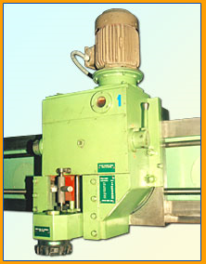

1. TECHNICAL DESCRIPTION
1.1. BASIC MACHINE
1.1.1. INTRODUCTION
The machine is intended for milling parts with large, flat surfaces and long slots as well as for simultaneous machining of more surfaces. It is fitted for machining workpieces of steel and cast iron.
The plano-miller consists of a cast iron bed. The machine table which accommodates the workpiece to be machined slides along the bed ways. The two columns placed on each side of the bed are rigidly secured to the bed at their lower side and joined together through a cross-beam, at their upper side. The bed, the two columns and the cross-beam make-up a frame which offers to the machine high stiffness. The right and left-hand horizontal milling heads and the cross-rail slide along the columns guideways. The right and left-hand vertical milling heads move along the cross-rail longitudinal guideways.
The machine controls are centralized on a pendant control panel located at the right-hand side of the machine. The machine can be also operated from its left-hand side, since it is provided with another control panel with the respective controls.
The electrical equipment of the machine is placed inside an electric cabinet, nearby the machine, to the right-hand side of the machine.
1.1.2. MILLING HEADS
The milling heads carry out the main cutting movement. The gearbox is made up of a kinematic gear train consisting of heat treated gears driven by an electrical asynchronous motor of 30 kW. The working speeds are shifted with manually driven sliding gears; a speed range from 12.5 to 630 rpm, in 18 steps, can be thus obtained. The main spindle is carried in radial bearings with cylindrical rollers with a taper bore and precision axial ball bearings. The main spindle is placed inside a quill having a travel of 300 mm. The quill feed can be manually achieved with a hand-wheel as well as mechanically, by means of an electrical motor; in the last case the quill feed rate is 500 mm/min. The milling head has the possibility to rotate as related to the normal (horizontal or vertical) position, to +_ 45 degrees. The milling head inclination is achieved with an electrical motor. A ruler and a vernier are provided for reading the inclination angle.
1.1.3. FEEDS OF THE MILLING HEADS
The feed movement of the horizontal milling heads along the guideways of the columns is accomplished through a feedbox placed at the lower side of the right-hand column, inside the column. The milling heads can be operated either simultaneously or independently. The six-speed feedbox provided with sliding gears is driven by a two-speed asynchronous electrical motor. A feed range from 24 to 480 mm/min, in 12 steps, can be obtained. The feed movement of the vertical milling heads, along the cross-rail guideways is performed by means of a feedbox placed at the right-hand end of the cross-rail. The vertical milling heads can be also operated either simultaneously or independently. The feedbox with sliding gears in 6 mechanical steps is driven by a 2-speed asynchronous electrical motor and provides 12 feed steps, from 24 to 480 mm/min.
1.1.4. CROSS-RAIL
The cross-rail is a casting with a vertical rapid traverse of 600 mm/min. The rapid traverse is performed with a reducing mechanism located inside the cross-beam.
The movement of the cross-rail as well as the movement of the milling heads are performed by means of a trapezoidal thread screw and bronze nuts.
The milling heads slides, the quills and the cross-rail are provided with hydraulic interlocks. The hydraulic panel is placed on the cross-rail, behind it. The working pressure is 100 daN/cm².
1.1.5. BED AND TABLE
The bed and the table are heavily ribbed castings which offer high stiffness with time.
The table feed is performed by means of a D.C. electrical motor and an electronic servo-motor. The rotational movement is translated into translational movement by means of a worm and worm rack mechanism. The table working feed ranges is from 2 to 2000 mm/min, with stepless adjustment during operation.
The table feed mechanism is supplementarily provided with a worm to take-up backlash at cut-down milling.
The table guideways are coated with a plastic material to diminish friction and increase the operating life of the guideways.
The lubrication is centralized and automatic. Graduated rules and verniers of 0.1 mm accuracy are provided for measuring the strokes.
1.1.6. ELECTRICAL SYSTEM
The electrical equipment of the plano-miller consists of driving, control and protection conventional devices such as driving contactors, control contactors, time relay, thermal relays, fuses, automatic switches, etc.
The electrical equipment consists of :
- electrical cabinet;
- pendant control panels;
- electrical equipment placed on the machine.
The electrical cabinet has compartments which each accommodates a counter panel with driving, control and protection equipment. The main switch of the machine, which is operated with a handle from the outside, is placed on the front wall of the electrical cabinet. The
cabinet doors are provided with microswitches which prevent the cabinet from being energize while one of the door is opened.
The pendant control panels contain the control, signalling and checking elements for the operator to command and surveil the machine operating. The machine controls can be initiated from either of the two control panels of the machine, that is either from the right-hand side, or from the left-hand side.
The electrical equipment on the machine is made up of the sets of connection conductors and electromechanical driving and checking elements, such as D.C. and A.C. motors, electromagnetic brakes and clutches, electrovalves, pressure switches, level indicators, microswitches. Connection couplings are provided for the electrical connections to the milling heads and the cross-rail.
The whole electrical system has been designed and built so as to provide the good operating of the machine in conditions of high safety and reliability.
1.1.7. COOLING SYSTEM
When steel parts are machined, a cooling system is required. It consists of a tank located in the machine bed, a pump with a max. flow rate of 100 l/min and the related piping.
1.2. SPECIAL ACCESSORIES
1.2.1. Angular milling head
The angular milling head is mounted on one of the vertical milling heads and it is driven by the last one. The angular milling head facilitates the milling of vertical surfaces difficult to machine with the 4 standard heads of the machine as well as milling of surfaces impossible to be machined with these four standard heads, such as the front faces of the long parts. The angular milling head has two ISO 60 tapers for tool clamping (at 180 degrees from each other) and has the same speed range as the vertical milling head on which it is mounted. The distance from the clamping flange to the main spindle of the angle milling head is 450 mm.
1.2.2. Indexing angular milling head
The indexing angular milling head displays the same size and features as the above mentioned one, with the only difference that it can be indexed in 4 positions (4 x 90 degrees).
2.TECHNICAL DATA

Table
- Width | mm | 1600
- Useful length | mm | 4250
- Total length | mm | 5930
- Number of T-slots |  | 9(+2)
- Width of T-slots | mm(H7) | 28
- Length between T-slots | mm | 145
- Maximum load | kg | 15000
- Maximum load | mm | 1045
- Longitudinal travel | mm | 5185
- Working feed rate, steples | s mm/min | 2-2200
- Approaching feed rate | mm/min | 300
- Positioning feed rate | mm/min | 2
- Rapid traverse | mm/min | 4000
- Driving motor torque | Nm | 90

Milling heads
- Number of vertical heads |  | 1
- Number of horizontal heads |  | 2
- Maximum vertical travel of the  horizontal head | mm | 1250
- Maximum horizontal travel of  vertical head | mm | 2370
Number of feed steps |  | 12
- Inclination angle of heads | dgrs | +/-45
- Working feed range | mm/min | 24-480
- Rapid traverse of horizontal head | mm/min | 600
- Rapid traverse of vertical head | mm/min | 860
- Horizontal head feed motor power | kw | 10/13
- Vertical head feed motor power | kw | 5,2/6,5
- Main spindle diameter, in  front bearing | mm | 160
- Number of main spindle  speed steps |  | 18
Main spindle speed range | rpm | 12.5-630
- Gearbox driving motor power  (per each head) | kw | 30
- Tool clamping taper according  to DIN 2079 standard | ISO | 60
- Quill diameter | mm | 270
- Quill travel | mm | 300
- Quill rapid traverse | mm/min | 500

Cross-rail
- Vertical travel | - | 1300
- Rapid traverse | mm/min | 600
- Driving motor power | kw | 15

Functional distances
- Length between columns | mm | 2050
- Length from columns to  table edge | mm | 225
- Min/max length between the  table surface and the horizon-  tal head main spindle axis | mm | 0/1250
- Min/max length from table  surface to cross-rail | mm | 425/1600
- Min/max length from the table  surface to the frontal surface  of the vertical head main spindles | mm | 0/1460

Overall dimensions
- Length | mm | 12800
- Width | mm | 5800
- Height | mm | 5850
- Approximate net weight | kg | 83000

Electric equipment
Electric equipment | kw | 180
- Operating voltage and frequency | 415 V/220 V +_ 10 % / 50 Hz
3. DELIVERY SET
3.1.Basic machine, as described under item 1.1.
3.2.Standard accessories
The following standard accessories are included in the price of the basic machine:
3.2.1. Spanners for servicing and maintenance of the machine
3.2.2. Hand pump for grease
3.2.3. Levelling blocks for machine setting on the foundation
3.3.Special accessories, as described under item 1.2.
The following accessories can be supplied against extra-price:
3.3.1. Angular milling head
3.3.2. Indexing angular milling head
3.3.3. Universal milling head
3.3.4. Chip conveyor
4.PAINTING
The colour of the paint shall be decided upon according to the technology of Manufacturer and the request of the Buyer.

