POWER MANAGEMENT BOX SUITE

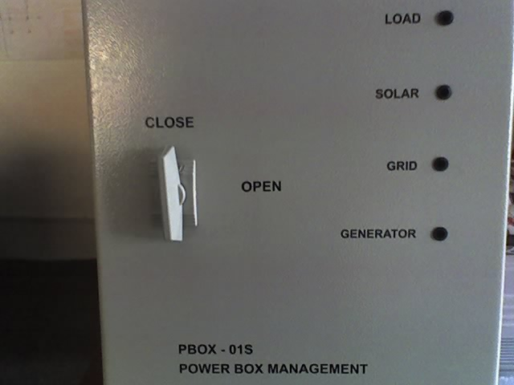

PBOX-01S
1-phase automatic switching unit, PV is prioritary, Grid & Generator are back-up.
Load power = 8 kW / 35 A,
Grid power = 8 kW / 35A,
PV-power = 8 kW / 35 A,
Genarator power = 8 kW / 35 A

PBOX-03S
3-phase automatic switching unit, PV is prioritary , Grid & Generator are back-up.
Load power = 24 kW / 3x35 A,
Grid power = 24 kW / 3x35A,
PV-power = 24 kW / 3x35 A,
Genarator power = 24 kW / 3x35 A

PBOX-01G
1-phase automatic switching unit , Grid is prioritary, PV & Generator are back-up.
Load power = 8 kW / 35 A,
Grid power = 8 kW / 35A,
PV-power = 8 kW / 35 A,
Genarator power = 8 kW / 35 A

PBOX-03G
3-phase automatic switching unit , Grid is prioritary, PV & Generator are back-up.
Load power = 24 kW / 3x35 A,
Grid power = 24 kW / 3x35A,
PV-power = 24 kW / 3x35 A,
Genarator power = 24 kW / 3x35 A

Common features:

- automatic switching
- in / out protected with fast power breakers (fuses)
- adjustable LVD (low voltage disconnect) to accommodate 12/24/48v PV system
- adjustable LVR (low voltage reconnect ) to accommodate 12/24/48v PV system
- start Generator before switching to load in order to reach nominal parameters
- adjustable time period needed by generator from start to switch
- selectable PV system type – 12/24/48v
- 4 LED display
- insulated metal case
- IP 55 protection

Prices : ( euro , VAT inclusiv )
PBOX-01S | 1250 | 1125 | 1000
PBOX-03S | 1535 | 1380 | 1228
PBOX-01G | 1280 | 1155 | 1024
PBOX-03G | 1580 | 1422 | 1265
Fob Ploiesti | 1 BUC | 10 BUC | > 25BUC

Delivery time:
Please contact us at: office@infolink.com.ro

