PLACI FIBROLEMNOASE
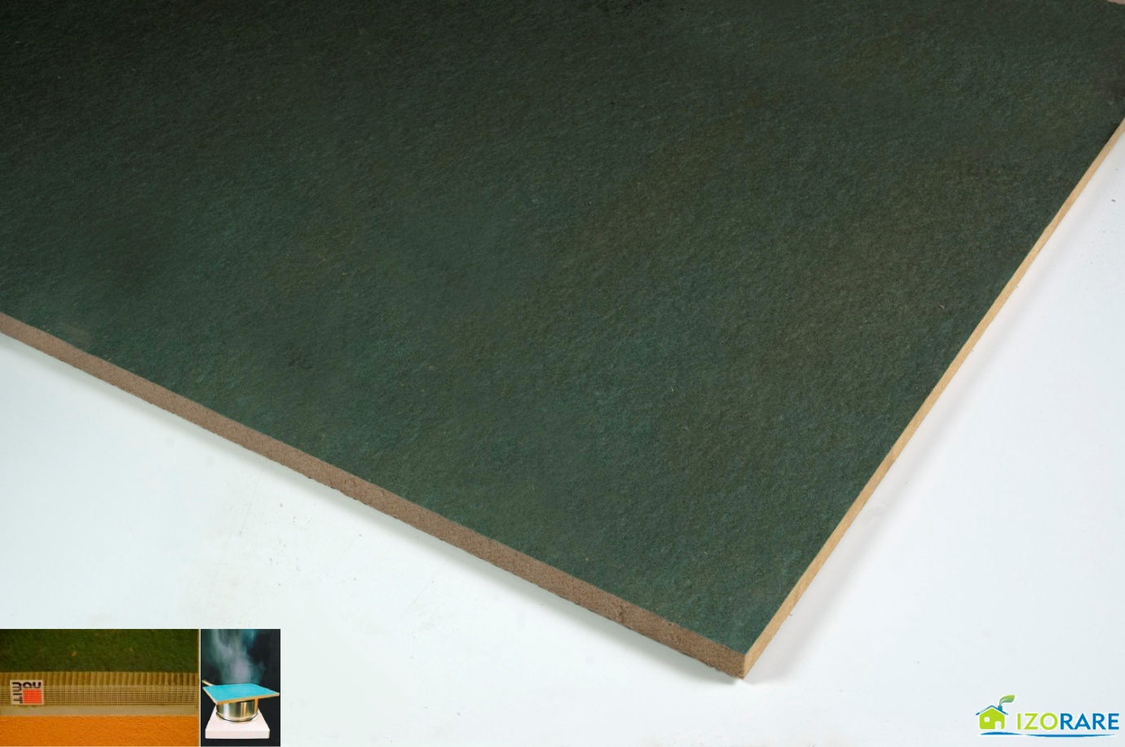

Informati :
- PROTECTIE EXCELENTA IMPOTRIVA ARSITEI
- PROTECTIE FONICA RIDICATA
- REGLAREA UMIDITATII
- CAPACITATE MARE DE STOCARE A CALDURII
- USOR DE PRELUCRAT
- REZISTENT LA PRESIUNE
- PRODUS ECOLOGIC
- IDEAL PENTRU PREFABRICARE A COMPONENTELOR SI ASAMBLARE PE SANTIER

IZOPLAC NATURAL STANDARD pt. interior
Grosime | mm | 12 ± 1.2 | 25 ± 1.8
Placi / paleta | buc | 90 | 45
Mp / palet | m² | 291,60 | 145,80
Latime | mm | 1200 ± 5
Lungime | mm | 2700 ± 5
Densitate | kg / m³ | ≥ 230 | ≥ 220
Conductivitate termica | W / mK | ≤ 0.045 - 0.050
Rezistenta la incovoiere | N / mm² | ≥ 1.7 | ≥ 1.3
IZOPLAC IMPREGNATE pt. exterior
Grosime | mm | 12 ± 1.2 | 25 ± 1.8
Placi / paleta | buc | 90 | 45
Mp / palet | m² | 291,60 | 145,80 / 162,00
Latime | mm | 1200 ± 5
Lungime | mm | 2700 ± 5
Densitate | kg / m³ | ≥ 240 | ≥ 230
Toleranta | mm/m | ± 2
Conductivitate termica λ10 | W / mK | ≤ 0.05
Rezistenta la incovoiere | N / mm² | ≥ 1.2 | ≥ 1.8
modul de elasticitate in indoire | N /mm² | ≥ 140 | ≥ 120
Umflarea in grosime | % | ≤ 6
Permeabilitatea la aer, ∆p 100 Pa | m³ / m²sPa | ≤ 25 x 10⁻⁶
Permeabilitatea la vapori | kg / m²sPa | 1,58 x 10⁻⁹ | 1,0 x 10⁻⁹
date tehnice
