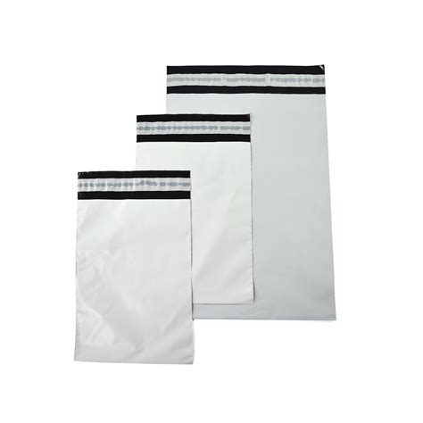
DIMENSIUNE IN MM | GROSIME | COMANDA MINIMA | PRET RON/1000 BUC
170X260+40 | 60 | 1000 | 180
230X230+50 | 60 | 1000 | 300
300X400+40 | 60 | 1000 | 400
350X450+50 | 60 | 1000 | 495
450X550+50 | 60 | 1000 | 720
500X500+50 | 60 | 1000 | 795
500X550+50 | 60 | 1000 | 805
700X500+50 | 60 | 1000 | 990

Preturile nu includ TVA.
Oferim livrare de pe stoc in 24/48 de ore de la plasarea comenzii.
Oferim transport gratuit la comenzi care depasesc suma de 1000 de ron.
Oferim discount cantitativ .La comenzi care depasesc 5,000 de bucati,oferim un discount de 15%.

