**Effective Technologies for an Effective Wellness State**

**The Healthy Lounge Chair®**

**Your unique back pain reliever and complete energizer**

**Health Lounge Chair®** it is an unique combination between a therapeutic chair and a chaise longue, specially designed for:

* physical but also psychological relaxation of the human body
* eliminate the killing back pains caused by spinal disorders
* energizing the organism, "repairing" the energy Aura
* regaining the state of well-being
* a very good and restful nap. <<read more>>

Include the most 2 effective technologies: Zero Gravity Position and Shungite Therapy. They provide **Healthy Lounge Chair®** the power to completely change the way you feel. Dare to switch just in few minutes:

* from killing pain to the utmost comfort!
* from crazy stress to perfect psychic and physical protection!
* from a dead-headed to a fully energized organism!
* from a distortionate Aura field to the most bright and colorful one!
* from the most unsettled to the most balanced person you know!

It's designed and built to perfectly fit into the ambience of:

* your living room
* first class airport lounge
* hotel lobby
* the relaxation areas of the malls, SPAs
* athlete's lockers.

Wherever someone could need few minutes of good rest and well being, the **Healthy Lounge Chair® it's the most suitable!**

**And The Golden Medals go to…**

**Healthy Lounge Chair®!**

**The Revolutionary Solution for your good shape!**

**Rewarded with 2 Golden Medals at the Invention Salon – International Society from Banat, Timisoara and at Euro Invent- European Exhibition of Creativity and Inventions Iasi, Romania,** <<read more>>

**The Healthy Lounge Chair®**

**is here to give you, in just few minutes a day, the back pain relief that you need. Mitigates and even puts an end to your sciatica or any other back pain derived from any condition caused by the compression of the vertebrae.**



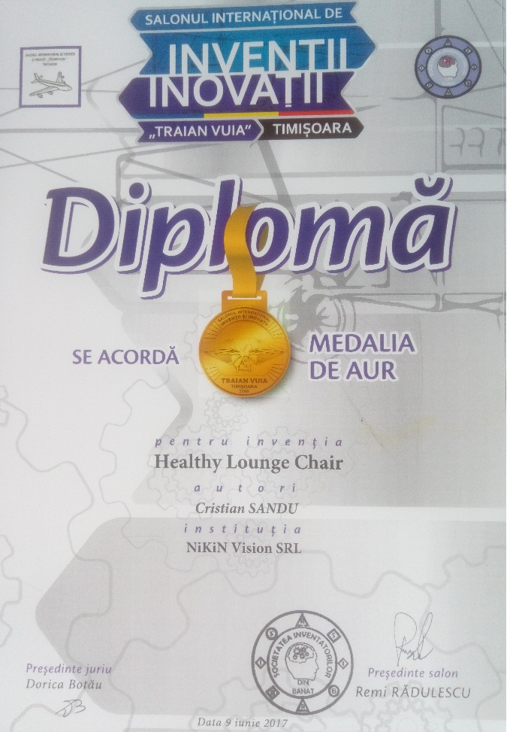

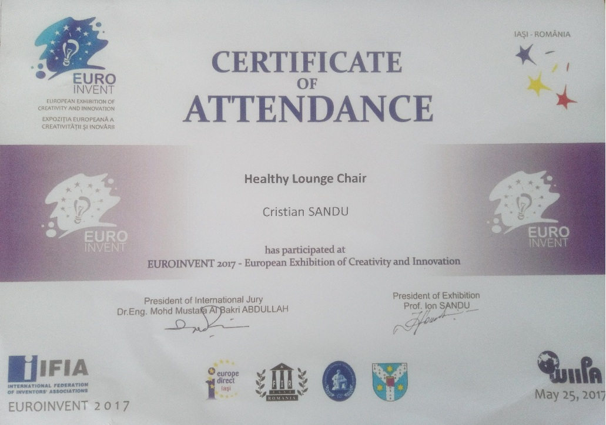

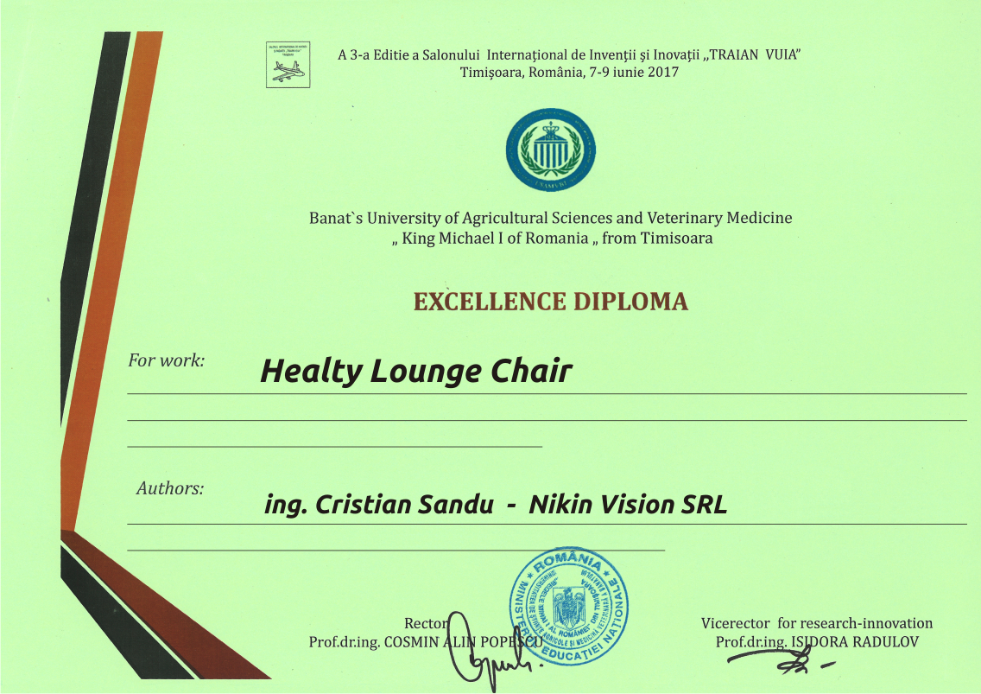

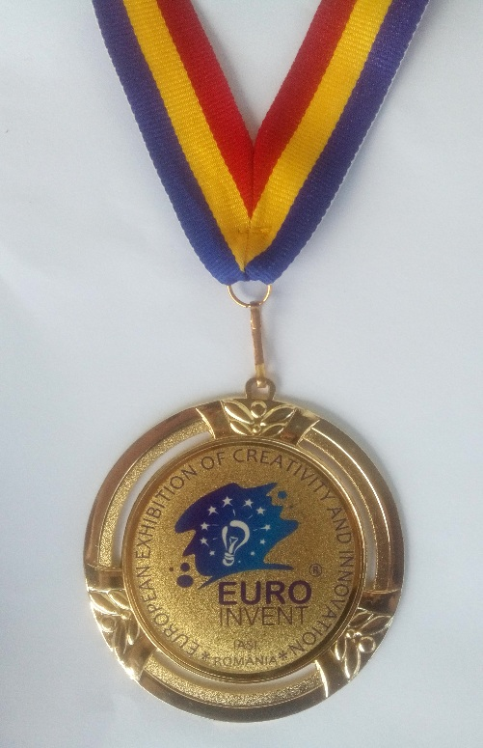

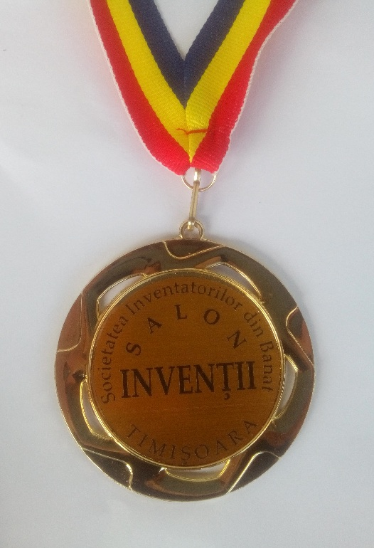

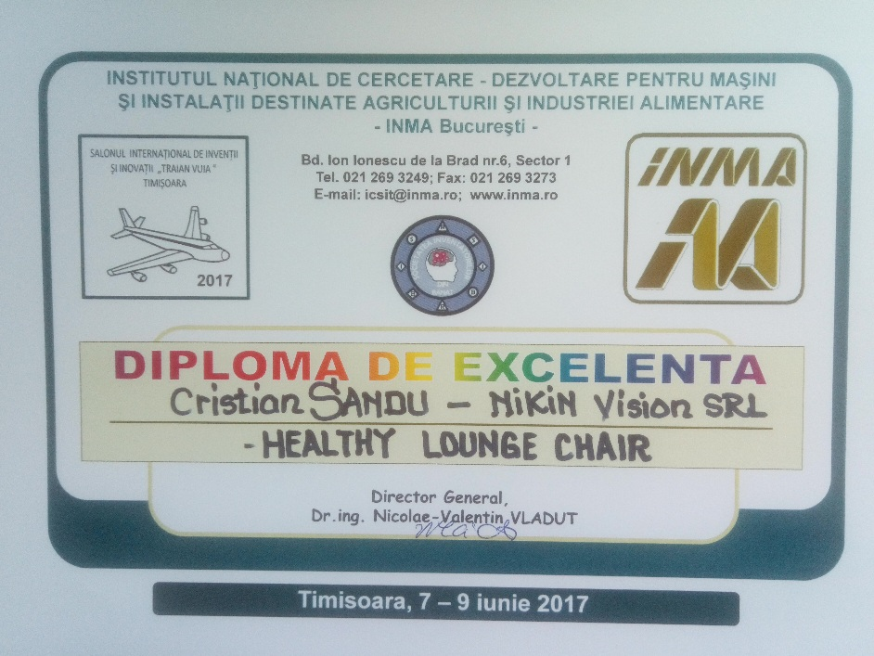

**Defy gravity in the very comfort of your home! Kill the pain that stresses your back!**

Get your perfect spine with **Zero Gravity Position!**

Was originally developed by NASA in their research of *Neutral Body Posture,* in their efforts to better prepare astronauts for the effects of gravity during launch and when orbiting earth. In this position, considered the body natural resting position, the spine is in the most relaxed and stable alignment hence giving utmost comfort. <<read more>>

Just a brief “flight” in this wonder position and you’ll feel its benefits instantaneously:

* relieved pressure on your spine
* improved blood circulation
* restored blood flow at the level of each disc
* regenerated discs, with regained volume so that they resume their function as shock absorbers
* reduced stress on your heart
* soothed muscle tension
* evenly distribution of your weight
* relaxed lungs for better breathing
* improved sleep quality.

Our zero- gravity chair embodies the latest research and smart ergonomics that promotes relief from back pain, endorsed by physicians as the healthiest way to sit. Manufactured piece by piece by woodcraft artisans, from oak or beech, after inspired plans of a modern architecture, **Healthy Lounge Chair®** combines old classic look with modern dynamic shape. Happiness both for the eye and for the spine! Over all - the perfect de-stressing tool! Prepare for the “flight” with

**Healthy Lounge Chair®!**

**Boost your energy level with Shungite Therapy!**

Shungite is a form of non-crystalline carbon which resembles nano-structure materials. What sets this stone apart from all the other crystals and minerals is the presence of *fullerenes* embedded within the stone itself, which are powerful anti-oxidants. <<read more>>

The energy embodied within this ancient stone (over 2 billion years old!) is said to absorb and eliminate anything that is a health hazard to human life, and it has **active metaphysical properties with strong healing powers.**

**Shungite** is a powerful stone that shields you from the electromagnetic radiation given off by electrical equipment, including computers, mobile phones, microwaves and televisions, which, please recognize, destroy our lives day by day**.**

Shungite is also used to bring Light into the Aura energy field, allowing positive energy only to reach within that field. This brings not only physical protection, but also psychic protection. It is said to calm, relax and energize anyone using or near it. In addition, Shungite gives power and equilibrates the chakras.

That’s way, in combination with natural wood handily crafted, **Shungite** used in **Healthy Lounge Chair ®** provides unrivaled benefits:

* **best magnetic deprivation (get rid of the effects of the electrosmog that surrounds you)**
* **restoring your Aura**
* **a perfect cleaning and unblocking energy chakras**
* **banishing of headaches, back pains , stressed muscles or heartaches**
* **balancing you energetically, emotionally, mentally and physically**

So… if you want to restore your health, take a ride on the

**Healthy Lounge Chair®!**

**Geometry for success**

Only someone who suffers from annoying back pain knows how important it is to always have the solution, the pain reliever. The new **Healthy Lounge Chair ®** is our most original solution for the relief of back pain. Its curves follow the natural curves of the body creating the most relaxing position you can get. The chair’s project provides the ***zero gravity position*** which is the perfect position to enjoy a massage, aligning your back relative to your thigh at an optimal level of comfort. <<read more>>

When reclined into ***the zero gravity position***, the complete weight of your back is virtually supported by the backrest which maximizes the intensity of the massage. This feature improves spinal decompression and decreases muscle tension of the spine.

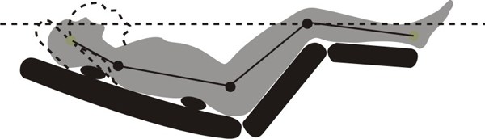

**Healthy Lounge Chair ®** provides two stages of zero gravity, the 2nd being more reclined. When fully reclined, to where your knees are higher than your heart level, the therapeutic effects are incredibly effective and may be felt immediately.

If you’re thinking ultimate relaxation, why not think about reading your favorite book or watching TV in your highly fashionable indoor gravity chair? However, don’t blame the chair if you fall asleep in it! Yes, it’s that comfy! Beside, the energy provided by Shungite bars helps you feel calm and relaxed.

Forming a 120°-130° angle between your abdomen and thighs, this kind of chair is recommended by orthopedists, reflexologists, hypnotherapists and psychotherapists because it helps with both psychological and physical stress.

The special geometry of the chair, the way Shungite bars alternate with the natural wood ones, the absence of any metallic piece of assembly give the **Healthy Lounge Chair ® that unique touch**. Laying in the perfect position for relaxation, supported in the essential points of the back, being all the time protected and energized by Shungite mineral - it's the simplest way ever to get your best holistic shape!

**The way they felt (Testimonials)**

*“Just 10 minutes sitting in that chair and I felt more energized as if I should have slept 8 hours!”-* **John S. UK**. <<read more>>

*"I bought this chair after the fifth come back flight from my business journeys. Every time I was arriving on that airport lounge, my first stop was on the Healthy Lounge Chair they had in there. It was so comfortable after such a long flight! After just 15 minutes in that chair I was as good as new! No back pain anymore!"-* **Steven A., US.**

*"I bought it for home. In the evening, after job, I was happy to use it. In time, I felt I need that good energy in the middle of the day, at work, when my back was so stiff and my energy so low. I told my boss about that chair. The company took two for lounge room. Now everybody is more than happy! Including me!"* - **Anthony V. RO**

*"Do you have spine troubles? HLC is the best way to say good bye to them! The combination of Shungite therapy with zero gravity position technology give that chair the power to make you feel wonderful! You should try one!"-* **Anne L., CA**

*"What a purchase! Worth every penny! It is now our best "masseur" and a beautiful piece of furniture too. My husband does not think he will need to visit his chiropractor too soon, which he did maybe once a month before this chair. It works the muscles and the spine so good. Thank you for this wonderful product.PS. We are fighting for it! :)" -* Nora W. and Tom W., NC

*"Using that chair is my every evening pleasure! Beside the comfort, the good feeling and the de-stress moments, I feel the pain is leaving me and the muscle relaxing. Is that moment of the day when the flight is really possible! I wouldn't miss it for anything at all!" -* Laura A., RO