KAWAI CN-25 5800 lei TVA inclus
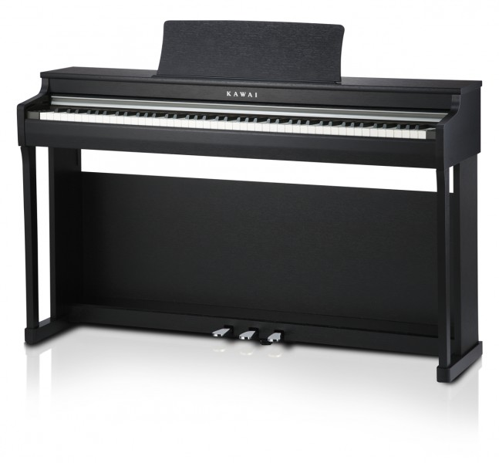



Claviatura: | Mecanica RX-3, 88 clape cu Ivory touch
Sursa sunetului: | Progressive Harmonic Imaging™ System (88 keys sampling)
Sunete: | Concert Grand, Concert Grand 2, Studio Grand, Studio Grand 2, Mellow Grand, Mellow Grand 2, Modern Piano, Rock Piano, Classic E.Piano, Modern E.Piano, Jazz Organ, Church Organ, Harpsichord, Vibraphone, String Ensemble, Slow Strings, Choir, New Age Pad, Atmosphere
Polifonie: | max. 192 notes
Functia lectii: | 240 cântece, Czerny, Burgmüller
Funcţii: | Mod dual ,patru mâini,inregistrare 3 cântece maxim 10000note, metronom,19 cântece demo,concert magic 40 cântece
Pedale: | Grand Feel System
Finisaje de culoare: | Premium Rosewood, Premium Satin Black or Premium White Satin
Jacks | Headphones x 2, USB-to-host, MIDI In/Out
Difuzor: | 12 cm x 2
Putere: | 20 Watt x 2
Dimensiuni: | 135,6 x 40,1 x 85,8cm  Greutate 42kg

