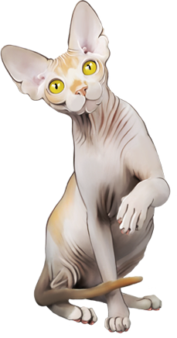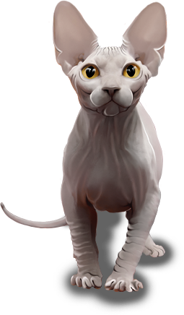 **sphynx cattery**

**Velvet Skin Skin Skin Skin**

**felisa sphynx canadian**